LLANWERN COMMUNITY COUNCIL

MINUTES OF MEETING

HELD AT LLANWERN VILLAGE HALL
MONDAY 26th JANUARY 2026 AT 7.00 PM

PRESENT: Cllrs M George (Chair), Brown, Clemo, Collingbourne, Davies, Grant and Jones

Clerk: Mandy George

Item | Description | Action
1. | APOLOGIES FOR ABSENCE  None.
2. | MINUTES OF PREVIOUS MEETINGS  The Minutes of the meeting held on 16th December 2025 were duly approved and signed.
3. | DECLARATIONS OF INTEREST  It was resolved that any declarations of interest should be stated during the course of the meeting, noted here and the necessary form completed.
4. | PUBLIC PARTICIPATION  None.
5. | SECTION A PLANNING  Station Road Flood Risk Management Scheme – Outline Business Case.  The Chair, CD and Cllr Kellaway are meeting with Newport City Council and ARUP on 13th February to discuss the business case and alternatives that have not been considered. The matters raised at the meeting will be to discuss the issues and anomalies identified and to outline the only viable option.  Redrow  The dog litter bin is now in situ at the start of the spine road, the emptying is the responsibility of the management company. Ward Cllr Kellaway has asked Redrow to request more frequent emptying.  The road is due to be re-closed opposite Little Milton Gardens in line with the original planning conditions.  Glan Llyn  Responses are still being chased from Revantage regarding the meeting with the Chair, Ward Cllr Kellaway and Cllr Clemo.  Future Energy Llanwern  A public drop-in event has been held.
 | 20/0986 – Reserved Matters Application for 32no. Residential Flat Units (Housing Phase 2), Associated Infrastructure and Landscaping all Pursuant to Outline Permission 16/0864 for Residential Development of up to 1100 Dwellings, a Primary School, Village Centre, Public Open Space, Landscaping and Associated Infrastructure Works and Details to Partially Discharge the Following Conditions in Relation to Phase 2, 01 (Reserved Matters), 05 (Building Materials), 06 (Hardscaping Materials), 07 (Boundaries), 09 (Construction Details of Roads, Footways and Highways), 12 (Drainage), 21 (Parking) and 24 (Landscaping) – Llanwern Village Development Site Phase 2 Cot Hill.  On-going (part approved and part refused). To be read in conjunction with 22/0435 which is part approved and part refused.  22/0801 – Reserved Matters Application (Pursuant to Outline Permission 06/0471) for Residential Development on Phases 4b & 5d at the Glan Llyn Regeneration Site to Provide 170 Dwellings Including Details of Access, Appearance, Landscaping, Layout and Scale Together With Details to Partially Discharge Outline Planning Conditions 6 (Recreation Areas), 8 (Materials), 9 (Hard Landscaping), 10 (Boundary Treatments), 11 (Management Of Open Space), 12 (Parking), 15 (Emergency Access), 16 (Roads, Cycleways and Footways), 18 (Road Works), 22 (Streetlighting), 24 (Site Levels), 33 (Surface Water), 34 (Foul and Surface Water Drainage), 35 (Oil Interceptors), 39 (Carbon Reduction and Sustainability) and 43 (Firefighting Access) Llanwern Works Queensway Llanwern Newport  A comprehensive revision was submitted by the applicant and circulated to all.  24/0465 - Reserved Matters Application for New Homes, Associated Infrastructure and Landscaping at Cedars 4 Pursuant to Outline Planning Permission 16/0864 for Residential Development of up to 1100 Dwellings and Provision of Primary School, Village Centre, Public Open Space, Landscaping and Associated Infrastructure Works Affecting Public Rights of Way 397/3, 397/7, 397/9 and 397/10, and Details to Discharge Conditions 5 (Building Materials), 6 (Hardscaping Materials), 7 (Boundary  Treatments), 9 (Highway Construction Details), 12 (Drainage), 18 (Ecological Management Plan), 19 (Noise Assessment), 21 (Parking) And 24 (Landscaping)  On-going.  24/0466 - Reserved Matters Application for new Homes, Associated Infrastructure and Landscaping at Parcels Known as Hollies 5 and Hollies 6 Pursuant to Outline Planning Permission 16/0864 for Residential Development of up to 1100 Dwellings and Provision of Primary School, Village Centre, Public Open Space, Landscaping and Associated Infrastructure Works Affecting Public Rights of Way 397/3, 397/7, 397/9 and 397/10, and Details to Discharge Conditions 5 (Building Materials), 6 (Hardscaping Materials), 7 (Boundary Treatments), 9 (Highway Construction Details), 12 (Drainage), 21 (Parking) and 24 (Landscaping) Site: Llanwern Village Development Site Phase 1 Cot Hill Llanwern Newport NP18 2DP  Additional/amended information submitted. Circulated to all.  24/0467 – Reserved Matters Application for Sports Pitches, Changing Facilities and Allotments, Associated Infrastructure and Landscaping Pursuant to Outline Planning Permission 16/0864 for Residential Development of up to 1100 Dwellings and Provision of Primary School, Village Centre, Public Open Space, Landscaping and Associated Infrastructure Works Affecting Public Rights of Way 397/3, 397/7, 397/9 and 397/10, and Details to Discharge Conditions 5 (Building Materials), 6 (Hardscaping Materials), 7 (Boundary Treatments), 12 (Drainage), 21 (Parking) and 24 (Landscaping) – Llanwern Village Development Site Phase 1 Cot Hill, Llanwern.  On-going.  25/0152 – Reserved Matters Application Relating to Layout, Scale, Appearance, Access and Landscaping for Residential Development at Phase4e/4g Pursuant To Outline Planning Permission 06/0471 for a Mixed Use Regeneration of the Former Llanwern Steelworks and Partial Discharge of Conditions 01 (Reserved Matters), 06 (Recreational Areas), 08 (Materials), 09 (Details of Hard Landscaped Access), 10 (Boundary Treatments), 11 (Management Strategy for Maintenance of Open Space), 12 (Off Street Parking and Cycle Parking), 15 (Emergency Access), 16 (Details of Roads/Cycleways/Footways), 18 (Estate Roads), 22 (Street Lighting and Car Parking Areas), 24 (Site Levels), 33 & 34 (Foul and Surface Water Drainage), 39 (Sustainability Statement) and 43 (Fire  Fighting Access) Site: Glan Llyn Development Site Phase 4e/4g  Queensway Llanwern Newport  A revised Plan Package was received and circulated to all.  25/0177 - Reserved Matters Application Relating to Layout, Scale, Appearance, Access and Landscaping for 3 No. Commercial Units (Use Class B1, B2, B8) Pursuant to Outline Planning Permission 06/0471 for a Mixed Use Regeneration of the Former Llanwern Steelworks and Partial Discharge of Conditions 01 (Reserved Matters), 08 (Materials), 09  (Details of Hard Landscaped Access), 10 (Boundary Treatments), 11 (Management Strategy for Maintenance of Open Space), 12 (Off Street Parking and Cycle Parking), 15 (Emergency Access), 16 (Details of Roads/Cycleways/Footways), 18 (Estate Roads), 22 (Street Lighting and Car Parking Areas), 24 (Site Levels), 33 (Surface Water Disposal), 34 (Foul and Surface Water Drainage), 39 (Sustainability Statement) and 43 (Fire Fighting Access)Site: Llanwern Works Queensway Llanwern  Newport South Wales  On-going.  25/1001 - Variation of Condition 1 (Plans Condition) of Reserved Matters 17/0250 for all Reserved Matters and Information to Partially Discharge Other Conditions of Outline Planning Permission 06/0471 for the Regeneration of the Former Llanwern Steelworks (Glan Llyn) in Relation to a Manufacturing Unit on the Celtic Business Park. Amendments are for the Delivery of a New Dynamic Test Track and Electrification with Associated Works and Landscaping  SITE: Land Known as Celtic Business Park Queensway Llanwern  Newport South Wales  This application was forwarded to Cllr Davies.  25/1058 – Erection of a Two-Storey Side Extension, New Front  Porch and Repositioning of Front Entrance Door SITE: 8 Routes View Llanwern Newport NP18 2DR  Awaiting decision.  25/1100 - S73 Application to Vary Condition 1 (Approved Plans) of 22/0073 Reserved Matters Application (All Matters) and the Partial Discharge of Conditions 08 (Materials), 09 (Hard Landscaping), 10 (Boundary Treatments), 12 (Parking and Cycle Storage), 15 (Emergency Access), 22 (Lighting), 24 (Flood Consequence Assessment), 33 (Surface Water Disposal) and 43 (Access to Open Water) of Permission 06/0471 for the Regeneration of the Former Llanwern Steelworks (Glan Llyn) in  Relation to a Permanent Warehouse Facility and Associated Infrastructure Associated With the Caf Commercial Unit at St Modwens Park  Site: 1 Monks Ditch Drive Indurent Park Newport  An application was received and circulated to all.  Flooding of Subway to Dawson Close  On-going.  Newport LDP  On-going.  Spate of Burglaries  Correspondence was received and forwarded to Gwent Police regarding the spate of recent burglaries. Gwent Police advised that the Officer in charge should be contacted by the reporting person for any updates. If this is unsatisfactory, it can be escalated to a supervisor. Footage of the perpetrators were given to the Police.  Litter Bins  Ward Cllr Kellaway has requested that NCC empty the village bins more frequently, they are filling up will dog litter which is a health and safety issue. | OD
 | SECTION B  FINANCE AND LOCAL GOVERNMENT  Bank reconciliation as at 26th January 2026  Accounts for Payment  DDs  YuEnergy - £232.05  TalkTalk - £33.37  Microsoft - £12.10  BACS  Clerk (January) – £446.25  Welsh Water - £186.58  HMRC (PAYE Q3) - £274.77  Defib World - £72.19  Hostworld (Security Certificate) - £33.70  SSE - £154.88  Hedgecutting - £216 (invoice awaited before payment made)  Local Government and Elections (Wales) Act 2021: Community and Town Councils Statutory Guidance  Training modules were circulated. It was requested that the Clerk investigate the possibility of planning training.  Audit 2024/25  No response received from Audit Wales regarding the disputed statement. The Clerk will chase.  S 106 Monies  The Clerk will contact NCC again to enquire whether Redrow have ever paid a S106 contribution to the school.  Section 137 Expenditure Limit  Correspondence was received advising that the maximum expenditure that can be incurred for Section 137 (1) and (3) will be £11.60 per elector. | Clerk  Clerk  Clerk
   |  | £
  A | Balance on current a/c bank statement at 30 December 2025  Balance on deposit a/c bank statement at 26 January 2026 Total | 708.14  79,510.47  80,218.61
   | Outstanding items
  B | Less unpresented cheques  Bank Commission  Microsoft  Yu Energy  SSE Energy  Hostworld Internet  Defib World  Total | 10.50  12.10  232.05  154.88  33.70  72.19  515.42
  C | Plus uncleared payments into bank  Transfer from deposit  Ground rent no 6  Total | 1,000.00  4.50  1,004.50
  D | Balance at 26th January A-B+C | 80,707.69
 | SECTION C – LEISURE AND AMENITIES  Village Hall  Car Park – Cllr Jones presented a summary of tenders received so far. A third contractor has been found and their tender is awaited. The Chair and Cllr Davies are chasing the Ecologist for their report, the S73 amendment can then be submitted.  Future Events – The next event in the calendar is a quiz night on 6th February.  Alcohol Licence – the Clerk will check how many events are able to be held per annum.  S106 monies – The Clerk will chase the S106 monies amounting to £24,233. | Chair/  OD  Clerk
SECTION D – HIGHWAYS AND UTILITIES

Llanwern Park Bridge

On-going.

Pubic Footpaths/Rights of Way

Correspondence was received regarding the condition of the footpath and lack of way-markers on the route to Underwood. The Clerk has advised Ward Cllr Kellaway who is in contact with the department concerned. Photographic evidence has been submitted.

6. | CORRESPONDENCE – the following were emailed to Councillors:  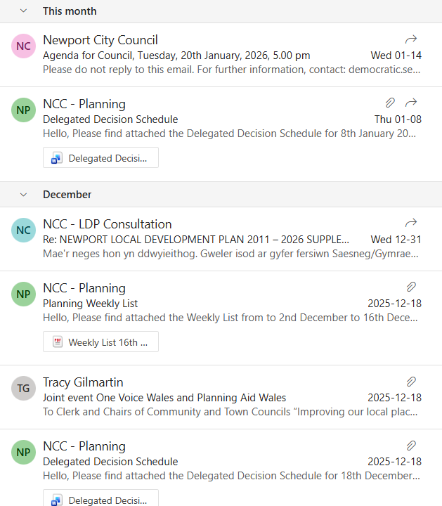
7. | DATE OF NEXT MEETING  The next meeting will be held on Monday 23rd February 2026 at 7.00pm. This meeting will be held at the Village Hall and also remotely. The meeting closed at 9.25 pm.

