LLANWERN COMMUNITY COUNCIL

MINUTES OF MEETING

HELD AT LLANWERN VILLAGE HALL
MONDAY 27th APRIL 2026 AT 7.00 PM

PRESENT: Cllrs M George (Chair), Brown, Davies and Grant
Clerk: Mandy George

Item | Description | Action
1. | APOLOGIES FOR ABSENCE  Apologies were received from Cllrs Collingbourne (holiday) Grant (work) and Jones (work).
2. | MINUTES OF PREVIOUS MEETINGS  The Minutes of the meeting held on 24th March 2026 were duly approved and signed.
3. | DECLARATIONS OF INTEREST  It was resolved that any declarations of interest should be stated during the course of the meeting, noted here and the necessary form completed.
4. | PUBLIC PARTICIPATION  None.
5. | SECTION A PLANNING  Station Road Flood Risk Management Scheme – Outline Business Case.  Ward Cllr Kellaway has received a response from NCC who have advised that ARUP are undertaking a modelling exercise, progress will be advised in due course.  Redrow  The GMPRA forwarded a letter received from Barratt/Redrow in response to the letter they received from John Griffiths MS. Jessica Morden's office will be writing to Barratt/Redrow to request a meeting, to include representatives from the residents’ association after the Senedd elections.  The Clerk forward the S106 obligations to all:  Cot Hill Llanwern - £188,323 for improvement works to existing water drainage controlled by the Council as are shown set out on drawing FA020/6 P2 appended to the "Newport Drainage Schemes Llanwern Village - Project Appraisals Report 18 May 2005" or such amended scheme as shall be agreed between the Council and Gallagher  Cot Hill Llanwern - £48,020 for the purpose of carrying out the Cot Hill Phase 2 Works  Cot Hill Llanwern - £538,829 for bus subsidy  Confusion still remains regarding the funding for the primary school, the Clerk will ask Ward Cllr Kellaway for advice.  Glan Llyn  Residents are concerned that there is no surplus capacity at Glan Llyn primary school. Residents who don’t have access to a car are particularly worried. The Clerk will contact Cllr Deb Davies again for comment.  Comment is still awaited regarding the speeding issues and speed signs.  Prohibition of Traffic Order to Cot Hill  On-going. | Clerk  Clerk
20/0986 – Reserved Matters Application for 32no. Residential Flat Units (Housing Phase 2), Associated Infrastructure and Landscaping all Pursuant to Outline Permission 16/0864 for Residential Development of up to 1100 Dwellings, a Primary School, Village Centre, Public Open Space, Landscaping and Associated Infrastructure Works and Details to Partially Discharge the Following Conditions in Relation to Phase 2, 01 (Reserved Matters), 05 (Building Materials), 06 (Hardscaping Materials), 07 (Boundaries), 09 (Construction Details of Roads, Footways and Highways), 12 (Drainage), 21 (Parking) and 24 (Landscaping) – Llanwern Village Development Site Phase 2 Cot Hill.

On-going (part approved and part refused). To be read in conjunction with 22/0435 which is part approved and part refused.

24/0466 - Reserved Matters Application for new Homes, Associated Infrastructure and Landscaping at Parcels Known as Hollies 5 and Hollies 6 Pursuant to Outline Planning Permission 16/0864 for Residential Development of up to 1100 Dwellings and Provision of Primary School, Village Centre, Public Open Space, Landscaping and Associated Infrastructure Works Affecting Public Rights of Way 397/3, 397/7, 397/9 and 397/10, and Details to Discharge Conditions 5 (Building Materials), 6 (Hardscaping Materials), 7 (Boundary Treatments), 9 (Highway Construction Details), 12 (Drainage), 21 (Parking) and 24 (Landscaping) Site: Llanwern Village Development Site Phase 1 Cot Hill Llanwern Newport NP18 2DP

Decision awaited.

24/0467 – Reserved Matters Application for Sports Pitches, Changing Facilities and Allotments, Associated Infrastructure and Landscaping Pursuant to Outline Planning Permission 16/0864 for Residential Development of up to 1100 Dwellings and Provision of Primary School, Village Centre, Public Open Space, Landscaping and Associated Infrastructure Works Affecting Public Rights of Way 397/3, 397/7, 397/9 and 397/10, and Details to Discharge Conditions 5 (Building Materials), 6 (Hardscaping Materials), 7 (Boundary Treatments), 12 (Drainage), 21 (Parking) and 24 (Landscaping) – Llanwern Village Development Site Phase 1 Cot Hill, Llanwern.

On-going. This application has been called-in.

25/0152 – Reserved Matters Application Relating to Layout, Scale, Appearance, Access and Landscaping for Residential Development at Phase4e/4g Pursuant To Outline Planning Permission 06/0471 for a Mixed Use Regeneration of the Former Llanwern Steelworks and Partial Discharge of Conditions 01 (Reserved Matters), 06 (Recreational Areas), 08 (Materials), 09 (Details of Hard Landscaped Access), 10 (Boundary Treatments), 11 (Management Strategy for Maintenance of Open Space), 12 (Off Street Parking and Cycle Parking), 15 (Emergency Access), 16 (Details of Roads/Cycleways/Footways), 18 (Estate Roads), 22 (Street Lighting and Car Parking Areas), 24 (Site Levels), 33 & 34 (Foul and Surface Water Drainage), 39 (Sustainability Statement) and 43 (Fire
Fighting Access) Site: Glan Llyn Development Site Phase 4e/4g
Queensway Llanwern Newport

Decision awaited.

26/0250 - S73 Application to Vary Condition 1 (Approved Plans) of 21/0223 Construction of Proposed Community Car Park and Pathway for Use in Association with Llanwern Village Hall
SITE: Car Park Milton Hotel Milton Hill Llanwern Newport
APPLICATION TYPE: Renewals and Variation of Conditions

Circulated to all.

Newport LDP

On-going.

Gwent Police – Llanwern Ward

A breakdown of calls was received and circulated to all.

 | SECTION B  FINANCE AND LOCAL GOVERNMENT  Bank reconciliation as at 27th April 2026  Accounts for Payment  DDs  YuEnergy - £218.90  TalkTalk - £39.37  Microsoft - £12.10  BACS  Clerk (April) – £446.25 (gross)  Zurich (Council Insurance) - £770.15  SSE Energy - £160.57  NCC S73 Planning Fees (car park)- £282.50  Local Government and Elections (Wales) Act 2021: Community and Town Councils Statutory Guidance  Training modules were circulated.  Audit 2025/26  Cllr Brown presented a report regarding our asset register and advised that commercial concepts of depreciation etc are not appropriate for Community Councils with income and expenditure under £2.5 m. For reporting purposes the book value of fixed assets may remain constant or until disposed of. The value of assets is a theoretical exercise as it has no direct impact on the financial accounts, as in every case the full cost is accounted for in the year it occurs. Cllr Brown will speak to our auditor.  It was recommended and approved that an asset register, independent of the insurance schedule, be established. | TB  TB/Clerk
   |  | £
  A | Balance on current a/c bank statement at 31 March 2026  Balance on deposit a/c bank statement at 27 April 2026 Total | 477.50  94,472.42  94,949.92
   | Outstanding items
  B | Less unpresented cheques  A George (planning application fees)  SSE Energy Solutions  Microsoft  Yu Energy  Talk Talk  HMRC PAYE  Transfer to deposit  Total | 282.50  160.57  12.10  218.90  39.37  70.20  18,500.00  19,283.64
   | Plus uncleared payments into bank  NCC Precept  Transfer from deposit a/c  R Games (sheep tack)  Total | 19,078.50  500.00  269.40 19,847.90
  D | Balance at 27th April A-B+C | 95,514.18
 | SECTION C – LEISURE AND AMENITIES  Village Hall  Car Park – The Chair advised that the S73 has been submitted to NCC.  An email was received from residents concerned about the footpath from the car park to the back of the village hall. The Clerk will write to the residents noting their concerns. Various amendments had to be made due to changing legislation, which resulted in the present S73 application to vary conditions (application 26/0250) being made.  The proposed lighting will be low level solar lights and the reason for the all-weather path is for the safety of pedestrians walking from their cars to the hall to avoid a road with no footpath.  The CC suggests that they make representations to the planning department of Newport City Council who will be the authority granting the amendments to this planning permission.  It was suggested that once the S73 is granted that a special meeting of this Council be held to discuss the contracts received.  Purchase of Stacking Chairs – a request was received for the purchase of 3 sets of 18 stacking chairs at a cost of £3,607.20 plus vat. This has been budgeted for and the Clerk was asked to contact the VHMC and request that an order be placed. The invoice will be presented at the next meeting.  AGM – the Village Hall AGM will be held on 18th May at 7pm.  S106 monies for Playing Field  The Clerk will again chase the S106 monies amounting to £24,233. | Clerk  Clerk  Clerk
SECTION D – HIGHWAYS AND UTILITIES

Llanwern Park Bridge

On-going.

6. | CORRESPONDENCE – the following were emailed to Councillors:  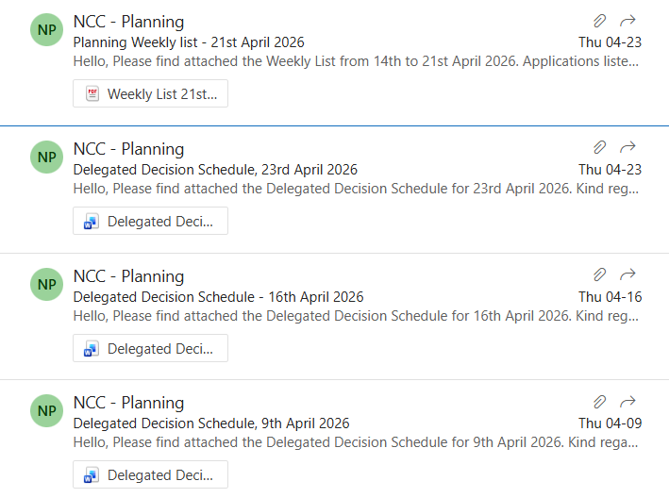  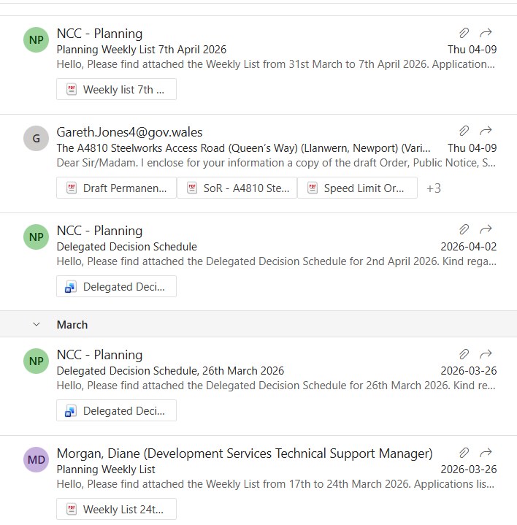
7. | DATE OF NEXT MEETING  The next meeting will be held on Tuesday 26th May 2026 at 7.00pm. This meeting will also be the AGM and will be held at the Village Hall and also remotely. The meeting closed at 9.00 pm

