LLANWERN COMMUNITY COUNCIL

MINUTES OF MEETING

HELD AT LLANWERN VILLAGE HALL

MONDAY 27th JULY 2026 AT 7.00 PM

PRESENT: Cllrs M George (Chair), Brown, Clemo, Collingbourne, Davies, Grant and Jones (Teams).

Clerk: Mandy George

Item | Description | Action
1. | APOLOGIES FOR ABSENCE  None.
2. | MINUTES OF PREVIOUS MEETINGS  The Minutes of the meeting held on 29th June 2026 were duly approved and signed.
3. | Review of Standing Orders, Financial Regulations and Policies  These were duly reapproved with the exception to temporarily waiver the £25,000 contract limit to £100,000 in respect of the car park project only, Section 11 (11.1g).
4. | Declarations of Interest  None.
5. | Public Participation  None
6. | SECTION A PLANNING  Station Road Flood Risk Management Scheme – Outline Business Case  A copy of the report has been received from ARUP. The Chair and Cllr Kellaway are meeting at the end of this week to discuss with our consultant.  Redrow  The Chair has spoken to Redrow regarding the amount of dust from the building site, they will investigate and ensure that more water is used to dampen down. The hedge also needs cutting on Cot Hill, this will be done after the nesting season.  The Chair will enquire who owns the hedge at the top of Cot Hill. A ‘No Through’ sign has been erected at the top of Cot Hill which can’t be seen until it’s too late, by implication it suggests that turning left is ok. The Clerk will ask for it to be brought forward into view.  The South Wales Argus has reported on the new School being built using a £6m S106 payment. The Clerk will investigate.  Glan Llyn  Responses are still being chased from Revantage (Adrian Andrews) by Cllr Clemo, regarding the meeting with the Chair and Ward Cllr Kellaway.  Prohibition of Traffic Order to Cot Hill  On-going. | Chair  Chair  Clerk  Clerk
 | 20/0986 – Reserved Matters Application for 32no. Residential Flat Units (Housing Phase 2), Associated Infrastructure and Landscaping all Pursuant to Outline Permission 16/0864 for Residential Development of up to 1100 Dwellings, a Primary School, Village Centre, Public Open Space, Landscaping and Associated Infrastructure Works and Details to Partially Discharge the Following Conditions in Relation to Phase 2, 01 (Reserved Matters), 05 (Building Materials), 06 (Hardscaping Materials), 07 (Boundaries), 09 (Construction Details of Roads, Footways and Highways), 12 (Drainage), 21 (Parking) and 24 (Landscaping) – Llanwern Village Development Site Phase 2 Cot Hill.  On-going (part approved and part refused). To be read in conjunction with 22/0435 which is part approved and part refused.  24/0466 - Reserved Matters Application for new Homes, Associated Infrastructure and Landscaping at Parcels Known as Hollies 5 and Hollies 6 Pursuant to Outline Planning Permission 16/0864 for Residential Development of up to 1100 Dwellings and Provision of Primary School, Village Centre, Public Open Space, Landscaping and Associated Infrastructure Works Affecting Public Rights of Way 397/3, 397/7, 397/9 and 397/10, and Details to Discharge Conditions 5 (Building Materials), 6 (Hardscaping Materials), 7 (Boundary Treatments), 9 (Highway Construction Details), 12 (Drainage), 21 (Parking) and 24 (Landscaping) Site: Llanwern Village Development Site Phase 1 Cot Hill Llanwern Newport NP18 2DP  Approved with conditions.  24/0467 – Reserved Matters Application for Sports Pitches, Changing Facilities and Allotments, Associated Infrastructure and Landscaping Pursuant to Outline Planning Permission 16/0864 for Residential Development of up to 1100 Dwellings and Provision of Primary School, Village Centre, Public Open Space, Landscaping and Associated Infrastructure Works Affecting Public Rights of Way 397/3, 397/7, 397/9 and 397/10, and Details to Discharge Conditions 5 (Building Materials), 6 (Hardscaping Materials), 7 (Boundary Treatments), 12 (Drainage), 21 (Parking) and 24 (Landscaping) – Llanwern Village Development Site Phase 1 Cot Hill, Llanwern.  Decision awaited.  25/0152 – Reserved Matters Application Relating to Layout, Scale, Appearance, Access and Landscaping for Residential Development at Phase4e/4g Pursuant To Outline Planning Permission 06/0471 for a Mixed Use Regeneration of the Former Llanwern Steelworks and Partial Discharge of Conditions 01 (Reserved Matters), 06 (Recreational Areas), 08 (Materials), 09 (Details of Hard Landscaped Access), 10 (Boundary Treatments), 11 (Management Strategy for Maintenance of Open Space), 12 (Off Street Parking and Cycle Parking), 15 (Emergency Access), 16 (Details of Roads/Cycleways/Footways), 18 (Estate Roads), 22 (Street Lighting and Car Parking Areas), 24 (Site Levels), 33 & 34 (Foul and Surface Water Drainage), 39 (Sustainability Statement) and 43 (Fire  Fighting Access) Site: Glan Llyn Development Site Phase 4e/4g  Queensway Llanwern Newport  Part approved with conditions and part refused.  26/0250 - S73 Application to Vary Condition 1 (Approved Plans) of 21/0223 Construction of Proposed Community Car Park and Pathway for Use in Association with Llanwern Village Hall  SITE: Car Park Milton Hotel Milton Hill Llanwern Newport  APPLICATION TYPE: Renewals and Variation of Conditions  Granted with conditions. The Chair will contact Roberts Limbrick regarding the pre-commencement conditions. The Clerk is authorised to pay up to £1,450 (plus vat).  26/0321 – Double Storey Side Extension, Demolition of Side Conservatory and Installation of Bifold Doors  Site: Mandwa, Station Road  Decision awaited.  Newport LDP  On-going.  Gwent Police – Llanwern Ward  A breakdown of calls were received and circulated to all. | Chair
SECTION B

FINANCE AND LOCAL GOVERNMENT

Bank reconciliation as at 26th July 2026

 |  | £
A | Balance on current a/c bank statement at 30th June 2026  Balance on deposit a/c bank statement at 26th July 2026 Total | 927.93 114,972.42  115,900.35
 | Outstanding items
B | Less unpresented cheques  SSE Energy Solutions  Microsoft  Yu Energy  HMRC  Total | 163.45  12.10  41.26  313.77  530.58
C | Plus uncleared payments into bank  Total | 0  0
D | Balance at 29th July A-B+C | 115,369.77

Accounts for Payment

DDs
YuEnergy - £41.26
TalkTalk - £39.37
Microsoft - £12.10
HMRC - £313.77

BACS
Clerk (July) – £446.25 (gross)
Chair’s Purse - £25.50 (raffle)
Audit Wales - £775.85
Village Hall Management Committee - £10,000 (roof)
SSE - £163.45
Ansvar - £1,052.68 (Village Hall insurance)

Budget Monitoring

Cllr Brown presented the spreadsheet showing the apportioned budget v actual for quarter 1.

Local Government and Elections (Wales) Act 2021: Community and Town Councils Statutory Guidance

Training modules were circulated.

Audit 2025/26 Approval of the Accounting Statements and Annual Governance Statement

On-going.

 | SECTION C – LEISURE AND AMENITIES  Village Hall  Car Park  a) Planning Consent - The application has finally been granted with conditions see 26/0250. The Chair is to contact Robert Limbrick with a view to finalising our pre-commencement conditions. The Clerk is authorised to pay up to £1450 (plus VAT) on receipt of Limbrick's invoice, to ensure that there is no further delay in this prolonged project.  b) Tenders - Council received Councillor Jones' tabled report analysing the following sealed quotations received from Contractor A - £92,423.60; Contractor B - £79,728 and Contractor C - £120,399, including taking up relevant references. A proposal by Councillor Brown, seconded by Councillor Collingbourne that the contract be awarded to contractor B was carried unanimously (Councillor Jones did not participate in the vote). The clerk is to contact Contractor B at the earliest opportunity to arrange a meeting to discuss start date and contracts etc.  Councillor Jones will be asked to project manage the works.  c) Council Standing Orders - Under Council’s Standing Orders projects currently have a maximum of £25,000, clearly this not adequate for the car park project; options are to increase the Standing Orders to a new limit of £100,000 or b) maintain the Standing Order at its present £25,000, but minute temporary increase to £100,000 in respect of the car park project only. It was resolved and hereby approved that option B be adopted. For the purpose of this Minute the delay in this application was due to amendments to the design and changing planning and Welsh Government legislation. We are currently awaiting the discharge of conditions relating to landscaping.  Roof – evidence of the spend was received and £10,000 will now be paid as our contribution. A contingency of £2,000 was set aside and we await proof before this money is released.  Playing Field  Repair of Field Gate – The existing gate can be re-used, with the post just requiring renewal. The Chair will arrange and is authorised to spend up to £500.  Dog Fouling – the situation is being monitored. | Clerk  Clerk
SECTION D – HIGHWAYS AND UTILITIES

Llanwern Park Bridge

On-going.

7. | CORRESPONDENCE – the following were emailed to Councillors:  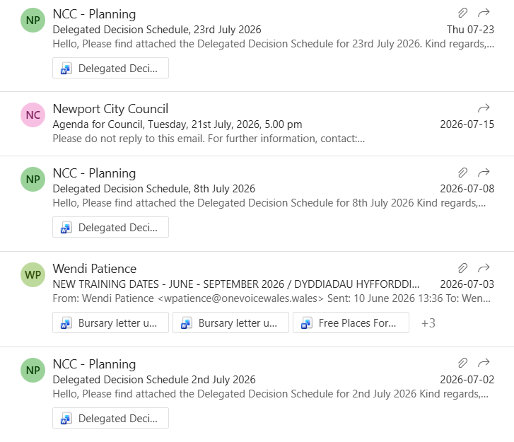
8. | DATE OF NEXT MEETING  The next meeting will be held on Monday 28th September 2026 at 7.00pm. The meeting closed at 8.45 pm.

