LLANWERN COMMUNITY COUNCIL

MINUTES OF MEETING

HELD AT LLANWERN VILLAGE HALL

MONDAY 29th JUNE 2026 AT 7.00 PM

PRESENT: Cllrs M George (Chair), Brown and Davies (via Teams)

Clerk: Mandy George

Item | Description | Action
1. | APOLOGIES FOR ABSENCE  Apologies were received from Cllrs Clemo (holiday), Collingbourne (family), Grant and Jones (work).
2. | MINUTES OF PREVIOUS MEETINGS  The Minutes of the meeting held on 26th May 2026 were duly approved and signed.
3. | Review of Standing Orders, Financial Regulations and Policies  These were duly reapproved. The template used are the models recommended by One Voice Wales.
4. | Declarations of Interest  None.
5. | Public Participation  None
6. | SECTION A PLANNING  Station Road Flood Risk Management Scheme – Outline Business Case  The Chair will liaise with Ward Cllr Kellaway for any updates.  Redrow  It was noted that works are happening to upgrade the main road for adoption. It was noted that the problems with flooding at the junction of Station Road and Bishton Road have still not been resolved. This needs to be determined before adoption. The Chair will remind Redrow and Newport City Council of this.  Glan Llyn  Responses are still being chased from Revantage (Adrian Andrews) by Cllr Clemo, regarding the meeting with the Chair and Ward Cllr Kellaway.  Ward Cllr Kellaway requested a contribution from this Council for the purchase of wild life signs, due to the number of geese in the vicinity. It was agreed that up to £500 be made available. The Clerk will advise and remind that signs can only be placed on adopted roads.  Prohibition of Traffic Order to Cot Hill  On-going. | Chair  Chair  Clerk
 | 20/0986 – Reserved Matters Application for 32no. Residential Flat Units (Housing Phase 2), Associated Infrastructure and Landscaping all Pursuant to Outline Permission 16/0864 for Residential Development of up to 1100 Dwellings, a Primary School, Village Centre, Public Open Space, Landscaping and Associated Infrastructure Works and Details to Partially Discharge the Following Conditions in Relation to Phase 2, 01 (Reserved Matters), 05 (Building Materials), 06 (Hardscaping Materials), 07 (Boundaries), 09 (Construction Details of Roads, Footways and Highways), 12 (Drainage), 21 (Parking) and 24 (Landscaping) – Llanwern Village Development Site Phase 2 Cot Hill.  On-going (part approved and part refused). To be read in conjunction with 22/0435 which is part approved and part refused.  24/0466 - Reserved Matters Application for new Homes, Associated Infrastructure and Landscaping at Parcels Known as Hollies 5 and Hollies 6 Pursuant to Outline Planning Permission 16/0864 for Residential Development of up to 1100 Dwellings and Provision of Primary School, Village Centre, Public Open Space, Landscaping and Associated Infrastructure Works Affecting Public Rights of Way 397/3, 397/7, 397/9 and 397/10, and Details to Discharge Conditions 5 (Building Materials), 6 (Hardscaping Materials), 7 (Boundary Treatments), 9 (Highway Construction Details), 12 (Drainage), 21 (Parking) and 24 (Landscaping) Site: Llanwern Village Development Site Phase 1 Cot Hill Llanwern Newport NP18 2DP  Decision awaited.  24/0467 – Reserved Matters Application for Sports Pitches, Changing Facilities and Allotments, Associated Infrastructure and Landscaping Pursuant to Outline Planning Permission 16/0864 for Residential Development of up to 1100 Dwellings and Provision of Primary School, Village Centre, Public Open Space, Landscaping and Associated Infrastructure Works Affecting Public Rights of Way 397/3, 397/7, 397/9 and 397/10, and Details to Discharge Conditions 5 (Building Materials), 6 (Hardscaping Materials), 7 (Boundary Treatments), 12 (Drainage), 21 (Parking) and 24 (Landscaping) – Llanwern Village Development Site Phase 1 Cot Hill, Llanwern.  Decision awaited.  25/0152 – Reserved Matters Application Relating to Layout, Scale, Appearance, Access and Landscaping for Residential Development at Phase4e/4g Pursuant To Outline Planning Permission 06/0471 for a Mixed Use Regeneration of the Former Llanwern Steelworks and Partial Discharge of Conditions 01 (Reserved Matters), 06 (Recreational Areas), 08 (Materials), 09 (Details of Hard Landscaped Access), 10 (Boundary Treatments), 11 (Management Strategy for Maintenance of Open Space), 12 (Off Street Parking and Cycle Parking), 15 (Emergency Access), 16 (Details of Roads/Cycleways/Footways), 18 (Estate Roads), 22 (Street Lighting and Car Parking Areas), 24 (Site Levels), 33 & 34 (Foul and Surface Water Drainage), 39 (Sustainability Statement) and 43 (Fire  Fighting Access) Site: Glan Llyn Development Site Phase 4e/4g  Queensway Llanwern Newport  Decision awaited.  26/0250 - S73 Application to Vary Condition 1 (Approved Plans) of 21/0223 Construction of Proposed Community Car Park and Pathway for Use in Association with Llanwern Village Hall  SITE: Car Park Milton Hotel Milton Hill Llanwern Newport  APPLICATION TYPE: Renewals and Variation of Conditions  On-going.  26/0321 – Double Storey Side Extension, Demolition of Side Conservatory and Installation of Bifold Doors  Site: Mandwa, Station Road  Decision awaited.  Newport LDP  On-going.  Gwent Police – Llanwern Ward  A breakdown of calls were received and circulated to all.  Street Naming and Numbering  Correspondence was received from Newport City Council regarding the proposed street naming for Phase 4D of Glan Llyn. It was requested that the Clerk advise that we have no comments to make. | Clerk
 | SECTION B  FINANCE AND LOCAL GOVERNMENT  Bank reconciliation as at 29th June 2026  Accounts for Payment  DDs  YuEnergy - £128.88  TalkTalk - £39.37  Microsoft - £12.10  BACS  Clerk (June) – £446.25 (gross)  Welsh Water – £311.39  J Wootton (Internal Audit) - £100  Local Government and Elections (Wales) Act 2021: Community and Town Councils Statutory Guidance  Training modules were circulated.  Audit 2025/26 Approval of the Accounting Statements and Annual Governance Statement  The Clerk circulated copies of the Annual Clerk’s Report, a copy of which will be sent to Audit Wales. The Clerk has published the audit notice to the website and noticeboard.  Chair’s Purse  It was agreed that £200 be made available. | Clerk
   |  | £
  A | Balance on current a/c bank statement at 29th May 2026  Balance on deposit a/c bank statement at 29th June 2026 Total | 1,365.72 115,472.42  116,838.14
   | Outstanding items
  B | Less unpresented cheques  J Wootton  Microsoft  Yu Energy  TalkTalk  Welsh Water  Total | 100.00  12.10  128.88  39.37  311.39  591.74
  C | Plus uncleared payments into bank  Total | 0  0
  D | Balance at 29th June A-B+C | 116,246.40
 | SECTION C – LEISURE AND AMENITIES  Village Hall  Car Park – The Chair advised that the S73 is still on-going as new drawings were requested, the result of the amended application is due very soon. It was noted that this Council’s reserves are set aside for the completion of this project. The Clerk has advised Audit Wales of this.  Roof – the roof repairs have now commenced. This Council has budgeted a contribution of £10,000 (plus a £2,000 contingency). Our contribution will be paid on production of evidence of the spend along with the contingency monies.  Playing Field  Repair of Field Gate – the Chair will contact a local contractor for a price for the repair of the field gate as this is an urgent health and safety matter.  Dog Fouling – the situation will be monitored. | Chair
SECTION D – HIGHWAYS AND UTILITIES

Llanwern Park Bridge

On-going.

7. | CORRESPONDENCE – the following were emailed to Councillors:  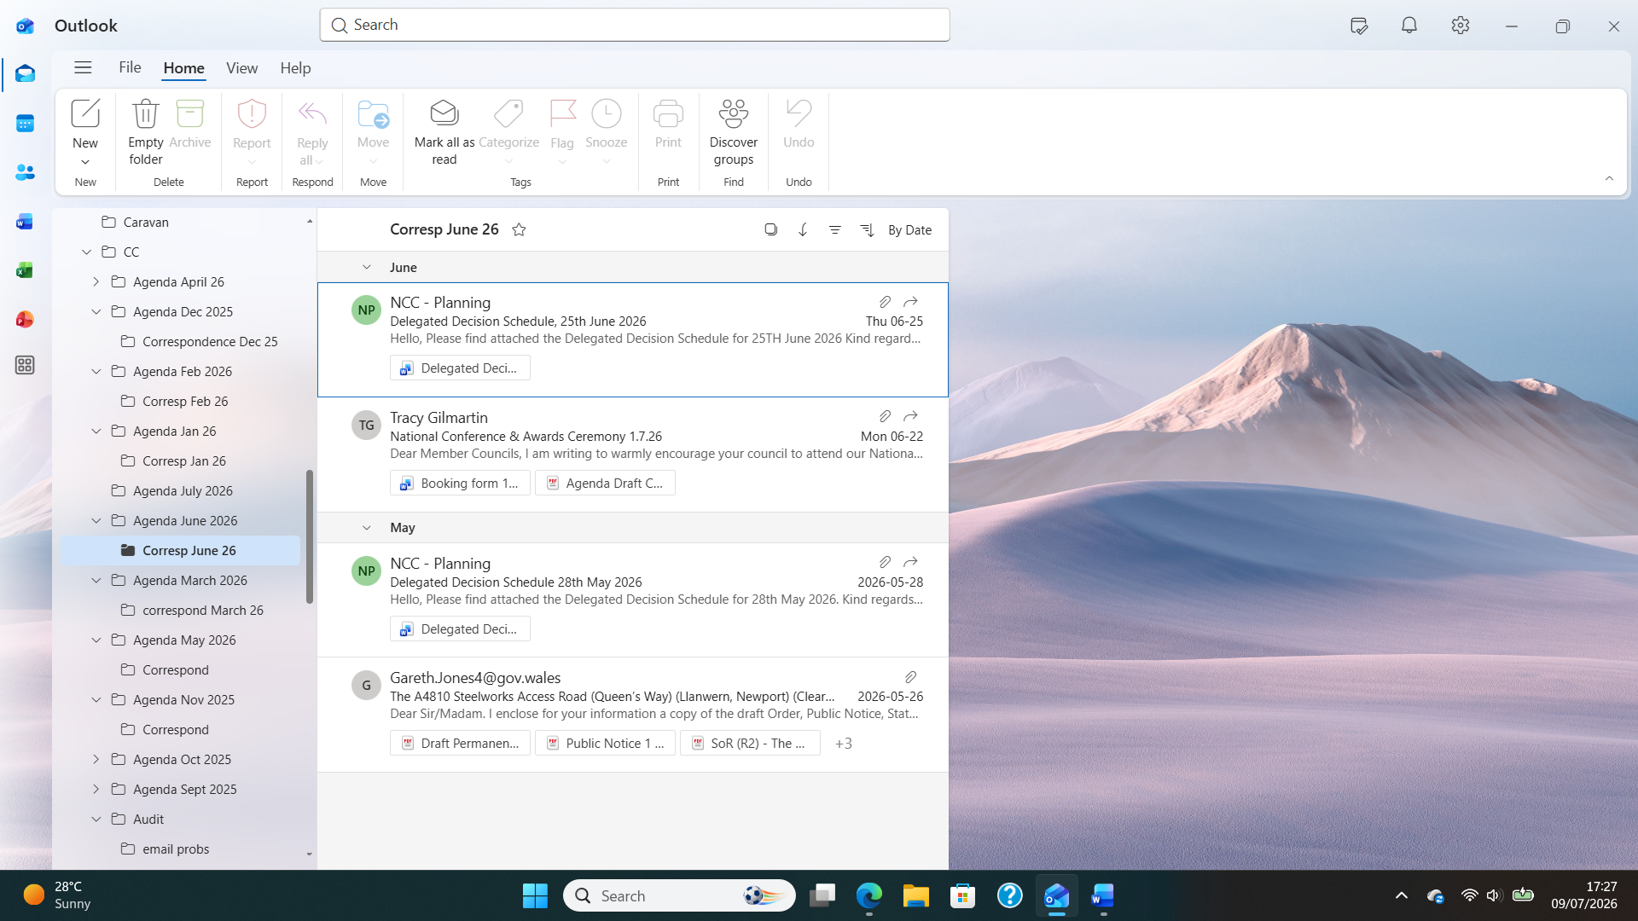
8. | DATE OF NEXT MEETING  The next meeting will be held on Monday 27th July 2026 at 7.00pm. The meeting closed at 8.20 pm.

