**Upcoming activities for our morning session children**

**Ballet:**

We welcome Taylor as our Ballet instructor. Taylor is giving her time voluntarily to teach the children Ballet. They have so far enjoyed a session and can decide if they would like to participate or not- it’s up to them.

The children seemed to really enjoy the session and Taylor enjoyed working with them and will come up each Friday morning to take them.

Taylor is about to undertake an SVQ qualification

in Early Learning and Childcare.





**Community partnership**

We will be working in partnership with Eder Glynn. We approached Mary Gardner (Manager of Eder Glynn) to see if it would be possible to take a small group of children down each week to join in activities with some of the residents. Maybe do some drawing, jigsaws, games, exercises etc.

They are delighted to have us and we are rather excited about it.

So each Wednesday a small group of 4-6 children will walk to Eder Glynn and spend 30-45 minutes with the residents. This is new to us and to them, so, to begin with we will only be taking our Pre-school children and building from there if appropriate. We would like this to be a long standing partnership and to bring a bit of youth and energy to the residents and help to make their day a bit brighter. As parents, you do not have to do anything other than bring your child as usual, however, if for any reason, you do not wish your child to be involved with Eder Glynn, Please put it in writing and give it to Rachael, if your reasons are private, you do not have to disclose them.



**Developmental Milestones:**

There is a new tool for measuring our children’s all round development, this is known as the Developmental Milestones Tool.

This has been devised by the Local Authority Early Years Team in conjunction with the legislation and the Curriculum that we work to, and ensures that children have the opportunities to meet their potential and get help in areas they may need It, whether there are difficulties or strengths each child has a programme tailored to suit their individual needs and abilities.

This will work alongside your child’s Personal Learning Plan (PLP) and the outcomes we are working to will be displayed on the SHANARRI (Achievement ) wall in the main hall.

There is a parent’s guide being issued in the next couple of days, so please read it. The Authority are also keen to have your feedback on the guide be it positive or negative, as they want parents to support and engage in the process.

This is a new initiative to us all, and we will work through it together, the main thing is you take the time to share your child’s PLP with them and their wider family and ensure you comment and sign it and return it to the centre. There is only one copy of this PLP therefore if it is lost, it cannot be replaced and it is a detailed journey of your child’s pre-school experience.

If you have any concerns about your child’s progress or any other worries about nursery life, please speak to your child’s key worker.

r

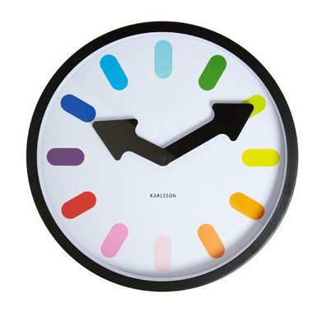

**Late Collection**

Please ensure you are on time to collect your children from the centre at the end of their session. This can be an anxious time for children wondering why someone hasn’t picked them up. If you are going to be late, then Please phone the centre and let the staff know so they can tell your child and help them be prepared for the change in their routine.

If the period of late collection over runs 10 mins then a charge for childcare will be put in place, as with habitual late collection.

We trust you understand we run to a tight timescale between sessions and we are bound by Adult: child ratios when the children are on the premises, therefore, children left over affect these ratios and could mean us breaking our registration conditions. Please do not put us in this position.

Thank you for your understanding.

