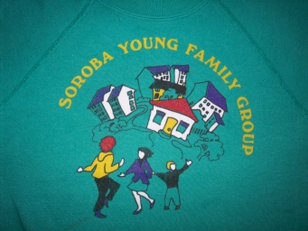

**Soroba Young Family Group**

**St. Andrew’s Day party**

On Tuesday 1st December we are hosting a St. Andrew’s Day party in the cathedral hall where we have Gym time. Both Nursery Groups are invited to attend, and therefore the times will be different. All children should come to the hall at 10.30am and be collected at 1.45pm. There will be entertainment from Oban High School with Pipers, Drummers, Accordionist, and hopefully some Highland dancers. We will have some Haggis neeps and tatties too. You are welcome to stay if you would like to. Wrap around care will run as normal, if this is your regular wrap around day.

**In-Service day:**

**Friday 13th November the centre will be closed for an in-service day, we will re-open as normal on Monday 16th November.**

**Saturday 21st November 2015**

**Argyll Animal Aid Christmas Fayre**

We have hired a table and we need families to volunteer to man the stall you can do an hour or longer, we hope to have a minimum of 2 people on the stall at any one time. If you are willing to help, please put your name on the list in the hall on the white board.

We also require donations for the stall, we have decided rather than a bottle stall, we will have a festive tombola, so we are looking for anything festive, food, drink, small gifts etc, anything that can be used as prizes, we have a few in already so if you need inspiration have a wee look at what is already there to give you an idea of what to bring.

On the Same day a member of the community has offered to run a shop for the day selling jewellery, bric-a-brac, ornaments, books, cds, etc with all profits going to the centre. This will take place in the Oban youth Café 11am-4pm. She is not asking for any help with the stall, only some donations of goods to sell, she has resourced lots of lovely gifts for sale too-all new.

Please support her by visiting the shop on the day and telling others about it.

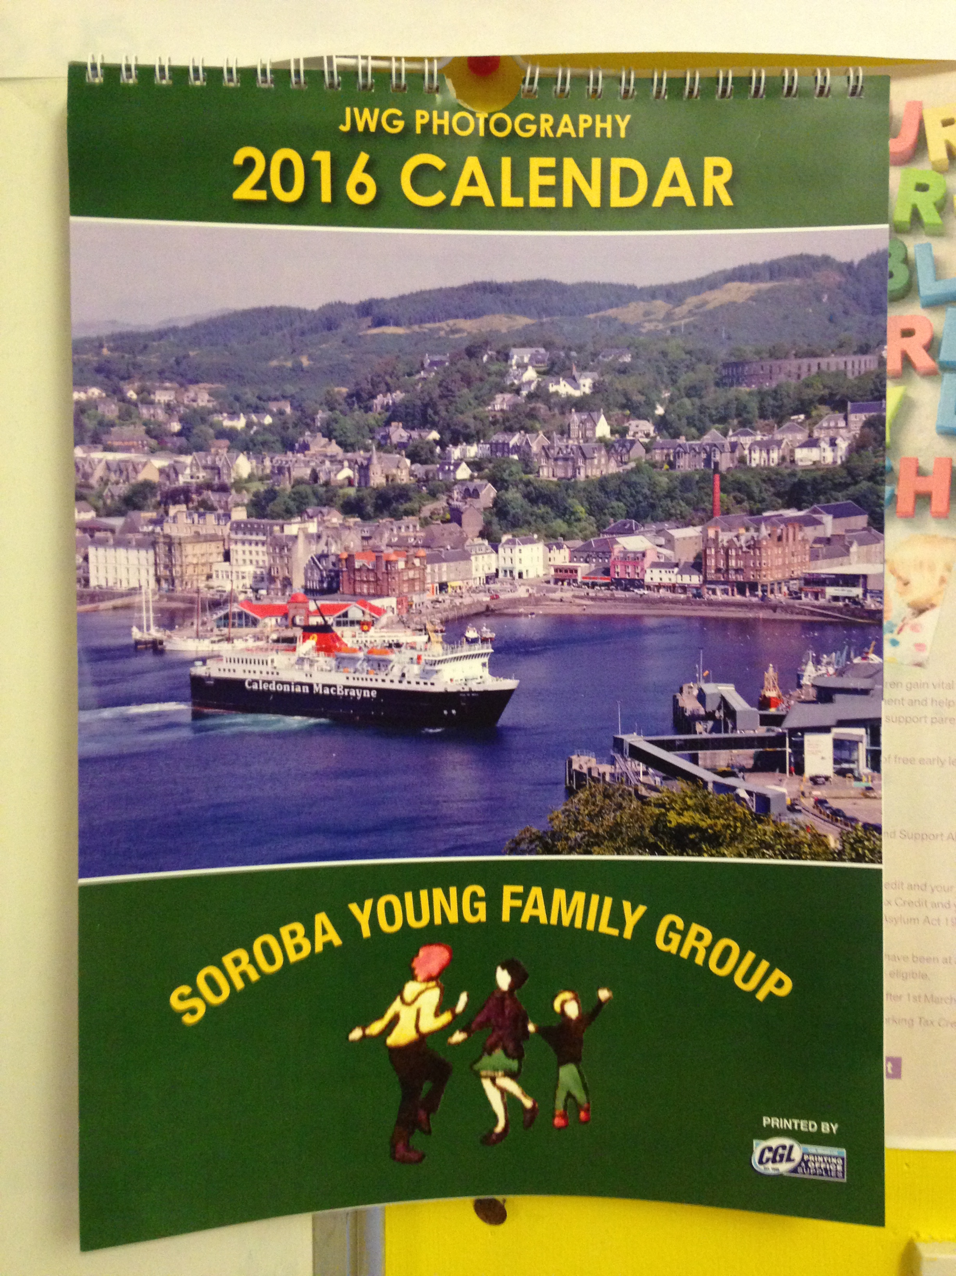

JWG photography have also made calendars to sell at £8.00 each, John has kindly offered to donate £1.00 from each sale to the centre, and for any bought directly from the centre he will donate £1.50. These are also available now from the nursery.

We have our Fabulous Handy bags for sale £6.00 each. These are available in the centre now.

**Fundraising news:**

As you are aware we are a registered charity and with that, we need to try to raise funds to enable us to provide extra activities and treats for the children.

We have a couple of great fundraising ideas on the go at the moment and we would ask you to support them as much as possible. We also now have our newly formed Fundraising committee who are working voluntarily to co-ordinate fundraising activities, collect prizes, approach local businesses for their help etc, all in their own time and free of charge!

November sees a busy time for fundraising as part of the Winter Festival celebrations.