**Spring Newsletter 2017**

**17.03.17 My first Poem:**

Please make sure all poems to be sent away for publishing are returned by 17th March.

**Alex’s Horse:**

Alex will be bringing her horse to visit, please remember if you wish your child to opt out for any reason, to put it in writing to Rachael.

**08.03.17 Childsmile:**

The ladies from Childsmile will be visiting the centre on Wednesday 8th March to apply the fluoride varnish.





**27.03.17 Easter Celebration**

We will be holding a fun day at the church centre to raise fund funds for the nursery and Crackerjacks Children’s Trust.

We will be having an Easter Egg Hunt, an Easter bonnet Parade and competition and fun and games. We hope to book Rosie Cheeks soft play again too.

All session times will be the same.

**31.03.17 Holidays**

**The centre will close on Friday 31st March for 2 weeks and we will re-open on Tuesday 18th April.**

**21.04.17 Ms. Carnie Visit**

Ms. Carnie from Park Primary will be coming to visit the children moving on to P1 at Park in August.

**28.04.17 Oban Music and Dance Festival (Morning Group)**

We have registered to take part in the Music Festival this year. The morning group will be singing 3 Craws sat upon a wa’. The children have been practising hard and you will be able to come along and support them. We will get more information to you as we get it.

**16.03.17**

**Please remember football training is finished and we are back at the centre from today.**

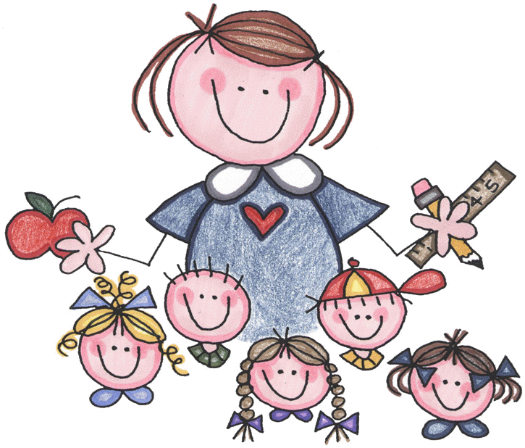

**10.03.17 Mrs. Campbell Visit**

**Mrs. Campbell from Rockfield Primary**

**School will be visiting the children**

**moving on to P1 in August, on Friday 10th March.**



**13.03.17 Football Awards: Morning group**

We are having a prize giving at the end of session for the morning children to mark the achievement of them completing their football training.

Families are welcome to attend, please be at the church hall for 11.30am