
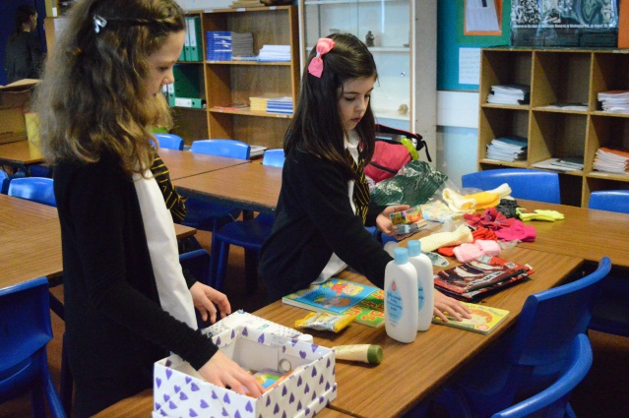
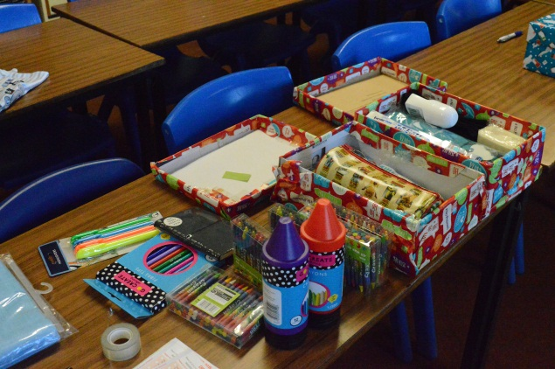
TUESDAY 30TH OCTOBER 2018 DAILY NOTICES

ASSEMBLIES: Tuesday S2 Wednesday S3 Thursday S4 Friday S5/6

ALL PUPILS MUST WEAR SCHOOL UNIFORM, INCLUDING A SHIRT AND TIE, which must be worn under your hoodie or black toP EVERY DAY.

Breakfast Club: Free toast with a selection of spreads is available every morning from 8.30am in the old Guidance Base (the room just outside the Assembly Hall). Pop in and collect a slice or stay and have a chat.

S2 Pupils: All S2 pupils are to go to their normal classes after break on Tuesday (TODAY) , register then come down to the Hall ready to watch a performance of Balisong – part of the No Knives Better Lives programme. All pupils are reminded of appropriate behaviour during the performance. Reminder to all staff who teach pupils during this period to accompany pupils down to the hall please.

After-school Study: The New-Media lab is available after school Monday to Thursday for study. Please sign-in on the sheet in the room and inform a member of SMT when you are leaving.

Poppy Appeal: Pupils will be coming round with poppies if you would like one - £1 donation (but feel free to contribute any spare change)

Sponsored Walk: Can all sponsor money please be handed in by Friday 2nd November

Hoodies: School Hoodies have arrived, they can be collected at Break Time ONLY from Reception / Waiting Room

Saltire Awards: Saltire awards certificates are awaiting collection from Youth staff at the award drop-in on Thursday in the old guidance base at lunchtime for:
Chloe Mackay, Alex MacDonald, Orla Young, Leah Mackenzie, Elise Innes, Savannah Martin, Lewis Ross

YouthBox: YouthBox is back on tonight (Tuesday) for those who attended before the break

Murrayfield Trip: 7 places remaining on the trip to see Scotland v South Africa. Price is £20 which is including coach and ticket. See Mr Pope for letters – closing date is Friday 2nd November

English Supported Study This will take place in Room 19 on Wednesdays, 3.45 – 4.30. Please come along if you want extra help, tuition tips, or just somewhere to study.

Human Rights Committee: The Human Rights Committee will continue to meet in Room 13 (RMPS) every Tuesday lunch time. All are welcome and you can bring your lunch.

Sports Clubs:
MONDAY – Rugby for boys and girls will be at the Top Pitch after school 3.40pm
WEDNESDAY – Football will be at the Astro Pitch after school 3.40pm
Hockey will be at the Astro Pitch after school 3.40pm
THURSDAY – Girl’s Football will be at the Astro Pitch after school 3.40pm
FRIDAY – Basketball will be in the Small Gym at 1pm
Badminton will be in the Games Hall at 1.15pm

Autumn Ceilidh: Thursday 1st November, 7.30-10pm. Tickets will be on sale at break time today until Wednesday.
£3 per ticket. Bottled Water will be on sale on the night 50p proceeds for Highland Hospice.

S6 ROTA
 | BREAK |  |  |  |  | LUNCH
Hall & Canteen | Sam | Kathryn |  | Lauren | Iona
Maths & History | Emma |  | Katie | Alix |  | Charlotte | Caitlyn
Music & Tech | Lewis M |  |  | Aaron |  | Hannah | Klaudia
English & Art | Luke |  |  | Robbie |  | Becky | Megan

