Great Glen Canal Users Association (GGCUA) was formed in 2002 to voice the views and interests of canal users with regards to the

Caledonian Canal. It aims to do so through dialogue with Scottish Canals and local authorities and offer realistic and constructive response to policies and practices which may affect the canal, its users, residents and the immediate environment.

Membership is open to all who have an interest in the Caledonian Canal from private boat owners to anyone who enjoys or uses the canal for leisure, pleasure or commercial purposes.

The Association is run by an elected committee of volunteers and is funded through its membership fees and donations. If you would like to join the Association and/or make a donation towards its running costs you can do so by completing the form opposite. Your support will be greatly appreciated. Any donation, however small, will be gratefully acknowledged.

Membership benefits include:

* belonging to a network of canal users and businesses
* events; quizzes, boat jumbles, association cruises, talks
* lobbying for improved facilities and services on the Caledonian Canal
* collaboration with Scottish Canals on canal Open Days and events
* discounts with retailers Gael Force, Caley Marina, Tiso, MacEwans

Great Glen Canal Users Association

*Improvement by Association*

Contact GGCUA;

[www.spanglefish.com/GreatGlenCanalUsersAssociation](http://www.spanglefish.com/GreatGlenCanalUsersAssociation)

Facebook page; Ggcua Highlands

Chairman David Edes 07860 524394

[GGCUA@btinternet.com](mailto:GGCUA@btinternet.com)

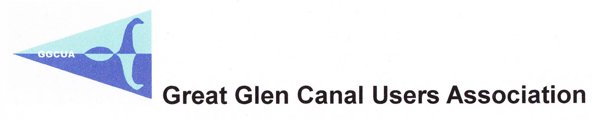

Membership Form

|  |  |
| --- | --- |
| Date |  |
| Name |  |
| Address |  |
| Tel |  |
| Email |  |
| Boat Name (If any) |  |
| Fees;  Individual £7.50  Business £15.00 |  |

please note that membership renewal is due at the end of March

Donations

I would like to donate £ to GGCUA

Pay membership fees and donations;

* by cheque please make payable to GGCUA and send to

David Edes, 44 Brudes Hill, Inverness IV3 8AG

* on the website;

[www.spanglefish.com/GreatGlenCanalUsersAssociation](http://www.spanglefish.com/GreatGlenCanalUsersAssociation)

* direct through your bank to; Bank of Scotland,

account number 12109864, sort code 80-22-60

adding your name as reference to all methods of payment