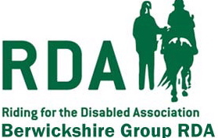
GIFT AID DECLARATION
Donor Details

Title______Forenames(s)__________________Surname_______________________
Home Address_________________________________________________________
_____________________________________________________________________
Postcode____________________

I wish the Charity to treat

*the enclosed donation of £………….. as a Gift Aid donation

*the donation(s) of £…………. which I made on…./…./……. as (a) Gift Aid donation(s)

*all donations that I make from the date of this declaration until I notify you
otherwise as Gift Aid donations

*all donations I have made for the six tax years prior to the year of this declaration
and all donations I make from the date of this Declaration until I notify you
otherwise, as Gift Aid donations

*delete as appropriate

You must pay an amount of Income Tax and/or Capital Gains Tax at least equal to the tax that the charity reclaims on your donations in the appropriate tax year. (currently 25p for each pound you give). +-

Date………./………./………. Signed: …………………………………………………..
NOTES
- You can cancel this Declaration at any time by notifying the charity.
- If in the future your circumstances change and you no longer pay tax on your
income and capital gains equal to that the charity reclaims, you can cancel your declaration.
- If you pay tax at the higher rate you can claim a further tax relief in your
Self Assessment tax return.
- Please notify RDA if you change your address.
- If you are unsure whether your donations qualify for Gift Aid tax relief or have any other questions please contact:

