ME3ST OF IRON – Why it may take some time!

Chapter III

Sir Ambrose Qrowley:

Expansion and (Consolidation
After fifteen years in business on his own account, Ambrose III wasstillasmall manufacturer, not yet even on the threshold of greatness. The number of workmen he had gathered together at Winlaton did not, by the standard of the domestic nail industry of his day, make him a large employer of labour.

origins. His start in life owed little to his father, by whom, in
¹ The genealogy of the Crowley family has been exhaustively unravelled by A. L. Reade in TAe Reades of Mackioood Hi// (privately printed, 1906)4 and Johnsonian Gleanings, Parts I-IX (1909-39). There are also genealogical tablet in B.M. Add. MSS. 14,831 and 19,12c, and in Ashbumham Lewes MS. 4jco.
¹ Le Neve's Knights, Harlcian Society, Vol. VIII, p. 49$. The Quaker record it in the ‘Examined Transcript of the Digested Copy of the Registers of Births of the Quarterly Meeting’, at the Friends’ Meeting House, Birmingham.
¹ Kidderminster Parish Register. Thomas Hall died in February 1659, leaving three sons and two daughters. I an indebted to Mr. B. G. Awty for a py^wffat ct Hall’s will. The Court Roll of Rowley Regis records that, in April 16<7,one Ambrtxe Crowley was a ‘complainant agt. Eleanor Hadcn. w
there is no indication as to whether this was Ambrose I or Ambrose II. (Dudley MSS., Dudley Public Library.)
⁴ Survey of Rents of Stourbridge, 1682. Palfrey MSS.
’ H. Sydney Grazebrook, The Hera/dry of Worcestershire (187)), I, 149.
A list of the children of Ambrose II by his second wife, Sarah, together with
the dates of their births, is given in a parchment-covered manuscript book entitled Interesting letters and history relating to the Lloyds of Dolobran and Lortt and Stanleys, in the Lloyd FMH MSS.
Society of Friends.² The minutes of the Chadwich Meeting record many small time-consuming services performed in the interests of others. The thankless duty of reproving and correcting erring Friends—‘the care of looking after the disorderly walking of such as possess the truth’—was an office accepted
position with his friend Allen I lallmark for several years? Until he was a very old man, Ambrose II travelled exten
and Ambrose Crowley held this
by certain senior
sively to attend Quaker meetings. Visits to Quaker gatherings at the house of Charles Lloyd (his son-in-law) at I)olobran, Montgomeryshire, were fairly frequent, while he occasionally travelled to London to visit his successful eldest son?
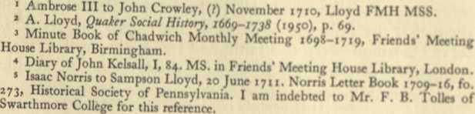
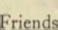
Ambrose 11 outlived his eldest son by some seven years, but

