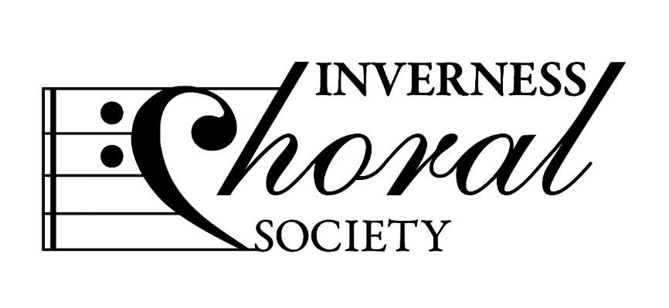
Inverness Choral Society Spring 2022 Newsletter
Dear Members,

Our Spring term concluded with the Concert on March 26th- see the short report below.

Important Dates for your Diary:

- Monday June 13th 730pm - Smithton Free Church Café Area - AGM
Please note there will be no catering this year.
Sheila will provide a Quiz after business is finished.

- Monday August 15th 2022 730pm - Smithton Church -Start of new session
New Members welcome.

- Saturday November 19th or 26th- 2022 - Concert. Date and Venue TBC

- Saturday December 17th Carolthon, Eastgate Centre. Details TBC

Report: Saturday March 26th Concert Ness Bank Church
We welcomed an audience of approx. 120 people to our concert. We thoroughly enjoyed the experience and the audience feedback was very positive. Everyone had worked very hard to reach a great performance standard. Our special thanks go to Gordon and Sheila, and our condolences to those who were unable to sing on the night, mostly because of Covid contact.

Centenary Books
Sales are going extremely well and we are down to our “Last 50” copies. Waterstones in Eastgate Centre are also selling copies on our behalf. If there is anyone whom you think has missed out on a copy, please let me know, or ask them to visit Waterstones.

Shopping Bags
These are still available at the bargain price of £5 each. Very handy for music or simply shopping and providing some advertising for the society. Let me know if you want one earlier, but they will be on sale at the AGM.

Dorothy and Jimmy Lindsay
As you know, our Centenary book was dedicated to Dorothy, our Honorary Life Member.
Some of you knew them when they were in Inverness and of course Dorothy was an outstanding
Force for innovation .
**Jimmy sadly passed away in December 2021, but please see the photo of him, with son Angus, receiving his complimentary copy of our book - the smile says it all!

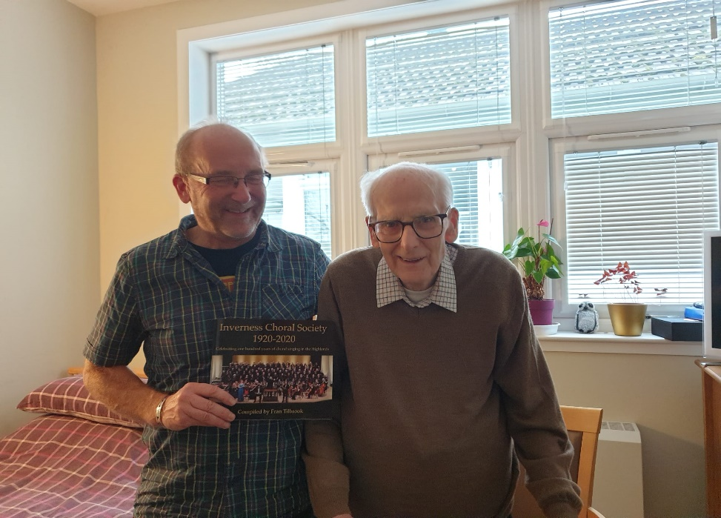

New Members
We were delighted to welcome several new, enthusiastic members this session.

Next Session from August 2022
The Committee are in the process of planning for our November Concert. We will update you as soon as we have confirmed plans.

Happy Singing chez vous, till we meet at the AGM,

Carol
(Chairman)

