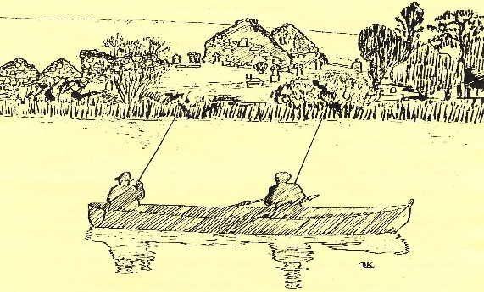
Company Secretary.

Tel:
Email: ddaaltd@btinternet.com
President
George Massey
ddaaltd@btinternet.com
Chairman
Eamonn O’Rourke
ddaaltd@btinternet.com
Treasurer
David Woodrow
ddaaltd@btinternet.com
Downpatrick & District Anglers Association Limited

Downpatrick and District Anglers Association Limited
Annual General Meeting: Thursday 17th January, 2017

MINUTES

Present: 46 Members were in attendance

Apologies: T. Clarke, J. Hanlon, P. McAuley, S. Ellison, I. Murray, H. McCabe, M. Crawford, M. Abbot.
1. | Minutes of the 2016 AGM
 | Adoption proposed by Paul Hanlon and seconded by George Freel.
2. | Opening Statement
Eamonn O’Rourke, Chairman, welcomed all in attendance and before going to the agenda he took the opportunity to extend our sympathies to the families of departed members Paddy O’Flagherty, John Shaw and possibly other members whom he was not made aware of.

Chair further referred to the retirement of David Woodrow as Treasurer after 10 years and outlined David’s role in promoting the Co. Ltd, re-registration of our properties, and renewal of the waste water plant in conjunction with his Treasurer’s role.

The Chair further informed the members that Noel Taggart, Secretary, had also resigned but would oversee the membership renewals and would hand over to any newly appointed Secretary. Noel was instrumental in developing our website which in turn has resulted in savings to the Association in terms of printing and postage.

John Hanlon has also retired, he was a long serving committee member and his experience and guidance was valued.

The members were invited to show their appreciation in the time honoured fashion.
3. | Matters Arising
A motion that all brown trout caught are to be returned to the lake unharmed was carried unanimously.
Proposed P. Hanlon, seconded G. Freel
4. | Secretary’s Report
 | Chair included an overview in his address.
5. | Treasurer’s Report
David Woodrow presented the Director’s Report on the financial statements for the year ended 31 Oct 2016 as prepared by Eamonn McGrady & Co. Accountants.
Copies of the financial statement were circulated to members and following an invitation to comment, were adopted unanimously.
6. | Stocking & Catch Report
 | George Freel presented the members with print-outs of statistical analysis on rod days, catches & returns. Comparisons month by month with previous years were reviewed and this encouraged further discussion and appraisal.
7. | Annual Fishing Competition – 27th August 2016
David Stewart co-ordinated a successful competition ably assisted by Noel Taggart and Terry McDermott. A BBQ and presentation followed.

We are grateful to both the sponsors and participants and approximately £500 was raised for a local charity, Listen hEAR which financially supports cochlear implants for hearing deprived children. Unfortunately there was not a great turnout of anglers and this year’s competition will be reviewed.
8. | Chairman’s address
Eamonn in his address again thanked the members for attending and on behalf of the membership further paid tribute to our resigning officers.

From the floor he encouraged nominations for members to put themselves forward for board vacancies, but in particular, the position of Company Secretary which at this time remains vacant.

The members of the Board thanks all of those who were active and attended work parties, painted the container, helped with stocking, ground maintenance, water quality management, stoning the driveway, gathering litter etc.

At the end of the season work-party we brought in the spent barley straw booms, prepared and placed out new ones. This is work intensive and is proving successful in reducing algae.
The club thanks the 16 members that assisted with this job.

9. | Election of Directors
Rotational Retired Directors Re-elected: Paul Hanlon & George Massey

Newly appointed: David Linter (Treasurer), Ray Crane, Ian Hastings and Peter Burns
10. | AOB
Pre-Season Work Party
Please note in your diaries that the next work party will take place on the last Saturday of February (25th). A good turnout is requested from members and remember to bring your own tools.

