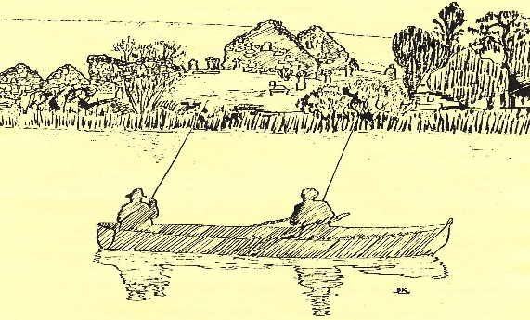
Company Secretary
Ryan Green
128 Loughinisland Road
Annacloy
Downpatrick
BT30 8JJ

Tel: 07877194448
Email: ddaaltd@btinternet.com

Tel:
Email: ddaaltd@btinternet.com
President

ddaaltd@btinternet.com
Chairman
Eamonn O’Rourke
ddaaltd@btinternet.com
Treasurer
David Linter
ddaaltd@btinternet.com
Downpatrick & District Anglers Association Limited

Downpatrick and District Anglers Association Limited
Extra Ordinary General Meeting & Annual General Meeting
Thursday 18th January, 2018

MINUTES

Present: 42 current members were in attendance at the meeting.

Apologies:

Extra Ordinary General Meeting (EOGM)
Eamonn O’Rourke (Chairman) opened this year’s AGM by welcoming all those members in attendance. Prior to the AGM a letter had been issued to all members, notifying them of a proposal to change the articles of association by reducing the number of Directors from 12 to 3. Eamonn invited David Linter, the Club Treasurer, to provide more information on the proposal.
David informed members present that the articles had to be changed in order for the club to become a Community Amateur Sports Club (CASC), this would remove a lot of red tape associated with HMRC. Also, in order to benefit from free business banking with Santander there must be 3 Directors or less.
One of the members present, David Woodrow, asked if there should be advice from a solicitor on the changes of the articles. David Linter informed David that the Committee makes decisions on how the club is run. David Woodrow also raised concern about the requirement for only one signatory’s name to appear on a cheque, pointing out that it may leave the club open to fraud.
Eamonn then put the proposal to the floor and asked for a show of hands of those in favour of the motion to change the articles of association. A unanimous number voted to approve with one against.

1. | Minutes of the 2017 AGM
 | Last year’s minutes were agreed as a true reflection of the 2017 AGM.
2. | Secretary’s Report
Ryan Green introduced himself to the members as the new Secretary of DDAA since February 2017, and reported on the past year as follows;
- During the past season we have continued to take water samples and send off for analysis. All reports are healthy and satisfactory.
- We purchased a new Fulmar boat costing £1550 which was delivered during March. We also purchased a new outboard engine at a cost of £850 to replace the one stolen from our container. Gerard Linden along with Eamon McMahon subsequently welded a safety guard to the container.
- George Massey & Paul Hanlon provided safety ladders to the platforms in the boathouse.
- Brian Broome provided us with 18 tonnes of blinding at cost price and thanks to the members of the pre-season work party who worked hard at spreading this over the driveway.
- We have registered as a community amateur sports club. David, our treasurer will have informed you of the advantages to be gained.
- The boat from Magheralagan was brought around to the container at Loughinisland and repaired by Ronnie Rodgers and George Freel.
- We have dealt with the usual correspondence throughout the year ie insurances, ulster angling federation etc

4. | Treasurer’s Report
David Linter gave an overview of the Director’s Report on the financial statements for the year ended 31 Oct 2017 as prepared by Eamonn McGrady & Co. Accountants. Approximately 40 copies of the final page of the Club’s Financial Statements were made available for members on the night and following an invitation to comment, were adopted unanimously.
David had already reported on the Community Amateur Sports Club status and the new banking arrangements during the Extra Ordinary General Meeting.
6. | Stocking & Catch Report
George Freel gave an overview of our rod days and catches. During 2017 the total fish caught was 3238 of which 2871 were rainbow trout and 367 were brown trout, giving an average of 2.16 fish per rod per fishing outing. George commented on the drop in the average catch during the months of May & June which coincided with an algae bloom thus highlighting the importance of producing these statistics, after 11 years we can start to see the trends.
There followed a short discussion about the quality of straw booms last year and how to improve going forward such as double wrapping the booms, placing them in strategic positions such as near to the sewage treatment plant and possibly replacing them half-way through the season.

8. | Chairman’s address
Eamonn in his address thanked the Directors and Members for work undertaken throughout the year such as attending the monthly meetings, stockings and work parties etc.
Eamonn acknowledged the passing of our esteemed President, George Massey, and all his work and dedication to the club over the years. Former Treasurer, David Woodrow who knew George well, spoke to the room to express the loss to the club of such a tremendous advocate. He continued that George played instrumental roles such as helping to map out the lake and negotiating for ownership, the construction of the boathouse and carrying out secretarial duties.

The main points coming from the rest of the address were as follows;

- David Linter & Ryan Green were welcomed to the club and thanked for their continued work.
- Due to a lack of volunteers, there was no annual fishing competition for 2017.
- Due to increased feed prices, there will be a rise in the price of stocked fish for the coming season, which may affect the club budget.
- A decision among committee members was made to stop stocking Magheralagan lake for one year due to high levels of fluke.
- The pre-season work-party will take place on 24th Feb 18, members were encouraged to help out.

9. | Election of new President & Directors
As per the Articles of Association a new President needs to be appointed and at the November 2017 monthly committee meeting Paul Hanlon was nominated by members present. Eamonn asked those members present at tonight’s meeting if there were any other nominations to which there was no reply. Paul Hanlon was then declared the new Club President.

Eamonn also asked those present if there was anyone interested in joining the advisory board as there were two vacancies. There was no response.
10. | Health & Safety and Buoyancy Aids
Eamonn informed those present that the committee group have been discussing Health & Safety at the monthly meetings with the aim of ensuring members are as safe as possible when out fishing, stocking setting booms etc. The following measures were agreed by the committee and actioned/ to be actioned;
- First aid box fitted in the boathouse
- Emergency Oars & rollocks fitted in the boathouse
- Life buoy fitted in the boathouse with attached rope
- Walkie talkies purchased for stocking and setting straw booms
11. | AOB

