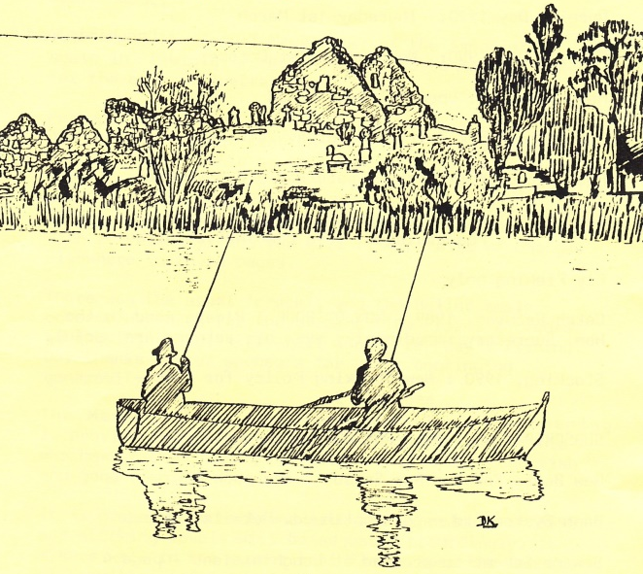
Secretary
Noel Taggart
2 Rockvale
Tullinisky Road
Kinallen
Dromore
Co Down
BT25 2LZ

Email: ddaaltd@btinternet.com
President
George Massey

Chairman
Eamonn O’Rourke

Treasurer
David Woodrow

Web: www.ddaaltd.co.uk
Downpatrick & District Anglers Association Ltd.

Newsletter: Winter 2015
Welcome once again to our winter newsletter. As our web site (www.ddaaltd.co.uk) is now well developed, live and comprehensive, we do not see the need for a May Newsletter saving us the necessary printing and postage charges. You will find all that you need on this website i.e. latest news, updated information, application forms for new members and a form for existing members to update us of their current details etc. which can now be downloaded.
I regret that there was no fishing competition held this year due to the unavailability of someone to co-ordinate this. If you wish to see this feature continue, can you submit your name to our Secretary with a view to forming a competition sub-committee?

Another season in Loughinisland has ended, ‘the best trout fishing lake in the country’, according to our stockists who visit many fisheries throughout the season. There have been two stockings of rainbow trout in Magheralagan Lake in October and December so take advantage of some great winter fly fishing.

As I reflect on the tasks undertaken by your Board of Directors, the work load has both been extensive and time consuming. More details will be discussed at the AGM.

Were you one of the volunteers who helped with the stockings, grounds and boat house maintenance or the straw boom fabrication? If you were, congratulations. If not, why not? The pre-season work party has been arranged for Saturday 27th February 2016 meeting at the boat house at 10am. You are invited to help maintain your property so bring some tools/gardening implements to help tidy the environment and prepare for the new season. My thanks to all of you; see you at the AGM as detailed below;

Wishing all members of Downpatrick and District Anglers Association and their families a Merry Christmas and a Happy New Year from the President, Chairman, Officers and Directors. Eamonn O’Rourke

A.G.M
Thursday 21st January 2016 @ 7:30pm
Notice is hereby given that the Annual General Meeting will take place at:
The Downpatrick Cricket Club premises on Thursday, 21st January 2016 @ 7:30pm.
If any member wishes to place a motion before the members or an item on the Agenda, they must give written notice to the Secretary no less than 21 days before the meeting. An Agenda will be prepared for the Meeting; only items which appear on the Agenda will be discussed and voted on as appropriate.
All correspondence should be sent to the Company Secretary, Noel Taggart.

The Directors of the Club are the President, Chairman, Vice-Chairman, Secretary, Treasurer and not less than four or more than eight other members of the club elected as provided in these Articles.

The First Directors and Officers of the Club for 2015 were:
- President : George Massey
- Chairman: Eamonn O’Rourke
- Vice-Chairman: Paul Hanlon
- Treasurer: David Woodrow
- Secretary: Noel Taggart
together with John Hanlon, Colin Ross, Lawrence Taggart, Tony Clarke, Ronnie Rodgers, George Freel, Jim Forster

At every Annual General Meeting of the club, 3 Directors of the club must retire from office. The retiring Directors shall be eligible for re-election. The Officers of the Club, other than the President, must be appointed by the Directors.

The first Directors to retire this year are: David Woodrow, John Hanlon and Lawrence Taggart. The retiring Directors can stand for re-election provided they are willing to do so. Director nominations, together with a proposer and seconder, both of whom must be current members of not less than one year, may be forwarded to the Secretary either in advance or on the night of the AGM.

Directors Motions
- That adult membership be increased to £130 from season 2017; adult joining fee will similarly increase to £130
- Late payment of membership fees will incur an increased penalty of £25 beginning 2016 season
Renewal of 2016 Membership: NOW DUE
Adult Membership £120 Private Boat Owners Insurance £13 to be
paid along with your Membership.
Junior Membership £12 An additional fee of £13 is required along
with a completed Bank Fishing Registration Form for bank fishing unaccompanied by an adult member.

Payments can be made on the night of the AGM or alternatively forwarded to Noel in advance of the AGM and please enclose a self-addressed stamped envelope for prompt return. Cheques must be made out to: ‘Downpatrick and District Anglers Association Limited’.

Failure to renew your membership by the 1st February 2016 will mean that you incur a fixed penalty of £25 (see proposal above) for late payment. If your membership is unpaid along with the fixed penalty by 14th February 2016 your place will be allocated to the next on our Waiting List. No other reminders will be issued.

Charity Raffle:

We will be holding a raffle during our AGM this year with the proceeds of same going to support a local charity. If anyone would like to donate a prize or indeed have their name included in the draw, please either send your donation to the Company Secretary, Noel Taggart or give to any of the Directors prior to the AGM for inclusion on the night.
Website Development

Our website is now up and running with more than 6500 hits so far this year! We will continue to maintain the site, adding Club news as it breaks and how this impacts and affects our members. We would invite you to use our selection of downloadable forms to introduce new members, keep the Secretary appraised of any changes of your details and would welcome you to send us your pictures so that we can use them within our gallery (please refer to our policy on image use found in our Library section prior to sending). We would ask that you pay us a visit at www.ddaaltd.co.uk and would welcome your comments and thoughts which can be fed back to the website administrators via the feedback page.

End of Season Work Party held on Saturday 7th November 2015

Many thanks to those members who attended and gave willingly of their time and effort to scrub the boats, pick litter and generally clean up the Loughinisland Boathouse and surrounding areas. A small group then proceeded to Magheralagan, cleared away brush on the pathway along the riverside, giving access to the far bank for Anglers.

Date for your Diary:

Pre-Season Work Party, Saturday 27th February 2016 @ 10am, meeting at the Boathouse
Please come along, bring your own tools, clear away brush, clear ivy etc. and prepare for the forthcoming fishing season.

Day Tickets
Day Tickets can be purchased from the following outlets:

Village Tackle
55a Newtownbreda Road, Belfast

SPAR
7 Saintfield Road, Crossgar

McGraths Service Station
41 Annacloy Road

Tight Lines
198-200 Albertbridge Road, Belfast

10% Discount for Members

10% discount is available to all DDAALTD Members on fishing tackle and accessories upon production of their Membership Card at the following outlets:

Village Tackle – Belfast
Tight Lines - Belfast

Please continue to support these outlets and take advantage of your membership discount.

Membership Details:
If your address has changed, can you contact the Company Secretary directly by downloading a ‘membership update’ form from the Library page on our website and send it either by post or copy and send it to our email address.
We would encourage you to update us with your current email address if you have one. If you have supplied us with an email address and have not had any communication from me during 2015, can I ask that you email me at: ddaaltd@btinternet.com and I will update your contact email address accordingly!
Engagement of DDAALTD Membership:
The Directors of DDAALTD would like to encourage greater participation of its membership in the continuing development our Club and facilities, not only for the benefit of our current members but for those who will join us in the years to come. There is more to our Club than just the provision of first class trout fishing; we are responsible for the provision and maintenance of equipment and other facilities as well as the stewardship and environs in and around our two lakes.
We are moving to a position whereby we, as Directors, feel it is getting increasingly harder to get the full engagement of our membership even in the basic maintenance of our facilities; the expectation however of our members is that we continue to provide safe and responsible level of facilities as well as great fishing. Increasingly we have to contract work at considerable expense to the Club. It is said that a club is only as good as the collective sum of its membership and it is with this view that we wish to ask you to become more involved with current and prospective projects.
We are looking to you for inspiration as to how we can develop our Club further by thinking about projects or ideas that you may have; by suggesting these to us and by becoming involved with these projects and areas of interest you have so that we can bring these to fruition with a view to enhancing the facilities we currently offer, the quality of the fishing we provide and by improving the environment in which we do it.
Fishing stories, ‘tall tails’ and fishing-related jokes wanted:
A Mr. Robert Williamson has contacted our fishing club as well as several other local ones in relation to an aspiration of compiling a book in memory of his late father. He is looking for jokes, poems, stories and the occasional 'tall tail' to help him on his journey; please see our ‘Club News’ section of the website which will explain more.
Robert has given permission for you to contact him directly on his email at: robert_williamso@hotmail.com and he will acknowledge all members within his book for any contributions submitted.
Thanking you all in anticipation.

