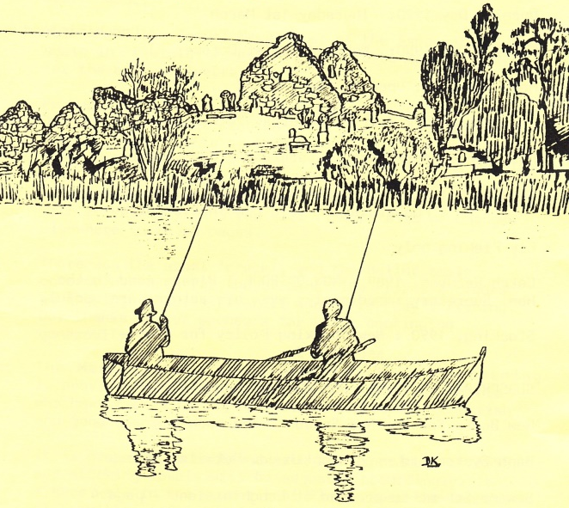
Secretary
Noel Taggart
2 Rockvale
Tullinisky Road
Kinallen
Dromore
Co Down
BT25 2LZ

Email: ddaaltd@btinternet.com
President
George Massey

Chairman
Eamonn O’Rourke

Treasurer
David Woodrow

Web: www.ddaaltd.co.uk
Downpatrick & District Anglers Association Ltd.

Newsletter: Winter 2016
Welcome once again to our winter newsletter. Another trout fishing season has come to an end on Loughinisland Lake. Magheralagan Lake has been stocked so members are encouraged to take full advantage of winter fishing for rainbows. Visitors’ tickets are not issued for Magheralagan Lake. Please note: A limit of 2 fish taken per day has been set in order to preserve stocks. Please visit our website for more information. www.ddaaltd.co.uk
Post of Treasurer Vacated
David Woodrow, our treasurer for the last 10 years will step down at the end of October 2016. It goes without saying that David’s knowledge and experience has greatly assisted the continued development of our Club. He was instrumental with the Club moving to a Company Limited by Guarantee which will safeguard and protect it and its members for generations to come. I am pleased to announce that David will remain as a Director and will continue to support us with his vigour and knowledge.
Treasurer Needed/Expression of Interest
We are now I search of a new treasurer and can co-opt and interested member who would be up to the challenge? If you are considering or would be interested in this position and would like to talk it over in confidence, can you contact the Club Secretary at ddaaltd@btinternet.com or alternatively speak to Eamonn who can be contacted on: 02844831198
Remember; this is your Club and volunteers are required to keep the wheels turning. I hope to see you all at next year’s AGM as detailed below.
DDAALTD would like to wish all our members and their families a very Merry Christmas and a Happy New Year from the President, Chairman, Officers and Directors.

Eamonn O’Rourke DDAALTD Chairman

A.G.M
Thursday 19th January 2017 @ 7:30pm
Notice is hereby given that the Annual General Meeting will take place at:
The Downpatrick Cricket Club premises on Thursday, 19th January 2017 @ 7:30pm.
If any member wishes to place a motion before the members or an item on the Agenda, they must give written notice to the Secretary no less than 21 days before the meeting. An Agenda will be prepared for the Meeting; only items which appear on the Agenda will be discussed and voted on as appropriate.
All correspondence should be sent to the Company Secretary, Noel Taggart.
The Directors of the Club are the President, Chairman, Vice-Chairman, Secretary, Treasurer and not less than four or more than eight other members of the club elected as provided in these Articles.

The First Directors and Officers of the Club for 2015 were:
- President : George Massey
- Chairman: Eamonn O’Rourke
- Vice-Chairman: Paul Hanlon
- Treasurer: David Woodrow
- Secretary: Noel Taggart
together with John Hanlon, Tony Clarke, Ronnie Rodgers, George Freel, Jim Forster, Terry McDermott and David Stewart

At every Annual General Meeting of the club, 3 Directors of the club must retire from office. The retiring Directors shall be eligible for re-election. The Officers of the Club, other than the President, must be appointed by the Directors. The Directors set to retire this year are: George Massey, Paul Hanlon and Tony Clarke.

The retiring Directors can stand for re-election provided they are willing to do so. Director nominations, together with a proposer and seconder, both of whom must be current members of not less than one year, may be forwarded to the Secretary either in advance of or on the night of the AGM.

Directors/Members Provisional Motions
- All brown trout caught will be returned to the lake. Proposed: P Hanlon; Seconded: G Freel

Renewal of 2017 Memberships:
Please note: Adult membership and new member joining fees will increase from the start of the 2017 season and agreed at our last AGM and as detailed below. Incorrect cheques and Postal Orders will be returned to sender if not correct; please note the amended bye-law below:
Adult Membership £130 Private Boat Owners Insurance £13 to be
paid along with your Membership.
Junior Membership £12 An additional fee of £13 is required along
with a completed Bank Fishing Registration Form for bank fishing unaccompanied by an adult member.

Payments can be made on the night of the AGM or alternatively forwarded to Noel in advance of the AGM and please enclose a self-addressed stamped envelope for prompt return. Cheques must be made out to: ‘Downpatrick and District Anglers Association Limited’.

Failure to renew your correct membership by the 1st February 2017 will mean that you incur a fixed penalty of £25 for late payment. If your membership is unpaid along with the fixed penalty by 14th February 2017 your place will be allocated to the next on our Waiting List. No other reminders will be issued.

Website Development

Our website is now fully functional with 1942 sessions activated and 6536 pages viewed in the calendar year between October 2015 – September 2016! We will continue to maintain the site, adding Club news as it breaks and how this impacts upon, informs and affects our members. We would invite you to use our selection of downloadable forms to introduce new members, keep the Secretary appraised of any changes of your details and would encourage you to send us your pictures so that we can use them within our gallery (please refer to our policy on image use found in our Library section prior to sending). We would ask that you pay us a visit at www.ddaaltd.co.uk and would welcome your comments and thoughts which can be fed back to the website administrators via the feedback page.

If there are any of our members who are more experienced in web development and design that could help us further develop the site to make it more interactive for our members, develop an easy-payment system for membership fees/day tickets etc. we would like to hear from you? Contact the Secretary at ddaaltd@btinternet.com

End of Season Work Party held on Saturday 5th November 2016

We require a big turn out to assist with the end of season general maintenance of both the Loughinisland and Magheralagan lake sites as well as preparing new barley straw bales and replacing the ones placed 12 months ago.

Date for your Diary:

Pre-Season Work Party, Saturday 25th February 2017 @ 10am, meeting at the Boathouse
Please come along, bring your own tools, clear away brush, clear ivy etc. and prepare for the forthcoming fishing season.

Day Tickets
Day Tickets, priced at £15 can be purchased from the following outlets:

Village Tackle
55a Newtownbreda Road, Belfast

SPAR
7 Saintfield Road, Crossgar

McGraths Service Station
41 Annacloy Road

Tight Lines
198-200 Albertbridge Road, Belfast

10% Discount for Members

10% discount is available to all DDAALTD Members on fishing tackle and accessories upon production of their Membership Card at the following outlets:

Village Tackle – Belfast
Tight Lines - Belfast

Please continue to support these outlets and take advantage of your DDAALTD membership discount.

Charity Fishing Competition:
This year’s charity fly fishing competition was held on 27th August in aid off the Listen hEAR project. The weather held out beautifully and adult and junior members and their guests had a productive day on the water. As well as an abundance of prizes for the winning anglers, there was a large range of raffle prizes made available on the day that supplemented the donation we were able to make to this year’s chosen charity.
21 anglers fished on the day and brought to the boats a total of 29 rainbow trout though no browns were caught. All anglers enjoyed the day and the BBQ that followed each fishing session. Lindsey baked a range of tray bakes for the anglers as well as a spectacular cake to celebrate the event, pictures of which you can see on our website. Once again we would like to thank all members who fished and/or made donations to this great cause. We would like to thank all those businesses and individuals who donated most kindly and who are too numerous to mention here.
Total raised on the day: £860.00 Added to the raffle money taken in January at our AGM giving a grand total of £1260 donated to Listen hEAR on behalf of DDAALTD in 2016.

Membership Details:
If your address has changed, can you contact the Company Secretary directly by downloading a ‘membership update’ form from the Library page on our website and send it either by post or copy and send it to our email address.
We would encourage you to update us with your current email address if you have one. If you have supplied us with an email address and have not had any communication from me during 2016, can I ask that you email me at: ddaaltd@btinternet.com and I will update your contacts and email address accordingly!

Engagement of DDAALTD Membership:
The Directors of DDAALTD would like to encourage greater participation of its membership in the continuing development our Club and facilities, not only for the benefit of our current members but for those who will join us in the years to come. There is more to our Club than just the provision of first class trout fishing; we are responsible for the provision and maintenance of equipment and other facilities as well as the stewardship and environs in and around our two lakes.
We are moving to a position whereby we, as Directors, feel it is getting increasingly harder to get the full engagement of our membership even in the basic maintenance of our facilities; the expectation however of our members is that we continue to provide safe and responsible level of facilities as well as great fishing. Increasingly we have to contract work at considerable expense to the Club. It is said that a club is only as good as the collective sum of its membership and it is with this view that we wish to ask you to become more involved with current and prospective projects.
We are looking to you for inspiration as to how we can develop our Club further by thinking about projects or ideas that you may have; by suggesting these to us and by becoming involved with these projects and areas of interest you have so that we can bring these to fruition with a view to enhancing the facilities we currently offer, the quality of the fishing we provide and by improving the environment in which we do it.

