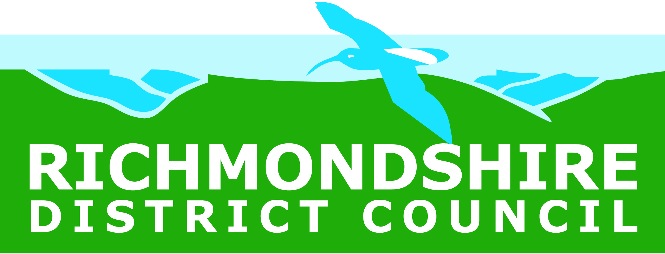

DISCOUNTED COMPOST BINS

Residents are being offered the opportunity to purchase discounted Compost bins. A 220 litre Compost Converter bin is just £8 and the 330 litre version is £9 - RRP £34.95
To order your compost bin please phone 01609 532512 during working hours and at least two days before the sale. Payment will be taken from a debit or credit card. A receipt will be issued by email which needs to be printed off and taken with you along with proof of address when you go to collect your bin – you can only collect from the sale you have chosen.
Compost Bin Sales are taking place on;
- Saturday June 14 between 10am – 1pm Richmondshire District Council Depot, Gallowfields Trading Estate, Richmond

- Thursday June 26 between 4pm – 6pm
Colburn Lorry Park

Bins must be pre-ordered and paid for in advance, no cash payments can be taken on the day.

A maximum of 2 bins per household maybe ordered.

