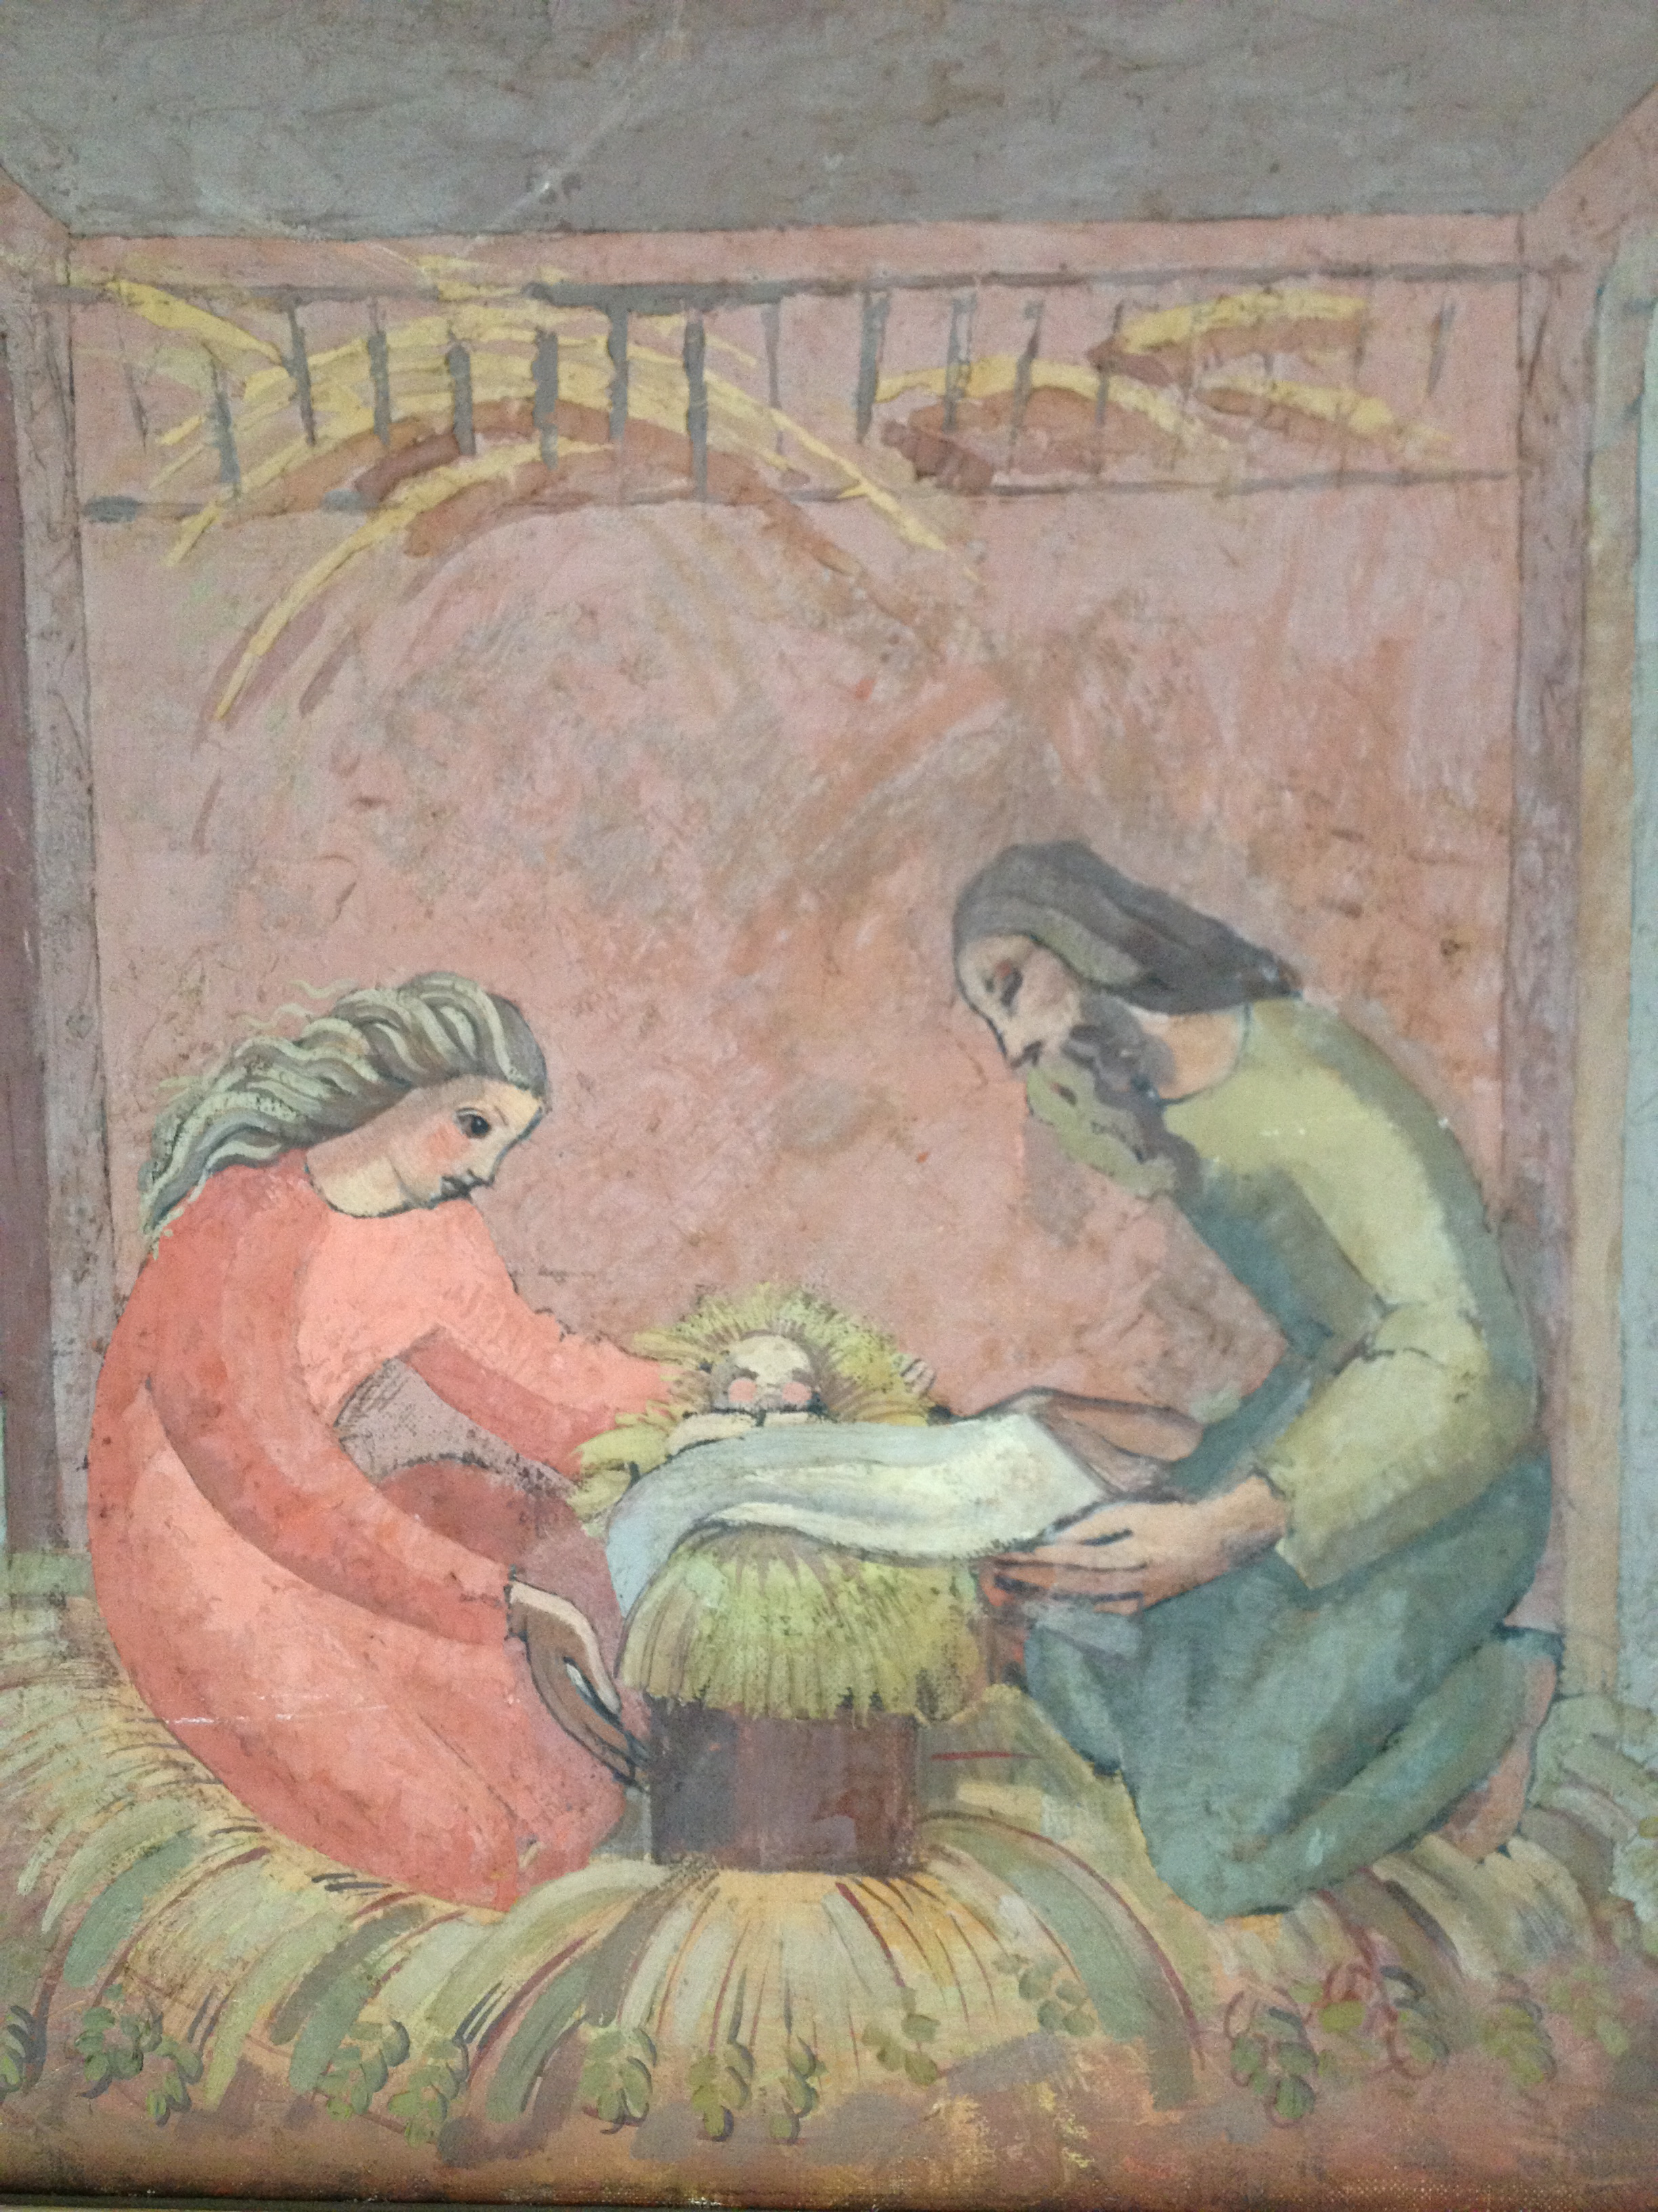
Advent Series
“Rejoicing in God’s Gift”
Friday evening
7-8pm
Dec 7th: “Secret Longings”
Dec 14th : “The Sound of God Approaching”
Dec 21st : “In the footsteps of Mary”
An evening of adoration and music…..

Our Lady of Mt Carmel & St Simon Stock
Kensington Church Street
London W8 4BB
0207 937 9866

