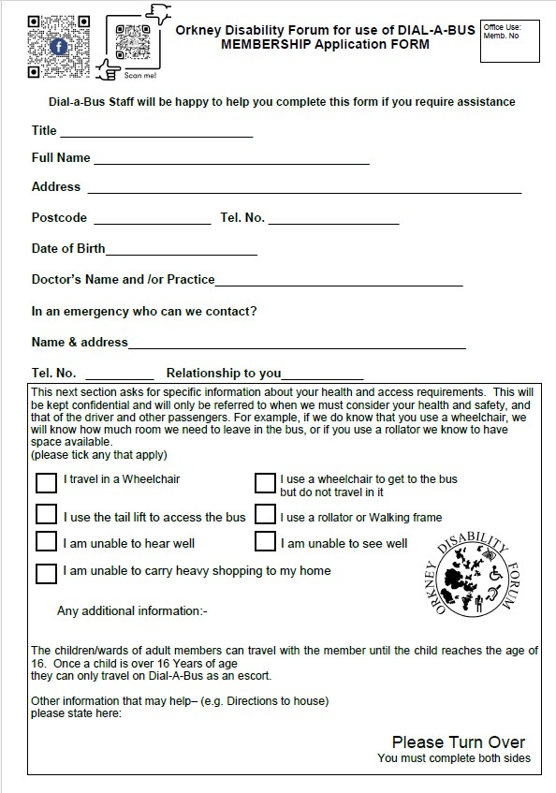

Concessionary Travel
Members of Dial-A-Bus who are Orkney residents in possession of a National Entitlement Card and are disabled or are over 65 may be entitled to participate in the Orkney Islands Council’s concessionary travel scheme. This entitles eligible members to three free return social or leisure-based trip on Dial-A-Bus per calendar month. You must provide the 16-digit number which is shown next to your photo on your entitlement card.
National entitlement card: 6337 34 __ ____ ____
Valid to date (not on all cards): __/__/____
Please confirm which type of card do you hold A) Disabled B) I am over 65
D– Disabled DC—Disabled + Companion A—Over 65
AC—Over 65 + Companion
Do you have escort entitlement C+ on your card

