William Shearer, Grocer and Ironmonger
Shearer’s in Victoria Street Kirkwall is something of a cultural institution. It is now the only traditional family retail business in Kirkwall to have survived almost unchanged since the 1960s, successfully meeting the challenges of the supermarkets and the Internet. Customers will recognise many of the ingredients of that success, such as the operation in niches where Shearer’s can compete and excel.
The history of Shearer’s goes much further back than the 1960s, to 1857 in fact. So it was fascinating for Orkney U3A to hear at its October meeting an account of that history – with historical and philosophical side excursions – from Richard Shearer, the fourth generation owner of the concern.
Now in his early seventies, Richard describes himself as “a grumpy old man”. But, on the contrary, he is a very amusing and entertaining speaker, who has a commendably down-to-earth philosophy of life. It was a pleasure to share his nostalgia for things of the past, and his photographs of family and of Kirkwall in earlier years.
William Shearer, Richard’s great-grandfather and founder of the business, was a Holm man, born in 1831. His original shop, selling groceries and fishing tackle, was based in what is now part of Bruce’s Stores, at 57 Victoria Street. The move up to the present location at 71 Victoria Street occurred in 1859.
At that time the building was a traditional three-storey house with a gable end on to the street. The shop was restricted to the ground floor. In 1964 a decision was made to demolish the building and replace it with the single-storey purpose-built shop we are familiar with today. Richard believes that without that development the business would not have survived.
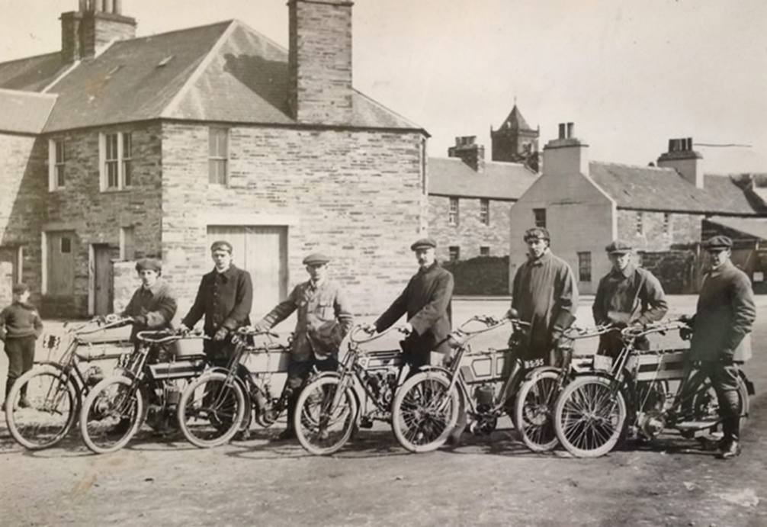
We learnt that motorbikes run in the family, but skipped a generation with Richard’s father. Richard himself still likes to ride to let off steam. The superb 1912 photo of Richard’s grandfather and great-uncle with five other pioneering motorcyclists and their machines is a classic.
As well as his photographs, Richard brought along a treasure trove of old objects. His unfurled stack net and a paraffin smoothing iron were of particular interest. Old lemonade bottles and a biscuit tin triggered memories for some if us – and served as an object lesson on recycling from Richard.
Some surprises were Shearer’s long-standing and continuing presence in the seed trade in Orkney; their historic agency in the wool business (and Richard’s confession that he didn’t enjoy packing wool for shipment); and the 1911 fire in their paraffin store in the premises at the back of the shop, which had to be rebuilt.
Richard was very punctilious about not promoting his business – he doesn’t need to! However, he did say that one of his ambitions is to sell off all of the lamp glasses he over-ordered back in the day, which would serve to prove his father wrong in his caustic prediction to young Richard that they would never sell.
We wish Shearer’s long continued success into the future as the fifth generation of the family takes over.
[u3a provides opportunities for people who are no longer working full-time to come together to learn, continue their interests and take up new pursuits. There is more information about us on our website www.orkneycommunities.co.uk/u3a. You can email us at info@orkneyu3a.org]

