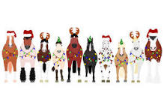
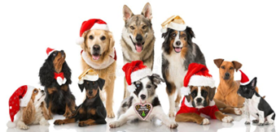

CHRISTMAS INHAND FUNdraising Open HORSE and DOG SHOW
Sunday 7th December at Orkney Riding Centre from 10am.
Judges: Sharon Nixon and Sonja Marwick
Open to ALL. Casual/Christmas dress.
Food available all day and a Raffle. Spectators welcome
All proceeds will go to the Orkney Riding Centre
Advance entry is £5 per class / Entry on the day is £10 per class

INHAND EQUINE CLASSES:
- Youngstock (3yrs & under) 2. Pony (under 14.2hh)
- Horse (14.2 & over) 4. Mountain & Moorland
5. Veteran (16yrs & over) 6. Winter Woolies
7. Christmas Horse 8. Christmas Pony
9. Young Handlers (14yrs & under) 10. Mince Pie & Spoon Race (with ponies)
11. Hobby Horse Race – bring your own hobby horses if you have ones

FUN DOG CLASSES:
12. Pups (12 months & under) 13. Seniors (10yrs & over)
14. Gorgeous Girls 15. Bonnie Boys
16. Christmas Canines 17. Dog Judge Wants To Take Home
18. Young Handlers (14yrs & under)

This is not a Championship Show. Rosettes will be awarded 1st-6th. The aim is to have fun with our horses and dogs and raise funds for the Riding Centre.
RAFFLE: there is a Northlink Travel Voucher, and we hope to get enough donations of items to make a grocery hamper prize. There is a box in the Canteen for grocery items or hand to Hellie Foulis. Anyone willing to make food please let us know.

ENTRIES & FEES TO BE RECEIVED BY WEDNESDAY 3RD DECEMBER: £5 per class
Email: orkneyridingclub@gmail.com.
Payment to Orkney Riding Club a/c 83-24-07 / 00242281 ref XMAS SHOW

Name of Handler & Horse: _______________________________________________________

Name of Handler & Dog: ________________________________________________________

Age of Young Handler (in case we need to split): _________________________________

Classes Entered: ____________________________ Amount Paid: £ _____________

Would you be keen to do a Dog Agility Class? YES / NO
If there’s enough interest we may run an enter on the day Agility class.

Please bring an item for the Grocery Hamper Raffle Prize, thank you

