POLTONHALL & DISTRICT COMMUNITY COUNCIL

Minutes of Meeting held on 12 August 2015

Present: J French (Chair), F Warner, K Fuller, M Fuller, A Munro, S Waterston, J Weir and D West

In Attendance: Cllrs I Baxter and D Milligan, Sgt Kenny Eccles, Mr & Mrs B Cunningham

Apologies: S Blain, S Mullen, A Thomson, and PC Ian Hutchison

1. Chair’s Remarks

1.1 Chair welcomed everyone to the meeting and advised there was a further item to discuss under ‘Local Issues’ concerning an application for change of use.

2. Minutes of Meeting of 10 June 2015 and Matters Arising

2.1 Item 4.2 Cala Homes’ proposed development by the golf practice ground at Mayshade. It was noted that nothing more was known regarding further developments.
.
2.2 Item 6.3 Contact with Openreach about the position of broadband cabinets. Amend 2nd sentence to read “Openreach staff had been advised not to comment on what was happening”.

2.3 Item 6.6 Fire at former Hopefield Primary school. It was noted that as a result of the fire furniture stored for homeless provision had been damaged or destroyed but as far as was known nothing else was lost.

2.4 Item 6.6 Amend 4th sentence to read “St Mary’s Primary school”.

2.5 The minutes of the Meeting were approved. Proposed by AM; seconded by KF.

3. Finance Report

.2 Statement of account as at 12 August 2015

Bank Cash

B/F 934.76 33.67

Income: Nil

Expenditure:

Printer Ink 16.98
Sponsor of Gala day 300.00

Account as at 12 August 2015 634.78 16.69

Total Bank & Cash 651.45

4. Secretary’s Report

4.1 An invitation had been received to attend a new community group, the Hot Topics Group, a partnership between the Health and Social Care Partnership and local people. The group’s aim was to influence the way that the health and social care partnership develop its services and work to improve the health of people in Midlothian. The date of the first meeting would be held on Thursday 3 September, 2pm – 4pm at Dalkeith Arts Centre. Anyone wishing to attend should advise Catherine Evans, Public Involvement Coordinator, Midlothian Community Health Partnership on 0131 271 3411 or email catherine.evans@nhslothian.scot.nhs.uk

4.2 Borders Railway would begin operation on 6 September 2015. Transport Scotland was undertaking research to analyse the impacts of the Borders Railway on the communities in Midlothian and the Scottish Borders served by these new services. As part of the research there was an Online Household Survey - www.streetwiseservices.com/bordersrail.html which would help to build up a picture of life in those communities today, before services commence on the new line. The survey would ask questions of about the household and current travel patterns and should take 20 minutes to complete. All completed responses would be entered into a prize draw to win one of five £50 shopping vouchers!

5. Police Report

Crime Statistics July 2015 - Bonnyrigg and Lasswade

Total Crimes Recorded: 42 Total Crimes Solved: 10 23.8 % solvency

July break down as follows
Received Solved
Violent Crime 0 0

Sexual Crime 2 1
Crimes of Dishonesty 18 3
Vandalism 9 0
Other Crime 13 6
INCIDENTS OF NOTE IN BONNYRIGG

Bonnyrigg Crimes
Total Recorded Group 1-5 Crimes: 42 Total Recorded Group 1-5 Crimes Solved: 10
23.8 % solvency

YTD 2014/2015 163 Group 1-5 crimes with 70 solved 43%
Last YTD 2013/2014 169 Group 1-5 crimes with 44 solved 26%

July break down as follows Received Solved
Violent Crime 0 0

Sexual Crime 2 1
Crimes of Dishonesty 18 3
Vandalism 9 0
Other Crime 13 6

INCIDENTS OF NOTE IN BONNYRIGG

Between 1.15pm and 6.10pm on 1st July, someone broke into a house in Eskbank Road, Bonnyrigg and stole property including electrical games and equipment, jewellery and money.
Update A 33 year old male was charged in connection with this crime and detained in custody to appear at court

About 8.30pm on 3rd July, someone smashed a livingroom window at an address in Dalhousie Place, Bonnyrigg.

Between 3.30pm on 3rd July and 8.15am on 4th July 2015 business premises in the High Street Bonnyrigg were broken into and a cash till and money were stolen.

Assault and Robbery, High Street, Bonnyrigg
Police in Midlothian are appealing for witnesses following an assault and robbery in Bonnyrigg. The incident happened around 11.30pm in the High Street on Saturday (4th July). A 21-year-old woman was walking at a vennel near to the RBS ATM machine and was assaulted. She was knocked unconscious and on waking found her purse, with bankcard and cash, to be stolen. The woman received minor injuries to her head and was treated by the ambulance service at the scene. Unfortunately there is no suspect description available as the victim was approached from behind, although she believes there was one man involved. Officers are now urging anyone who can assist with their enquiries to come forward. Detective Constable James Welsh of Dalkeith CID said: "This was an extremely distressing incident for the young woman involved and we're urging anyone who may have witnessed the incident, seen anyone acting suspiciously in the area at the time of the incident, or who has any information which can help with our enquiries, to come forward."

Update Assault and Robbery High Street Bonnyrigg
Enquiries are ongoing. I cannot provide any further information at this time; however I am hopeful I will be able to provide you with a positive update in due course.

Between 1pm on 4th July and 8.35am on 5th July, someone broke into a garden hut in Raes Gardens, Bonnyrigg. Several items of property were stolen including power tools and gardening equipment.

Between 8pm on 7th July and 8am on 8th July, someone smashed a window of a Vauxhall Corsa parked in Dalhousie Gardens, Bonnyrigg.

Overnight between the 9th and 10th July someone broke into a house in Eskbank Road, Bonnyrigg and thereafter stole the owner’s Vauxhall Corsa car, which was parked outside.

Between 8pm on 10th July and 1am on 11th July 2015, someone smashed a window of a house at Sherwood Court, Bonnyrigg.

Between 27th June and 14th July, someone attempted to break into a garden shed at a house at Peacock Parkway, Bonnyrigg. No property was taken.

Between 10th and 17th July, someone damaged the cellar door and a window at Cockpen Parish Church Hall, Dundas Street, Bonnyrigg.

On 23rd July, someone made an attempt to break into a painting studio located in the High Street in Bonnyrigg. No entry was gained to the premises.
Between 6pm on 24th July and 5am on 25th July 2015 a house in Green Lane Lasswade was broken into, property including the owners Silver Volvo was stolen. This was subsequently traced burnt out outwith the area.

About 12.30pm on 31st July, someone threw an object at a Lothian Bus, as it travelled along Cockpen Road, Bonnyrigg. A window in the upper deck was smashed.

If any person has any information about the incident(s) listed above or indeed any other issue please contact your Community Policing Team. Police Scotland use social media to circulate the latest news, events and information to the public via Twitter (@policescotland) and Facebook (www.facebook.com/policescotland). Hate crime incidents and domestic abuse incidents can now be reported online via the official Police Scotland website, www.scotland.police.uk or by visiting a third Party Reporting Centre. Information regarding crime can be passed to Crimestoppers on 0800 555 111 or through an anonymous Online Form - both of these routes are completely anonymous and available 24 hours a day, 365 days a year. E-mail LothianScotBordersPenicuikCPT@scotland.pnn.police.uk Telephone: Bonnyrigg Police Station 101 or Crimestoppers: 0800 555 111

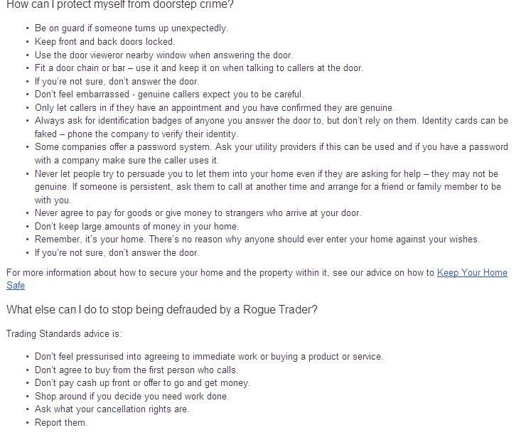

5.2 FW asked if there was anything to report on the incident in Bonnyrigg High Street in early July when a young woman was assaulted. Sgt Eccles undertook to ask PS Michele Lindsay for an update.

5.3 Mrs Cunningham asked about coverage at the front desk at Dalkeith Police Station as no one had been available in the early afternoon to take a golf cart which had been found. The matter would be referred to PS Michele Linsday.

6. Midlothian Councillors’ Report

6.1 Cllr IB reported on an issue with developers concerning a housing advertising sign at Burnbrae. The sign had been up for a long time and the houses had since been sold. He was advised it would be removed soon.

6.2 Cllr IB had sent an email to the Advertiser and to residents at Hopefield who had contacted him complaining about lack of action on broadband by Openreach. Brendan Dick, Director, BT Scotland advised that he was pushing to get cabinet 56 at Hopefield. Scottish Government was due make an announcement on phase 2 but it was unlikely anything would happen at Hopefield. Despite being the newest housing estate in Scotland it was unlikely to be upgraded until 2017.

6.3 There were various options regarding traffic wardens. One was to pay £12k for services to Police Scotland for 2016 or decriminalise parking and thus make it a civil matter. It was noted that City of Edinburgh Council had been working with a private company for several years and it might be beneficial for Midlothian Council to do the same.

6.4 It was noted that Cllr IB was moving his surgery to the Library at Lasswade Centre and from a Wednesday to the 3rd Thursday each month.

6.5 Cllr DM commented on the traffic warden issue and advised it would cost £150-200k to buy a service from Edinburgh meaning issuing £30 parking tickets. To break even there would need to be in excess of 500 tickets issued per month. Police Scotland had announced in 2014 that it would no longer be providing traffic wardens. At the earliest it would be 18 months to privatise parking.

6.6 The Shadow Health Board had agreed to do away with one on-call doctor during the week. A quality impact assessment had been requested to be carried out first but had it been outvoted.

6.7 The Boys’ Club had lost £4k of equipment through theft which had now been replaced. The SFA had given a large yellow container that was now located by the all weather pitches. It was noted that the all weather court needed to be fully re-laid. The Council was drawing in a lot of money from it and should it fall into disrepair then it would not be used. Cllr DM suggested that the money generated from renting out the training areas should be used for the repairs.

6.8 Cllr DM reported on a motion for CCTV to be introduced in the area where 2 sexual assaults had taken place over the past year. No one had yet been apprehended. He advised that the motion was not accepted and that the Council was looking at widening CCTV usage.

7. Local Issues

7.1 Midlothian Federation of Community Councils (MFCC) – invitation to become a member. PDCC had been previously been invited to join not only MFCC but also the Scottish Association of Community Councils (which had subsequently disbanded when funding was ceased). KF had attended a couple of MFCC meetings but it reported that it was the same people who took the floor and addressed the meetings. PDCC took the view that there was no benefit to being a member of MFCC. Any issues arising could be raised by PDCC through Midlothian Councillors. It was agreed to decline the invitation. Action: FW

7.2 Chair reported that a local resident had asked PDCC to support objections to the change of a use of a shop to a takeaway. One hundred and sixty four objections had been submitted. It was noted that there was now a For Sale/To Let sign on the property.

7.3 It was noted that a further 2 units were under offer at Staiside Court but it was not yet known who the interested parties were.

Date of Next Meeting

The next meeting would be held on Wednesday 9 September 2015.

