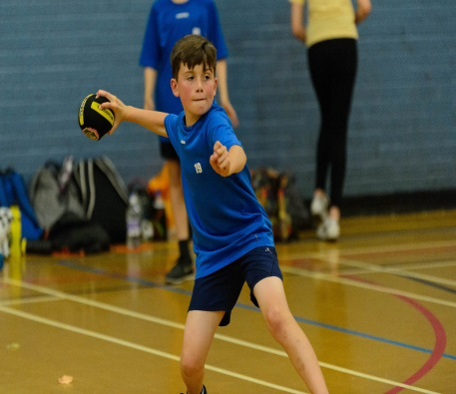

Dodgeball Camp
Tuesday 30th July
10am – 3pm
£20 per child
Suitable for boys and girls aged 7-16 Years
Coaching from District Sports coaches


Roller Disco
Wednesday 31st July &
Tuesday 27th August
Session 1: 1.30-2.30pm
Session 2: 3-4pm
Adults £4.30, Children £3.60
Skates available to hire (£1.50)
Disco Dion playing all the latest tunes!!


Tidworth Leisure Centre Summer Activities 2019
Amesbury Sports Centre Summer Activities 2019
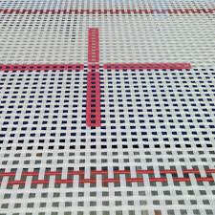
Trial Trampoline Sessions
Wednesday 7th August
10.30am – 12.30pm: Open to those aged 5-8 Years
1 – 3pm: Open to those aged 8-14 Years
£6 per session
We are starting weekly trampoline courses from September 2019, come along and see if you like it!

Skating Sessions
Tuesday 6th, 13th & 20th August
2pm – 4pm
£3 per skate, £1.50 skate hire
Open for anyone!
Messy Play Arts Sessions

Monday 5th 12th & 19th August
10am – 12noon
£3 per child
Open for anyone under 6 and their parents.



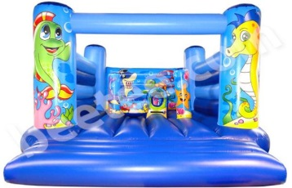
Inflatable Fun Sessions
Thursday 1st, 8th, 15th, 22nd, 29th August
10am – 12noon
£3 per child
Open to any children under 8 years old.
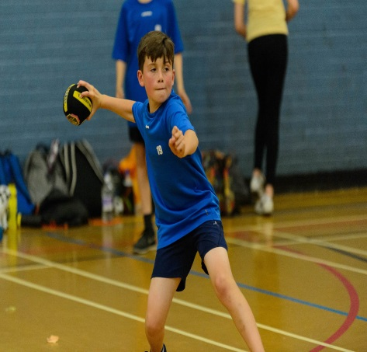

Dodgeball Camp
Monday 29th July
10am – 3pm
£20 per child
Suitable for boys and girls aged 7-16 Years
Coaching from District Sports coaches



Basketball Camp
Friday 9th August
10am – 3pm
£20 per child
Suitable for boys and girls aged 8-16 Years
Coaching from Innov8 Sportz CIC Coaches



Multi-Sports Camp
Wednesday 28th August
10am – 3pm
£20 per child
Suitable for boys and girls aged 7-16 Years
Coaching from District Sports coaches
Sports include basketball, nerf, handball, tri-golf and more!
Amesbury Sports Centre Summer Activities 2019


Courts for £2!
Every Friday between 9am – 4pm*
Badminton or table tennis when booked for children will only be £2 for a court!
*when the hall space is available



Sumer activties 2019
For more information on any of the activities or to book a space, please either speak to us at reception; contact us on 01980 622173 or book online:
www.leisure.wiltshire.gov.uk/bookings




Tidworth Leisure Centre Summer Activities 2019

