

The Herbert Protocol is here to help find them if they do


Do you care for an elderly vulnerable person and worry they might go missing?

www.wiltshire.police.uk/herbertprotocol 2019

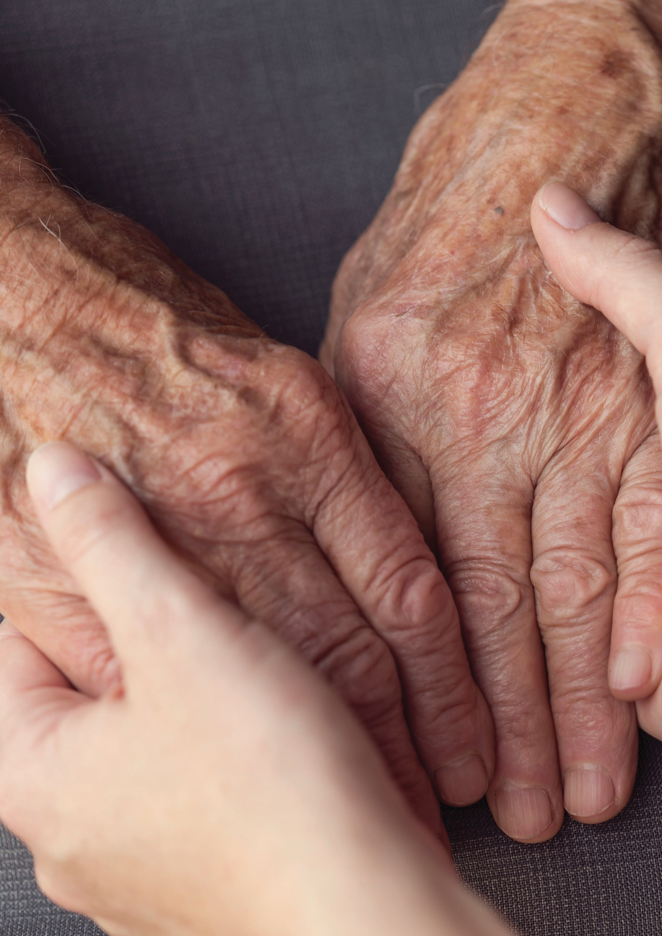


If you are worried about an adult at risk of going out and forgetting their way home, help is at hand.
This information is intended to assist family, friends, care workers, Telecare providers, responders and the police if the person goes missing.
Please complete this booklet and keep it in a safe place. If possible please also complete and save the electronic version of the form, available to download at: www.wiltshire.police.uk/herbertprotocol
The booklet contains a lot of questions – do not worry if you don’t have, or cannot get, all of the information it asks for – some of it won’t apply to everyone. There are sections intended for professional carers; please don’t worry if you do not understand what they mean.
Please save this booklet – either in electronic format or handwritten – in a place where it can easily be found if the person it refers to goes missing. It may need to be located quickly, at any time, day or night, by the police who may need the information to begin the initial searches.
We also suggest that if the person has a Telecare (lifeline) system a copy is shared with the Monitoring centre, so they can email the details including a photograph to the police or wellbeing responders if they have requested their service.
When complete, the booklet will contain personal information and must be stored appropriately to protect the person’s privacy in accordance with GDPR legislation. However, if the person goes missing, sharing the information with professionals, including the police, to protect and safeguard the person is justified.
The police will only ever ask for the form if the person is reported missing.
Thank you for taking the time to complete it. It could help to save someone’s life.

If you are concerned about the whereabouts of your friend/relative then you MUST call the police on 101 or 999 in an emergency

PART ONE
(to be completed when it has been identified the individual is at risk of going missing)

Full name of vulnerable person:  jhgjhgjhgjhg |  | Please attach a recent photo here  Please find one that is a good likeness of the person.  It is also helpful if you have an electronic photo stored with Telecare monitoring centre (if telecare is in place) so it can be emailed to the police in the event of the person going missing.  Press the pendant and ask for an email address if you want to email a photograph for their records.
Preferred name/nickname:
Current address including postcode:
Telephone:
Mobile:
Email:
If this is a care home or if there is an on call team supporting the person who should be contacted?
Care provider name:
Telephone numbers:

Ethnicity and first language:
Date of birth: | Age:
Any communication needs? (e.g. hearing, speech, language)
Description of the person to help in any search (e.g. height, build)
Distinguishing features (e.g. scars, tattoos)
If they drive or may have access to a car please give details (e.g. registration, make, model, owners details)

Do they usually use a bus or train and where is the nearest stop to their home? If a bus route/ direction of travel is known, please note here
Has the person got a mobile phone? Yes  No 
If yes, what is the number?
Has the person got any access to money or taken money with them? Yes  No 
If yes, how much?

NEXT OF KIN
Next of Kin name:
Mobile number: |  | Landline number:
Contact address:
Email:
If the person has the following in place please provide their contact details:
A lasting power of attorney for personal welfare:
Court appointed deputy with a court order for personal welfare:

GP CONTACT DETAILS
Doctor’s name:
Telephone: |  | Out of hours:
Surgery address:
Email:

OTHER PROFESSIONAL CONTACT DETAILS
Professional’s name, agency and role:
Telephone: |  | Out of hours:
Address:
Email:

OTHER CLOSE FAMILY OR FRIENDS NAME, TELEPHONE NUMBER AND ADDRESS
(Add as many as you are able)
1.
2.
3.
4.
5.

MEDICAL INFORMATION (please include where Deprivation of Liberty, guardianship or section 117 of the Mental Health Act, discharge are applicable)
Any diagnosis or investigation regarding poor memory?
Any other medical conditions?
Any medication prescribed on a regular basis (including mental health medication) and time required:
What are the risks if medication is not taken?

TELL US A LITTLE ABOUT THE PERSON THAT WILL HELP ANY SEARCH
Have they been missing before? Where did they go? How long were they missing and how were they found? Approximated dates of previous missing episodes
Are there any favourite places where this person liked to go, or, places of interest or significance (e.g. old school, work place, childhood home, favourite walk, shop, cafe, cemetery?)

MOBILITY
How easily can the person walk?
If walking, how far can they get before becoming tired?
Do they use a stick or other walking aid?
Can they move between furniture without help?

MENTAL HEALTH
Do they have any fears or phobias? (e.g. water or heights)
How might they react to being upset or scared?
How would/do they react to a police and/or uniformed presence?
Are there any behaviours that may result in conflict or challenges placing the missing person/others at risk?

PLACES OR ADDRESSES OF NOTE / WHERE THEY MAY GO
Previous home address(s)? | Childhood address(s)?
Family address(s)? | Work place(s)?

ROUTINES
Daily / weekly / weekend with times | Venue with address and phone number if known

PERSON COMPLETING FORM
Name: | Role or relationship:
Address:
Landline: | Mobile:
Date:

PART TWO (to be completed only when the person has been reported as missing)

DESCRIPTION OF WHAT THE PERSON WAS LAST SEEN WEARING
(include colour, designer labels / brands)
Shirt / sweater:
Trousers / skirt:
Outerwear (e.g. coat, jacket)
Headwear:
Gloves:
Scarf:
Footwear:
Jewellery (e.g. watch, rings)
Other:
Has the person got access to any money? | Yes  No  | If yes, how much? £
How independent is the person at the time of going missing?

LAST LOCATION / RISKS
Time, date and location last seen:
Risk factors (‘check X’) | Suicidal  Depressed   Other  (describe): | Confused  | Alcohol  | Violent 

PERSON COMPLETING FORM
Name: | Role or relationship:
Address:
Landline: | Mobile:
Email:
Date:

ANY OTHER RELEVANT INFORMATION?







Wiltshire Police Headquarters, London Road, Devizes, SN10 2DN
www.wiltshire.police.uk/herbertprotocol
2019

