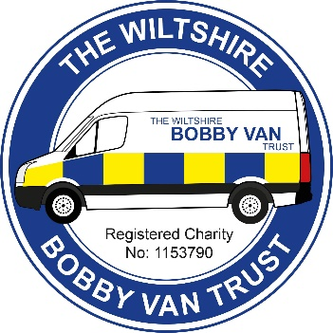
The Wiltshire Bobby Van Trust
During the current lockdown we would like to notify you of the services still available through The Wiltshire Bobby Van Trust to those over 60 or 18+ with a registered disability.
Our team of Home Security Operators are still securing the homes of victims of house crime and domestic abuse. Our office team are on hand to give telephone support and advice on a range of home security issues. Please call 01380 861155 and leave a message, your call will be returned within a few hours during working hours. Our operators are also delivering Personal Protective Equipment for Wiltshire Police across the County.
Our team of Stay Safe Online volunteers are available to offer telephone advice on a range of issues from improving cyber security awareness, to cyber and scam prevention advice and signposting to future advice and resources. Please call and leave a message on 01380 861191 and someone will get back you shortly.

.

