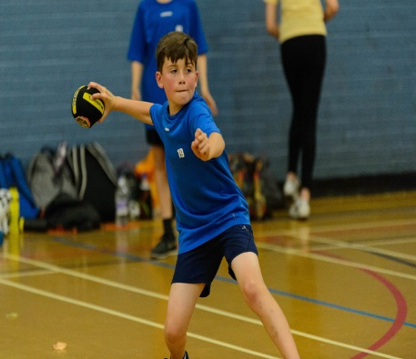


Dodgeball Camp
Monday 29th July
10am – 3pm
£20 per child
Suitable for boys and girls aged 7-16 Years
Coaching from District Sports coaches

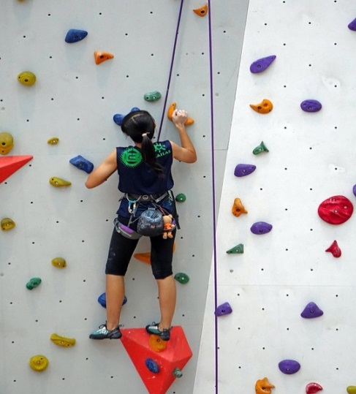
Summer Climbing Sessions
Available on the following dates:
01/08/19, 08/08/19, 22/08/19 & 29/08/19
9.30 – 11am: Open to those aged between 9-12 Years
11 – 12.30pm: Open to those aged between 13-16 Years
Non-members £7.35, Members £5.85, Concession £2.95

Tidworth Leisure Centre Summer Activities 2019
Tidworth Leisure Centre Summer Activities 2019

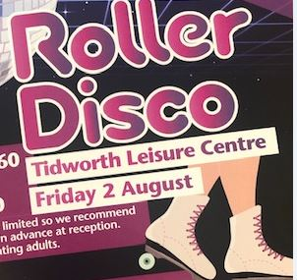

Roller Disco
Friday 2nd August
Session 1: 1.30-2.30pm
Session 2: 3-4pm
Adults £4.30, Children £3.60
Skates available to hire
Disco Dion playing all the latest tunes!!

Gymnastics Camp
Tuesday 20th August & Wednesday 21st August
10am – 3pm
£40 per child
Suitable for boys and girls aged 5-14 Years




Swim Disco
Tuesday 20th August
6pm – 7pm
Adult: Non-member £5.80, Member £4.30, Conc £2.15
Children: Non-member £5.55, Member £4.05, Conc £2.15
Disco Dion playing all the latest tunes!!
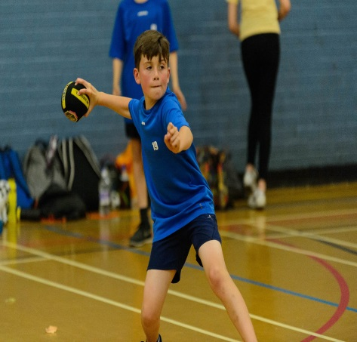

Dodgeball Camp
Monday 29th July
10am – 3pm
£20 per child
Suitable for boys and girls aged 7-16 Years
Coaching from District Sports coaches



Basketball Camp
Friday 23rd August
10am – 3pm
£20 per child
Suitable for boys and girls aged 8-16 Years
Coaching from Innov8 Sportz CIC Coaches

Tidworth Leisure Centre Summer Activities 2019


Multi-Sports Camp
Tuesday 27th August
10am – 3pm
£20 per child
Suitable for boys and girls aged 7-16 Years
Coaching from District Sports coaches
Sports include basketball, nerf, handball, tri-golf and more!

For more information on any of the activities or to book a space, please either speak to us at reception; contact us on 01980 847140 or book online:
www.leisure.wiltshire.gov.uk/bookings
Please enrol your children prior to the date to ensure your booking.


Sumer activties 2019

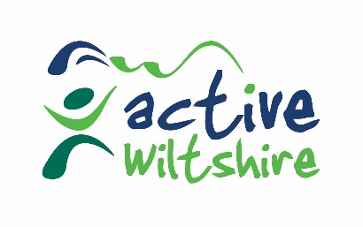

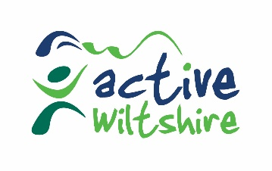

Tidworth Leisure Centre Summer Activities 2019

