What should I already know? |  | Diagrams | What will I know by the end of the unit?
- There are different size houses.  - You get different styles of house.  - People’s homes are in all different locations. |  | 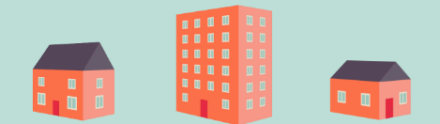  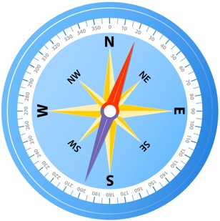  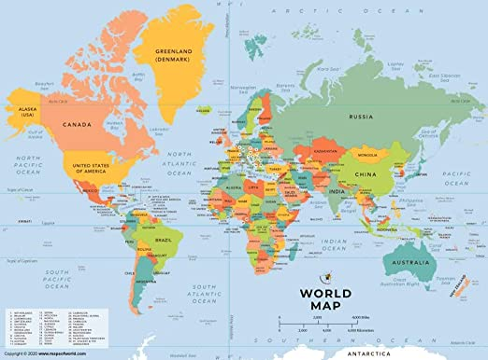 | - The different names for types of houses  - Why houses are built differently. Age, location, surroundings etc.  - How different materials are used to build houses.  - How to use a map  - To understand the use of a compass  - Looking at houses around the world.  - Discuss the style of house we can see in the local area.  - Recreate the local village of Carbrooke using different materials to build houses.  - How to create a map and use this to navigate.
Key Vocabulary
House | a building for human habitation.
Home | the place where one lives permanently, especially as a member of a family or household
Detached house | a stand-alone residential structure that does not share outside walls with another house or building.
Semi-detached house | house that shares one common wall with the next house
Terrace house | a house built as part of a continuous row in a uniform style.
Bungalow | a low house having only one storey
Map | representation of an area of land or sea showing physical features
Location | a particular place or position
Building | a structure with a roof and walls
Materials | the matter from which a thing is or can be made
Question 1
Which type of house do you live in?
Detached
Semi- Detached
Bungalow
Flat
Other. (please write your answer in the box).

Question 4 | Start of Term | End of Term
Name 4 materials used to build houses.

Question 2 | Start of Term | End of Term
Write down the 4 main points on a compass?

Question 3 | Start of Term | End of Term
Name 1 soft material and 1 hard material.

Question 5 | Start of Term | End of Term
What materials have been used in the buildings in Carbrooke?

