Community Councils of Inverness

Alex Norris MP
Minister for Border Security &
Asylum
2 Marsham Street
London SW1P 4DF

17th December 2025

Dear Sir,
Cameron Barracks Inverness
We write on behalf of the local populations we represent in Inverness as Crown and City Centre, Raigmore, and Culcabock and Drakies Community Councils
It is with great disappointment and deep concern that we write to state our strong objection to the decision you have taken to use Cameron Barracks, Inverness as a temporary location for 300 asylum seekers. The lack of transparency and communication on the situation is already causing major problems in the form of misinformation, ill-judged assumptions and rising community tension. We simply do not have information to reassure us or our residents that the wellbeing and safety of both asylum seekers and local communities will be properly resources and safeguarded.
We also feel that the proposed location of Cameron Barracks, immediately adjacent to a secondary school, near a primary school, within close proximity to local housing and short walking distance to Inverness city centre, is highly inappropriate and has not been given enough consideration.
We have concerns about staff resources at the camp, the provision of sufficient officers from Police Scotland, security around the boundaries and the additional strain on already over-stretched public services, particularly NHS services locally. None of our concerns, or possible mitigation measures have been formally discussed with us or our residents. The FAQ published by your department do not provide either the detail or reassurance we seek.
There is no trust or confidence in the statements that the Barracks will be vacated at the end of twelve months. We would like a formal written guarantee from you that the home office will not use the site in this manner for more than the stated and proposed time of one year. We also request that you give due notice to Highland Council of all and any intended operational changes that may affect residents and services within a reasonable time frame. Ie three to six months minimum.

We highly value and understand the importance of good community relationships and transparency in communication about major changes that can affect local dynamics.
We would reiterate that in the face of the rising community tensions being expressed to us locally, it is essential for the Home Office to clearly communicate any plans properly and meaningfully with our residents and would welcome the opportunity of an open dialogue with you and your officials prior to any progress of this proposal.
To this end we would urgently request you engage with all relevant public sector partners, Highland Council, the Community Councils, relevant stakeholder groups, local MPs, the voluntary sector and the local community itself.
While we repeat that we remain firmly against the use of this site in this manner, the above suggestions may help mitigate the significant impacts on the local community.
We look forward to your swift response.

Yours Faithfully

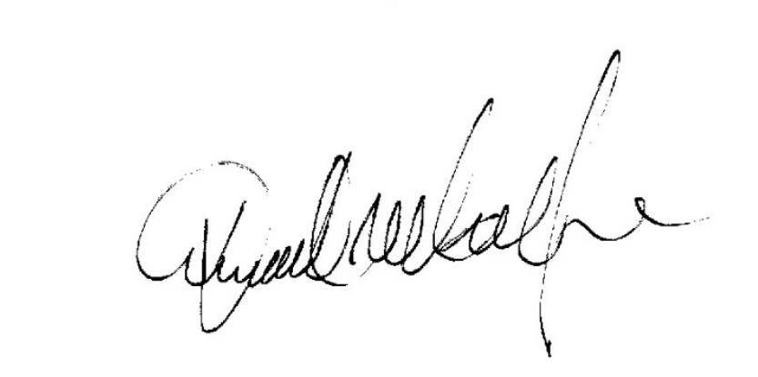

Donald MacKenzie Munro Ross Donald MacLeod
Chair Crown and City Chair Raigmore for Drakies
Centre Community Council Community Council Community Council

