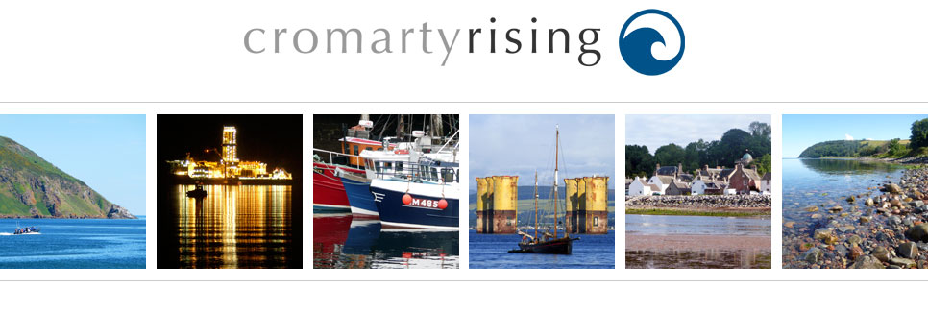

**Thousands have signed the 38 Degrees petition to stop plans to allow ship-to-ship oil transfers in the Cromarty Firth.**

**Can you come along to help hand the petition in this Thursday?**  
  
**Here are the details:**  
**When:** Thursday, 30th June, 11:45am  
**Where:** Outside the Cromarty Port Office, Shore Rd, Invergordon, Ross-Shire IV18 0HD  
Follow A9 and turn left at sign to Alness/Invergordon (B817)

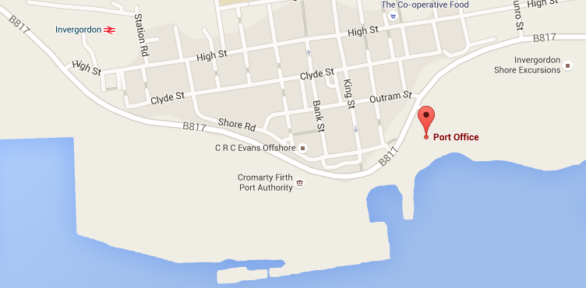  
**The more of us that come along, the bigger the impression we’ll make on the port authority.**

If you need a lift, or could offer transport please ring: 600819

<http://www.cromartyrising.com/> : web site established to provide information relating to the application by The Port of Cromarty Firth (formerly the Cromarty Firth Port Authority) for a ship to ship oil transfer license.