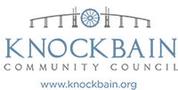

**KNOCKBAIN COMMUNITY COUNCIL AGENDA**

**Meeting 19 October 2021 at 7 pm Village Hall – Main Hall**

1. Welcome, Introductions and Apologies
2. Minutes
3. Matters Arising (not covered in the agenda)
4. Finance
5. Information from the Police
6. Planning
7. Outstanding actions, projects and current responsibilities

* Road Safety measurers update
* Community Development SCIO
* Welcome sign - NK village
* COVID update

1. Monthly update on Torgorm Point Community Project /Gordon Park Project
2. Correspondence
3. AOCB
4. Date of next meeting