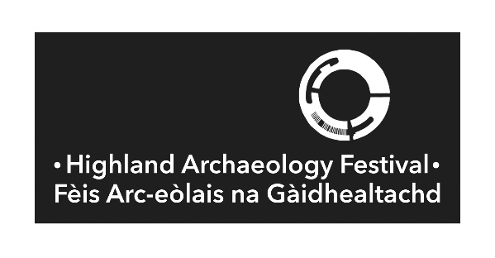
HIGHLAND ARCHAEOLOGY FESTIVAL 2025 CONFERENCE

FEEDBACK FORM
We very much welcome your feedback on the HAF 2025 Conference as this will help with evaluation and future planning.
- What is the postcode of your normal/main place of residence? ________________________________

- What age bracket do you fit into?

____ Under 18
____ 18 – 30 ____ 50-65
____ 30 - 50 ____ Over 65

- How satisfied were you with the range and content of the talks?
____ Extremely happy ____ Unhappy
____ Happy ____ Extremely unhappy
____ Neither happy nor unhappy

Please tell us what you were happy/unhappy about:

- We offer poster sessions for organisation who do not want to present longer talks. Did you attend any of these? Was there sufficient time? Would you like to see these continued?

- We invite a range of national, regional and local organisations to host stalls. Do you find this a valuable element to the conference?
____ I attend predominantly for the talks programme
____ I attend predominantly for browsing the stalls and networking
____ I attend for both the talks and the stalls

Please tell us more. Is there anything else you would like to see in addition to the talks programme?

- How/where did you find out about the HAF Conference?
____ Social Media ____ Word of mouth
____ HAF Website ____ Other (Please Specify)

Where else do you feel it would be useful for us to promote the event?

- We are assessing the current conference format. We also hope to open it up to those who cannot attend in person. In future would you prefer:
____ An in-person conference only
____ An online conference only
____ In person and online options

  - If the Conference offered both online and in-person options (with a reduced ticket price for an online option), which option would you be most likely to attend? Please tell us why.

  - We try to keep the ticket cost down and in line with comparable conferences in Scotland. Most others are single day conference, and we have concerns that two days may become unfavourably costly. Would you prefer to attend a one or two day conference?

- We try to keep the conference around the same time each year, however it is difficult to avoid clashes with other local events and archaeological conferences. Would you prefer it to remain fixed in Sept/Oct or would you prefer another time of year?
____ Spring ____ Autumn
____ Summer ____ Winter
Does a ‘Conference fatigue’ effect have an impact on whether you attend the conference?

- For the past two years for Highland Archaeology Festival, we have only held the conference. If we reinstated an events programme, would you or your organisation commit to running an event (walk, talk, workshop etc.)? Please specify your organisation and what you might offer.

- Do you have any other comments, suggestions or questions about the Highland Archaeology Festival Conference (or further comment for the above questions)?

