Jason Allen-Paisant
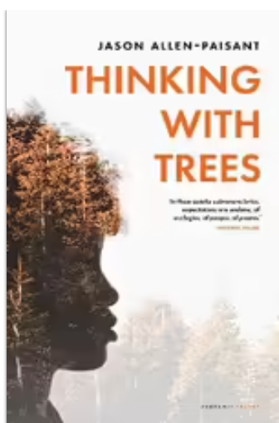
An Irish Times Best Poetry Books of 2021. Jason Allen-Paisant grew up in a village in central Jamaica. 'Trees were all around, ' he writes, 'we often went to the yam ground, my grandmother's cultivation plot. When I think of my childhood, I see myself entering a deep woodland with cedars and logwood all around. [...] The muscular guango trees were like beings among whom we lived.' Now he lives in Leeds, near a forest where he goes walking. 'Here, trees represent an alternative space, a refuge from an ultra-consumerist culture...' And even as they help him recover his connections with nature, these poems are inevitably political. As Malika Booker writes, 'Allen-Paisant's poetic ruminations deceptively radicalise Wordsworth's pastoral scenic daffodils. The collection racializes contemporary ecological poetics and its power lies in Allen-Paisant's subtle destabilization of the ordinary dog walker's right to space, territory, property and leisure by positioning the colonised Black male body's complicated and unsafe reality in these spaces.

Industry Reviews
' Jason Allen-Paisant deftly inscribes his own signature on worlds inner and outer in these gorgeous poems. The future of Caribbean lyric poetry is in great hands.' - Lorna Goodison; 'These observant poems lay their burdens down by the rivers of Babylon and try to sing the Lord's song in a strange land. What might it mean for the black body to experience nature, not as labour, but as leisure? What might it mean to simply walk through a park and observe the birds and the trees? These poems are beautiful and gentle, but the questions they raise are difficult and important.' - Kei Miller; 'In these quietly subversive lyrics, expectations are undone, of ecologies, of people, of poems.' - Rachael Allen

- Position: Lecturer in Caribbean Poetry and Decolonial Thought
- Areas of expertise: Theatre studies; performance studies; African diaspora studies; poetics; critical race theory; performance and justice
- Email: J.Allen1@leeds.ac.uk
- Phone: +44(0)113 343 4734
I am a Lecturer in Caribbean Poetry and Decolonial Thought, with joint appointments in the School of English and the School of Languages, Cultures and Societies. I am also currently the Director of the Institute for Colonial and Postcolonial Studies, having taken over from Professor Graham Huggan in September 2020.

