Cofnodion Cyfarfod Cyffredin Cyngor Tref Penrhyndeudraeth 8 Medi 2022 am 7yh yn ystafell gefn Neuadd Goffa Penrhyndeudraeth
Minutes of Cyngor Tref Penrhyndeudraeth’s Regular meeting 8 September 22 at 7pm in the back room of the Neuadd Goffa, Penrhyndeudraeth

COFNODION/MINUTES
- Croeso/Welcome
Croesawyd pawb i’r cyfarfod gan roi croeso arbennig i’r aelod diweddaraf i’r cyngor sef Gwyn Vaughan Jones ac I cynrichiolwyr o Williams of bala a grwp cynefin. Hefyd oedd yna funud o ddistawyrdd ir frenhines Elizabeth 2 ac I claire Williams merch lleol
Everyone was welcomed and a special welcome was given to Gwyn Vaughan Jones, the newest member and resprestives from Williams of bala and grwp cynefin. We held a minute silence for the late queen Elizabeth 2 and for a local girl claire williams

- Cyflwyniad gan Williams of Bala (tai yn Canol Cae/Houses in Canol Cae ) Presentation
Am wybodaeth am y cyflwyniad, gweler atodiad 1.
For more information, see Atodiad 1

- Presennol ac Ymddiheuriadau/ Present and Apologies
Presennol: Meryl Roberts, Siân Llywelyn, Victoria Burfield, Gareth Jones, Llinos Marples, Nicola Griffiths a Gwyn Vaughan Jones.
Ymddiheuriadau / apologies: Clerc, Iolo Lewis, Gruffydd Rhys, Emma Mantle

- Cymeradwyo cofnodion Gorffennaf / Approve July minutes
Cymeradwywyd /accepted

- Datgan buddiant, cysylltiad, diddordeb/ Declaration of interest, benefits ,connection
Gareth Jones gyda chais chynllunio / planning application
- Adroddiadau/ Reports
  - Adroddiad ariannol / financial report
  - Ffurflen flynyddol/awdit 2020/21 : Methu ei chwblhau gan nad yw’r Clerc yn ôl yn ei waith.
  - Y llyfr arian/ cash book
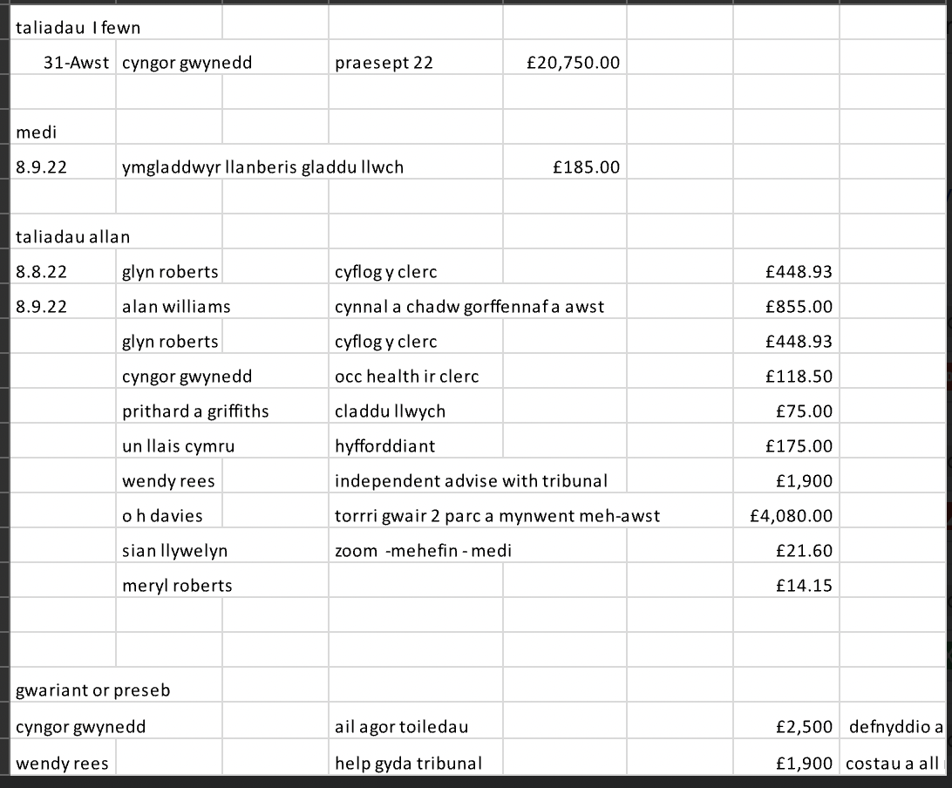

- Eitemiau sefydlog/Regular items
  - Mynwent Minffordd
Mae’r sefyllfa gyda’r cement a roddwyd i lawr heb ganiatad yn parhau. Pasiwyd bod angen apwyntio aelod o’r cyngor i fynd ar y safle i wirio cyflwr y fynwent gyda rhestr wirio a luniwyd gan y Cadeirydd er mwyn cadw golwg ar y sefyllfa, a safon popeth arall. / the situation with the cement which was placed without permission continues. The council agreed that we need to appoint a member to check the site of the cemetery with a check list, formed by the chairperson. The appointed member can keep an eye on the situation and the general condition of everything else.
  - Neuadd Drefol / Trafnidiaeth i Gymru (TFW)
Mae’r asesiad risg ar gyfer y system awyru a TFW sydd i fod i’w chwblhau, nid y cyngor ei hun.
Mae ffurflen gymleth ynglŷn â cyflenwr newydd I TFW wedi cymryd mwy o amser i’w chwblhau ac felly bydd y rhent ychydig yn hwyrach yn cyrraedd. / The risk assessment for the air con is to be completed by TFW, and not the council. A complicated new supplier form from TFW and it will take more time to complete it and the rent will be late in coming
  - Parc Mileniwm
Bydd y Cadeirydd yn cyfarfod y twrna ddydd Mawrth er mwyn trafod y mapiau er mwyn cael gwell dealltwriaeth o berchonogaeth y wal rhwng yparc a Phen y Bryn.
The Chairperson will meet the lawyer on Tuesday to discuss the maps in order to have a better understanding of the retaining wall’s ownership underneath Penbryn View.
Bydd y toriad gwair olaf yn niwedd mis Hydref. Bydd angen tyllu’r ddaear â thyllau mân er mwyn draenio’r dŵr fydd yn glanio dros y gaeaf yn ogystal.
The last grass cutting of the season will take place at the end of October. The employee will also spike the ground in order to help it drain better over the coming wet months.
Pasiwyd bod diwrnod ar y cyd efo’r Dref Werdd yn cael ei drefnu er mwyn chwynu a chlirio gor dyfaint
It was passed that a day with y Dref Werdd will be organized to weed and clear overgrown plants soon.
Nodwyd bod y bin sbwriel wedi gwneud gwahaniaeth mawr i faint o sbwriel sy’n cael ei adael yno. Nododdd un cynghorydd ei bod yn medru gweld y gwahaniaeth yn glir o’i thŷ. Cytunwyd bod y CCTV wedi gwneud gwahaniaeth hefyd. Pasiwyd bod bin arall i fynd yn y flwyddyn nesaf er mwyn helpu’r sefyllfa hyd yn oed yn fwy.
It was noted that the litter bin has had a positive effecs on the amount of rubbish left on the ground. One councillor noted that they can see the difference on a daily basis. It was agreed that the CCTV has made a difference also. The council passed that another bin will be put on site next year to improve the situation even further.
Bydd rhestr wirio yn cael ei chwblhau gan y Cadeirydd a bydd dwy o’r cynghorwyr yn mynd o gwmpas y parc unwaith yr un bob wythnos er mwyn sicrhau bod safonau yn cael eu cynnal.
A check-list will be completed by the Chairperson and two councillors will take it in turn to check the site on a weekly basis to ensure the quality of standard regarding litter etc.
  - Cae Cookes
Bydd Hochief yn rhentu Cae Cookes am rhyw 2-3 mis (i ddechrau) : £1500 y mis am hynny gan gychwyn y mis Hydref. Byddent yn ei rentu er mwyn cadw rhywfaint o’u hoffer yno ar gyfer dechrau ar y gwaith o dwllu’r twnel o dan aber Afon Ddwyryd i’r Grid Cenedlaethol.
Hochief will be renting Cae Cookes for 3 months (initially) from October onwards, which means £1500 per month to the council. They will occupy it in order to keep their equipment there whilst working for the National Grid as contractors during the operation of digging a tunnel across the estuary and taking the pilons down.
  - Cae Chware Minffordd
Aeth y Cadeirydd o gwmpas y cae chwarae ddydd Sul yn dilyn cwynion ar Facebook am y ceir sydd wedi parcio yno ers tro. Cysylltwyd efo’r PCSO a nododd mai cyfrifoldeb Cyngor Gwynedd ydy delio efo fo. Maent wedi cael rhybudd o 7 diwrnod i’w symud gan CG neu byddent yn cael eu symud gan y cyngor ei hun. Bydd rhestr wirio yn cael ei chreu gan y cadeirydd er mwyn i aelod o’r cyngor fynd yno i wirio safon y safle a chadw golwg ar y sefyllfa. Bydd angen prynu tri chlô clap gyda rhifau arnynt er mwyn eu rhoi ar y ddau blwch sydd yn dal y cctv ar trydan ac y trydydd fel un wrth gefn. Mae yna problem gyda y cctv + felly mae snowdia fire yn dod I edrych arno I ni =.
The chairperson visited the site on Sunday following complaint by members of the public about some vehicles that had been parked there for a long time. PCSO was contacted and was referred to Cyngor Gwynedd. CG has given the owners of the vehicles 7 days’ notice to remove them or they will be removed by the council. A check-list will be created by the chairperson in order to appoint a member of the council to check the site and keep an eye on the situation. Three padlocks will need to be bought so that they can be put on the two boxes in the parc which holds the cctv and electricity . there is a problem with the cctv and snowdonia fire will attend soon to look at it

  - Maes y Parc
Gweler 10.3 isod / see 10.3 below.

- Gohebiaeth/ Correspondence
  - Gweinyddu sgrinio calon / heart screening admin –
Nododd dwy o’r cynghorwyr y byddent yn dymuno cael hyfforddiant ar sut i’w defnyddio gan y sefydliad. Penderfynwyd derbyn y grant o £300 er mwyn cael y diffibrilydd newydd, a byddai un o’r cynghorwyr yn mynd i weld pa safle sydd orau ar gyfer cael un rhwng Adwy Ddu a Bron y Garth.
Two of the councillors noted that they wish to have training on how to use the defibrillator by the establishment. It was passed that the council is to apply for the £300 grant in order to have a new defibrillator. One of the councillors will check to see where between Adwy Ddu and Bron y Garth would be a suitable place to keep it.
  - Anghenion iaith a hygyrchedd aelodau’r bcd/rcp language and accessibility
Atgoffwyd y cynghorwyr i agor y linc er mwyn ateb y 3 chwestiwn. Hanner munud y bydd yn ei gymryd i’w wneud.
The councillors were reminded to open the link in the email to answer the 3 questions. Ond has already done so and it only took 30 seconds.
  - Gwobrau Dewi Sant gwobrau Cenedlaethol Cymru/St .Davids Awards – the national awards of Wales : Cytunwyd y byddai pawb yn meddwl am enw rhywun i’w roi erbyn Hydref.
All councillors agreed to think of a member of the public to name for the award by October.
  - Hwb Dref Werdd – be sydd ymlaen yn Medi/ What’s on in September : er gwybodaeth. / FYI
  - Cadw Cymru Daclus – pecyn perllen cymunedol/Keep Wales Tidy – community orchard Awgrymwyd cae chwarae Minffordd gan bod lle yno i gael perllen. Cytunwyd ei fod yn lle addas ac y gellid gofyn am grant ychwanegol gan gynllun grantiau y Grid Cenedlaethol ar ben y cynnig gan Cadw Cymru’n Daclus.
It was agreed that Cae Chwarae Minffordd would be suitable for an orchard and an additional grant could be applied for by the National Grid Community Grant Project.
  - Ffordd yn cau / road closure
Nodwyd bod ffordd B sy’n arwain o’r ffordd fawr ym Minffordd tuag ar PLas CAnol a Phenrhyn Isaf yn cau am gyfnod byr ar y 13/9/22.
It was noted that the B Road that leads from the main road in Minffordd towards Plas CAnol and Penrhyn Isaf will close temporarily on the 13/9/22

- Materion Cynllunio/Planning Matters
C22/0747/08LL Griffin Penrhyndeudraeth LL48 6LW cais ol-weithredol I gadw estyniad unllawr cefn ac adeilad cwrtil fel ystafell gyfarfod ychwanegol gyda chynhwysydd mewnol/ retrospective application to retain single story rear extension and curtilage building as additional function room with internal container – dim gwrthwynebiad/ no objections
C22/0806/08/AM meusydd llydan bryniau hendre penrhyndeudraeth LL48 6BA – cais amlinellol I godi 3 byngalo fforddiadwy ac 1 yn arbenigol gyda gwaith draenio mynediad a ffordd cysylltiedig/outline appliacaition to erect 3 bungalows 1 specialist with associated drainage works access and road
- Eitemau i’w trafod/ items for discussion
  - Arwydd Penrhyndeudraeth sign : Aberstalwm – Mae 7 diwrnod arall i’w aros am ateb gan Trunk Roads (Senedd) yn holi am ganiatad ar y mater.
Trunk Roads will respond to the chairperson in 7 days on this matter.
  - Trefnu Pwyllgor Goleuo Penrhyn/Goleuo Penrhyn Committee
Nos Wener gyntaf o fis Rhagfyr. Bydd y noson yn cael ei threfnu ar y cy defo Cyfeillion Cefn Coch unwaith eto. Bydd y Cyfeillion yn cwrdd ar y 19eg, ac wedyn bydd y cyd-bwyllgor yn cyfarfod yn dilyn hynny. Pasiwyd gofyn i Gwyn Vaughan Jones agor y noson a chytunodd. Diolchwyd am hynny. Os na fydd amserlen waith Gwyn yn ffitio efo’r dyddiad, cytunodd y Cadeirydd wneud yn ei le fel cynghorydd sir.
The first Friday evening of December. The event will be organized by the Noson Goleuo Penrhyn sub committee and Cyfeillion Cefn Coch. Cyfeillion will meet on the 19th Sept. and the joint committee will meet following that date.
  - Trefnu pwyllgor Maes y Parc i gwrdd/ arrange for Maes y Parc committee to meet.
Nos Iau 22ain – cyfarfod fel ymddiriedolwyr Maes y Parc yn yr Ogof, Griffin, am 7 o’r gloch.
Thursday Night, 22nd Sept. – councillors will meet as the trustees of Maes y Parc at 7pm. Yr Ogof, Griffin.
  - Ffos wrth y toiledau/ ditch by the toilets
Nid yw’r Cadeirydd wedi clywed dim am y ffos gan Gyngor Gwynedd, ond mae yna gwaith agor ffosydd o blaen cefn ar stad diwydiannol griffin felly fydd hyn yn ychydig o help ir ffos.
Chairperson has not received communication from Cyngor Gwynedd, but it is a requirement that the ditch is sorted soon, as a large part of the ditch has already been cleared between the industrial estate and Blaen Cefn.
  - Deudraeth cyf : gwefan y cyngor/ council website
Mae modd cael cyfeiriad ebost ar gyfer pob aelod o’r cyngor e.e meryl@cyngortrepenrhyn.cymru.
…is an example of the type of email address the councillors could have, according to the web designer, in order to avoid using our personal email.
Bydd adeiladwr y wefan yn ymddeol yn fuan ond fe awgrymodd gwmni arall sy’n medru gwneud yr un gwaith – Delwedd. Soniwyd am ddau arall sy’n medru gwneud yr un gwaith gan gynghorwyr eraill. Nodwyd bod angen symleiddio’r wefan hefyd wrth ei hailwampio. Aros tan cyfarfod nesa cyn gwneud penderfyniad.
The website designer will be retiring soon but suggested another company ; Delwedd who deso the same type of work. Two more website designers were mentioned by other councillors. It was noted that the website needs to be more user friendly and easier to navigate It was decided to wait till next meeting before making a decision
  - Eitemau na gafodd ei drafod yn cyfarfod blynyddol/ items which were not discussed in the annual meeting : dim byd.
  - Mater caeadig / closed meeting (tribiwlus/tribunal)
Dyddiad a lleoliad cyfarfod nesa/ date and location of next meeting

12/10/22 : Neuadd Goffa, 19.00yh

