GOHEBIAETH TACHWEDD/ CORRESPONDENCE NOVEMBER

1.
Subject | FW: Helpwch Ni i’ch Helpu Chi / Help Us Help You
From | Katie Powis
Date | 2022-10-25 12:17
- 104297 HUHY Pharmacies Flyer A5 HR copy.pdf (~789 KB)
- 104297 HUHY Pharmacies Poster A3 HR copy.pdf (~1.5 MB)
- HUHY NHS toolkit WELSH V4.pdf (~141 KB)
- HUHY NHS toolkit ENG V3.pdf (~394 KB)
Download all attachments
Good Afternoon,
Welsh Government and NHS Wales are still seeking support with the Accessing NHS Services communications and would also welcome support in sharing the attached poster and flyer on how local pharmacists can support minor health concerns and provide some over the counter and prescription medicines free of charge. These are still images which we understand are easier to share.
From: Katie Powis
Sent: 01 September 2022 15:06
Subject: Helpwch Ni i'ch Helpu Chi / Help Us Help You
Hi,  Thank you to everyone who has supported our 'Keep Wales Safe' / 'Help Us Help you' so far by sharing content from the 'Living Safely with COVID' toolkit.  I'm getting in touch today with our next campaign toolkit for Help Us Help You.  The 'Primary Care' toolkit contains useful assets and social media post copy providing clear, easy to digest information about the ways in which NHS services in Wales have changed, how to access them and how to make the best decisions when it comes to accessing primary care.  The assets in the toolkit are designed to highlight which services are available for use in a range of scenarios, as well as simple things people can do to look after their health and prevent themselves from needing to use these services too frequently.  Subjects covered by these assets include...  - Virtual consultations  - The role of pharmacists  - The Common Ailments Scheme and how to access it  - Oral health including dental check-ups, what to expect when visiting your dentist and how to maintain a healthy mouth and teeth  - Eye health, including acute eyecare and short sightedness (myopia) in children  We would be grateful if you could please help us spread the message by sharing these assets with your audiences on social media, on your website or in any e-newsletters you issue. Social media copy in the toolkit is suggested and can be tweaked for your channels.  As well as Dropbox, all content can be accessed on WeTransfer using the following link, which will be valid until 6th September: https://we.tl/t-AxXhKc4w4H  If you have any questions about this toolkit or its contents, please get in touch. Thank you again for supporting our campaign.  Many thanks,  Katie | Shwmae,  Diolch i bawb sydd wedi cefnogi ein hymgyrch 'Diogelu Cymru' / 'Helpwch Ni i'ch Helpu Chi' hyd yn hyn drwy rannu cynnwys o'r pecyn cymorth 'Byw'n Ddiogel gyda COVID'.  Rwy'n cysylltu heddiw gyda phecyn cymorth ein hymgyrch nesaf ar gyfer Helpwch Ni i'ch Helpu Chi.  Mae'r pecyn cymorth 'Gofal Sylfaenol' yn cynnwys asedau defnyddiol a negeseuon ar gyfer y cyfryngau cymdeithasol sy'n darparu gwybodaeth glir, hawdd ei deall am y ffyrdd y mae gwasanaethau'r GIG yng Nghymru wedi newid, sut i gael gafael arnynt a sut i wneud y penderfyniadau gorau o ran cael mynediad at ofal sylfaenol.  Mae'r asedau yn y pecyn cymorth wedi'u cynllunio i amlygu pa wasanaethau sydd ar gael i'w defnyddio mewn amrywiaeth o sefyllfaoedd, yn ogystal â phethau syml y gall pobl eu gwneud i ofalu am eu hiechyd ac er mwyn peidio â defnyddio'r gwasanaethau hyn yn rhy aml.  Mae rhai o'r asedau yn cwmpasu'r canlynol...  • Ymgynghoriadau Dros y We  • Rôl fferyllwyr  • Y Cynllun Anhwylderau Cyffredin a sut i gael mynediad ato  • Iechyd y geg gan gynnwys archwiliadau deintyddol, beth i'w ddisgwyl wrth ymweld â'ch deintydd a sut i gadw'r dannedd a'r geg yn iach  • Iechyd y llygaid, gan gynnwys gofal llygaid acíwt a golwg byr (myopia) ymhlith plant  Byddem yn ddiolchgar pe gallech ein helpu i ledaenu'r neges drwy rannu'r asedau hyn â'ch cynulleidfaoedd ar gyfryngau cymdeithasol, ar eich gwefan neu mewn unrhyw e-gylchlythyrau y byddwch yn eu cyhoeddi. Mae awgrymiadau o negeseuon ar gyfer y cyfryngau cymdeithasol wedi'u cynnwys yn y pecyn cymorth ac mae modd i chi eu haddasu ar gyfer eich sianeli.  Yn ogystal â Dropbox, gellir lawrlwytho'r holl gynnwys ar WeTransfer gan ddefnyddio'r ddolen ganlynol, a fydd yn ddilys tan 6 Medi: https://we.tl/t-AxXhKc4w4H  Os oes gennych unrhyw gwestiynau am y pecyn cymorth hwn neu ei gynnwys, cysylltwch â ni. Diolch eto am gefnogi ein hymgyrch.  Diolch o galon,  Laura
Katie Powis
Stakeholder Engagement
Tel: 07493 060539
Email: kpowis@golleyslater.co.uk
Website: www.golleyslater.co.uk

2.
Subject | Cyfyngiadau Parcio Arfaethedig/Proposed Parking Restrictions - Parcio Meirionnydd rhif 10 - 2022- Harlech a Phenrhyndeudraeth
From | Marie Lyn Williams (AMG)
To | northwalespolice@nthwales.pnn.police.uk, CT.Control, wayne.davies@wales.nhs.uk, sian.jones39@wales.nhs.uk, TrafficOrdersWales@logistics.org.uk, northern@rha.uk.net, andy.kettle@royalmail.com, Priffyrdd Meirionnydd PRI/HIG, Gwenan Huws Tomos (AMG), Rhian Wyn Williams (AMG), Annwen Hughes (CYNG/COUN), Gwynfor Owen (CYNG/COUN), Annwen, Meryl Roberts (CYNG/COUN), clercpenrhyn@clegyr.plus.com
Copy | Andrew Roy Gregson (AMG)
Date | Wed 10:04
- Pre con. - 26-10-2022 -...eirionnydd 10 - 2022.doc (~453 KB)
- Cynllun - Harlech, Stry...ser aros cyfyngedig.pdf (~506 KB)
- Cynllun - Penrhyndeudra...Maes Teg - Bae Anabl.pdf (~362 KB)
Download all attachments
Er gwybodaeth / gweithrediad. Diolch
For your information / action. Thank you
Mrs Mari L. Williams
Cydlynydd Prosesau Statudol/Statutory Processes Co-ordinator,
Gwasanaeth Traffig a Phrosiectau /Traffic and Projects Service.
Adran Amgylchedd / Environment Department,
Cyngor Gwynedd Council,
Swyddfa’r Cyngor/Council Offices,
Caernarfon,
Gwynedd.
LL55 1SH
3.
Subject |  | Newyddlen Hydref Gwybodaeth i Deuluoedd GWYNEDD Family Information Newsletter October 2022
From |  | Llinos Haf Owen-Jones (PLANT)
Date |  | Fri 14:47
 | Newyddlen Gwybodaeth i Deuluoedd GWYNEDD Family Information Newsletter Hydref # October 2022
 | Croeso i newyddlen Hydref 2022 gan Gwasanaeth Gwybodaeth i Deuluoedd Gwynedd.
  Go to this Sway
Rhannwch ymhlith eraill a fydd yn gweld y wybodaeth hon yn ddefnyddiol os gwelwch yn dda.
Diolch
Please share amongst others who will find this information useful.
Thank you
Tim Gwasanaeth Gwybodaeth i Deuluoedd GWYNEDD Family Information Service Team
Ty Cegin, Rhodfa Penrhyn, Maesgeirchen, Bangor, Gwynedd LL57 1LR
GGTGwyneddFIS@gwynedd.llyw.cymru01248 352436 07976 623816
Gwybodaeth i Deuluoedd GWYNEDD Family Information
Gwybodaeth i Deuluoedd GWYNEDD Family Information
Gwasnaeth Gwybodaeth i Deuluoedd Gwynedd Family Information

4.
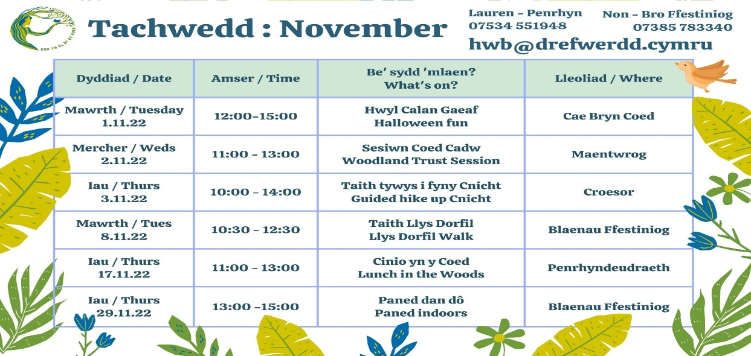
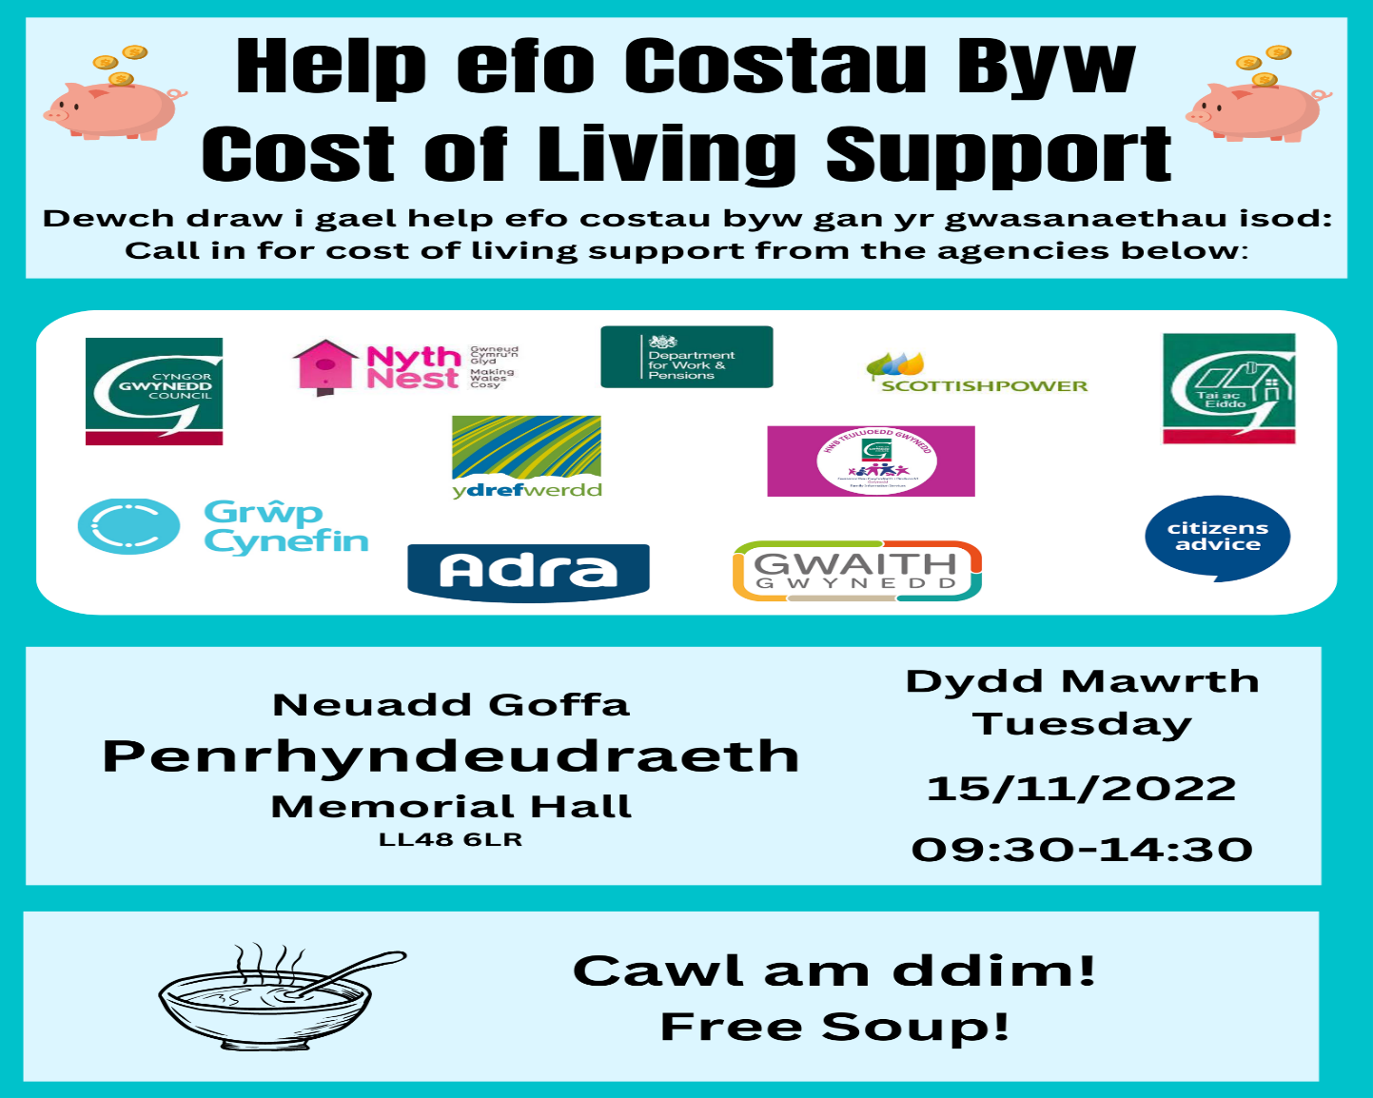
5.
Subject | Important Information Regarding Defibrillators / Gwybodaeth Bwysig am Ddiffibrilwyr
From | Tracy Gilmartin
To | Tracy Gilmartin
Copy | Phil Hill (Aneurin Bevan UHB - Primary Care and Community Division)
Date | Today 14:06
Dear Colleagues
This week I have again been made aware of further unsolicited emails being sent direct to Councils across Wales. One of these was from a charity offering grants towards Defibrillators but a rudimentary search online reveals this charity no longer (or never) exists. The person also again cites the forthcoming changes to the law in relation to Defibrillators. I previously emailed you last month to reassure that there is no immediate forthcoming legislation related to defibrillators.
The other company are citing international issues that have caused shortages of equipment and offering packages off the back of this. I have already been advised by the main representatives involved that the situation has improved and there should be no need to stockpile or panic buy at present. Finally, if your Pads are used on a patient wherever possible I will try and replace them for free even if it means posting them to you overnight. If you have any queries about Defibrillators, Pads, Batteries or Cabinets please do not hesitate to contact me.
If any of the above situations change I will be in touch again.
Best wishes.
Phil Hill, Advanced Nurse Practitioner
Annwyl Gyfeillion
Cefais wybod eto’r wythnos hon fod rhagor o e-byst diofyn wedi cael eu danfon at gynghorau ar draws Cymru. Roedd un o’r rhain oddi wrth elusen yn cynnig grantiau ar gyfer prynu diffibrilwyr, ond mae chwiliad syml ar-lein yn dangos nad yw’r elusen hon yn bodoli (neu nad yw erioed wedi). Mae’r person hefyd yn cyfeirio hefyd at newidiadau arfaethedig yn y gyfraith ynghylch diffibrilwyr. Danfonais e-bost atoch y mis diwethaf i gadarnhau nad oes unrhyw ddeddfwriaeth yn yr arfaeth ynghylch diffibrilwyr ar hyn o bryd.
Mae’r cwmni arall yn cyfeirio at faterion rhyngwladol sydd wedi creu prinder offer ac maent yn cynnig pecynnau i ymateb i hynny. Cefais wybod yn barod gan y prif gynrychiolwyr dan sylw fod y sefyllfa wedi gwella ac na ddylai fod unrhyw angen pentyrru offer neu brynu panig ar hyn o bryd.
Yn olaf, os yw eich Padiau’n cael eu defnyddio ar glaf, fe geisiaf lle bynnag y gallaf gael un arall am ddim hyd yn oed os yw’n golygu eu postio nhw ichi dros nos. Os oes gennych unrhyw ymholiadau am Ddiffibrilwyr, Padiau, Batris neu Gypyrddau cofiwch fod croeso ichi gysylltu â mi.
Os yw unrhyw un o’r sefyllfaoedd hyn yn newid byddaf yn cysylltu eto.
Dymuniadau gorau
Phil Hill, Uwch Ymarferydd Nyrsio
Community CPR and Defibrillator Manager / Rheolwr CPR a Diffibrilwyr Cymunedol
One Voice Wales / Un Llais Cymru
24c College Street / Stryd y Coleg
Ammanford / Rhydaman
SA18 3AF
07422 077162
7. un Llais cymru hyfforddiant / training
Please find below details of Remote training sessions that are taking place in November & December please bring this to the attention of your council.
There is a bursary available to eligible councils.
Session times are listed against the module date – Please note all training sessions are in English unless otherwise stated.
Date | Day | Module | Time
01/11/2022 | Tuesday | Code of Conduct - Module 9 | 2.00-3.30pm
01/11/2022 | Tuesday | New Councillor Induction | 6.30-8pm
01/11/2022 | Tuesday | Local Government Finance - Module 6 | 6.30-8pm
02/11/2022 | Wednesday | Health & Safety - Module 7 | 6.30-8pm
02/11/2022 | Wednesday | Chairing Skills - Module 10 | 6.30-8pm
02/11/2022 | Wednesday | Community Engagement Part ll - Tools & Techniques - Module 13 | 2.00-3.30pm
02/11/2022 | Wednesday | The Council Meeting - Module 5 | 6.30-8pm
03/11/2022 | Thursday | The Councillor - Module 2 | 6.30-8pm
03/11/2022 | Thursday | Introduction to Community Engagement - Module 8 | 6.30-8pm
03/11/2022 | Thursday | The Council - Module 1 | 6.30-8pm
07/11/2022 | Monday | Advanced Local Government Finance - Module 21 | 6.30-8pm
07/11/2022 | Monday | Code of Conduct - Module 9 | 6.30-8pm
08/11/2022 | Tuesday | The Councillor - Module 2 | 6.30-8pm
08/11/2022 | Tuesday | Understanding the Law - Module 4 | 6.30-8pm
08/11/2022 | Tuesday | New Councillor Induction | 6.30-8pm
09/11/2022 | Wednesday | Local Government Finance - Module 6 | 6.30-8pm
09/11/2022 | Wednesday | Creating a Community Place Place - Module 12 | 2.00-3.30pm
09/11/2022 | Wednesday | Information Management - Module 15 | 6.30-8pm
09/11/2022 | Wednesday | The Council - Module 1 | 6.30-8pm
10/11/2022 | Thursday | The Council as an Employer - Module 3 | 6.30-8pm
10/11/2022 | Thursday | Use of IT, Social Media and Websites - Module 16 | 6.30-8pm
10/11/2022 | Thursday | Code of Conduct - Module 9 | 2.00-3.30pm
14/11/2022 | Monday | Chairing Skills - Module 10 | 6.30-8pm
15/11/2022 | Tuesday | Code of Conduct - Module 9 | 2.00-3.30pm
15/11/2022 | Tuesday | Local Government Finance - Module 6 | 6.30-8pm
15/11/2022 | Tuesday | The Council Meeting - Module 5 | 6.30-8pm
16/11/2022 | Wednesday | New Councillor Induction | 6.30-8pm
16/11/2022 | Wednesday | Code of Conduct - Module 9 | 6.30-8pm
16/11/2022 | Wednesday | Introduction to Community Engagement - Module 8 | 2.00-3.30pm
16/11/2022 | Wednesday | Equality and Diversity - Module 14 | 6.30-8pm
17/11/2022 | Thursday | Understanding the Law - Module 4 | 6.30-8pm
17/11/2022 | Thursday | Advanced Local Government Finance - Module 21 | 6.30-8pm
17/11/2022 | Thursday | Local Government Finance - Module 6 - In Welsh | 6.30-8pm
21/11/2022 | Monday | New Councillor Induction | 6.30-8pm
21/11/2022 | Monday | The Council as an Employer - Module 3 | 6.30-8pm
22/11/2022 | Tuesday | Local Government Finance - Module 6 | 6.30-8pm
22/11/2022 | Tuesday | Chairing Skills - Module 10 | 6.30-8pm
22/11/2022 | Tuesday | Creating a Community Place Place - Module 12 | 2.00-3.30pm
23/11/2022 | Wednesday | Information Management - Module 15 | 6.30-8pm
23/11/2022 | Wednesday | Code of Conduct - Module 9 | 6.30-8pm
23/11/2022 | Wednesday | Advanced Local Government Finance - Module 21 | 6.30-8pm
24/11/2022 | Thursday | Understanding the Law - Module 4 | 6.30-8pm
24/11/2022 | Thursday | Code of Conduct - Module 9 | 2.00-3.30pm
24/11/2022 | Thursday | New Councillor Induction | 6.30-8pm
28/11/2022 | Monday | Advanced Local Government Finance - Module 21 | 6.30-8pm
28/11/2022 | Monday | Health & Safety - Module 7 | 6.30-8pm
29/11/2022 | Tuesday | Introduction to Community Engagement - Module 8 | 2.00-3.30pm
29/11/2022 | Tuesday | Use of IT, Social Media and Websites - Module 16 | 6.30-8pm
29/11/2022 | Tuesday | Understanding the Law - Module 4 | 6.30-8pm
30/11/2022 | Wednesday | The Council Meeting - Module 5 | 6.30-8pm
30/11/2022 | Wednesday | Local Government Finance - Module 6 | 6.30-8pm
30/11/2022 | Wednesday | Code of Conduct - Module 9 | 6.30-8pm
01/12/2022 | Thursday | The Council - Module 1 | 6.30-8pm
01/12/2022 | Thursday | The Council as an Employer - Module 3 | 6.30-8pm
8. gwasanaeth sul y cofio yn eglwys y drindod Penrhyn ar 13 tachwedd am 10.40yb/ remembrance Sunday service at holy trinity church on 13 nov at 10.40am

