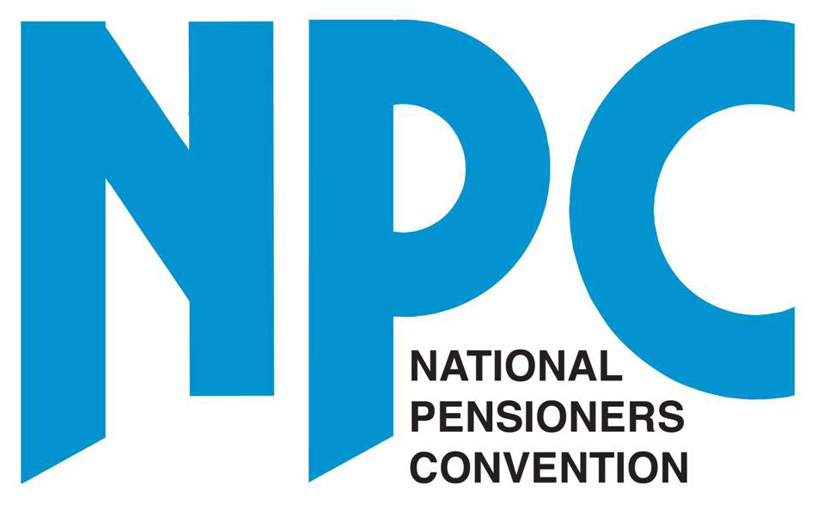
NPC Budget Briefing
March 2011

On 23 March 2011, the Chancellor George Osborne presented his first full Budget. The main announcements affecting older people, including some which had already been made previously, were as follows:

- From April 2011, the Basic State Pension (BSP) will rise in line with the Retail Price Index (RPI) figure for September 2010 of 4.5%, giving a rise from £97.65 to £102.15 per week for a single pensioner and from £156.15 to £163.35 for a couple. From next April the basic state pension will be linked to the higher of earnings, the Consumer Price Index (CPI) or 2.5%. The State Second Pension, SERPS and/or Graduated Pension were linked to the CPI from this April. All benefits, tax credits and public sector pensions will also be uprated by the CPI rather than the RPI.

- From April 2011, the means-tested Pension Credit Guarantee for a single pensioner will rise from £132.60 to £137.35 per week and from £202.40 to £209.70 per week for a couple. The capital disregard will remain at £10,000. The Saving Credit threshold will rise from £98.40 to £103.15 for a single pensioner and from £157.25 to £164.55 for a couple.

- The Government will issue a Green Paper in the Easter to introduce a flat–rate state pension of around £140 a week based on contributions that would potentially abolish means-testing and second state pension provision. This would be introduced around 2016, but would not apply to existing pensioners.

- Personal Tax Allowances have risen as follows:
Up to 65 - £6475 rises to £7475
65-74 - £9490 rises to £9940
75 + - £9640 rises to £10,090
The age related earnings limit has increased from £22,900 to £24,000 and the married couples allowance applicable to those born before April 6 1935 goes from £6965 to £7295. The allowance will be subject to an income limit of £24,000 but there will be minimum allowance of £2,800.

- The Winter Fuel Allowance will be cut from 2011 by £100 to £300 for households over 80 and by £50 to £200 for households under 80.

- From April 2011, Housing Benefit will be capped at £400 a week for a four bedroom house, £340 for a three bedroom, £290 for a two bedroom and £250 for a one bedroom property.

- Further grants have been made available to local authorities and this may mean a freeze in council tax until 2015. More details to follow.

- The state pension retirement age for men and women will be raised to 66 by 2020. This is estimated to save £2.5bn every year in extra contributions and fewer pension payments. The Government will also issue a consultation document in the next few weeks aimed at finding an automatic mechanism for raising the state retirement age in line with estimates of life expectancy. More details to follow.

- From April 2011, National Insurance (NI) contributions will be paid by employees at 12% on earnings between £139 and £817 per week and at 2% on all earnings over £817 per week. The Government will also issue a consultation documents shortly on merging NI with income tax, but have suggested that pensioners would be exempted from the change. More details to follow.

NPC Response
After the announcement, the NPC gave a reaction to the proposals. This is reproduced below for information. Media coverage of our comments included statements in the Daily Mail, Daily Telegraph (twice), Daily Mirror (twice), The Guardian and a number of other regional papers and websites.

The Budget raises a number of serious concerns:
  - The plans to introduce a flat-rate state pension for future pensioners will not only create a two-tier pension system, but also could potentially leave future pensioners with less state income than today’s retirees if they also lose their second state pensions and other benefits. We will continue campaigning for a basic state pension paid to all, regardless of contributions, set above the official poverty level now estimated to be £178 a week before housing costs.
  - The proposal to raise the state retirement age in line with longevity fails to recognise that all parts of society do not age in the same way. All the evidence shows that life expectancy and income are closely linked – and the poorer you are, the shorter your life will be.
  - The proposal to merge National Insurance with income tax must not be seen as a way of undermining the funding of the state pension system, or of raising the taxes of around 5m tax paying pensioners.
  - The Chancellor’s decision to cut the winter fuel allowance is absolutely scandalous, particularly when he didn’t even mention it in his speech. We have already launched a petition (on our website) opposing the move and are calling on all MPs to sign Early Day Motion 481 which supports our campaign to protect the payment.
  - The decision to link pensions and benefits to the Consumer Price Index rather than the Retail Price Index was also confirmed. This is part of an ongoing campaign that we will continue to pursue.
Budget signals pension apartheid
Britain’s biggest pensioner organisation, the National Pensioners Conventions (NPC) has criticized the chancellor for proposing a 2-tier pension system that ignores the need of existing pensioners.
Dot Gibson, NPC General Secretary said: "Millions of older people are struggling with the rising costs of living and the chancellor has totally ignored their plight. Pensioners will be angry that the plan to raise the state pension to a £140 a week is only for future generations. This will leave existing pensioners with one of the worst pensions in Europe and a complicated means tested system."
Cut to winter fuel allowance breaks Coalition promise
and betrays older generation

Britain’s biggest older people's organisation, the National Pensioners Convention (NPC), has accused the Chancellor of betraying the country’s pensioners by cutting the winter fuel allowance, despite rising energy costs and winter deaths amongst the over 75s.

The NPC has also been angered by the way the cut was buried in the Budget papers and didn’t form part of the Chancellor’s statement.

Dot Gibson, NPC general secretary said: “It’s absolutely outrageous that George Osborne didn’t have the guts or common decency to make this announcement public in his speech yesterday, but instead chose to bury it in all the paperwork. It’s a shabby way to treat Britain’s older generation. If we really are all in this together, why is he going to take £100 off the winter fuel allowance for the oldest members of society at a time when fuel bills are rising and winter deaths amongst older people are a national scandal? He should be ashamed of his behaviour.”

“Up to 3m pensioner households are already spending more than 10% of their income on fuel bills, and are living in fuel poverty. What older people need now is more money – not less. They need to be reassured that when the cold weather comes they will not be financially punished for keeping warm in winter. We will be fighting this change all the way.”

The NPC has been warning of this cut for nearly a year, and already over 70 MPs have signed an Early Day Motion (481) opposing the move.

ENDS

