Government Briefing May 2010
National Pensioners Convention
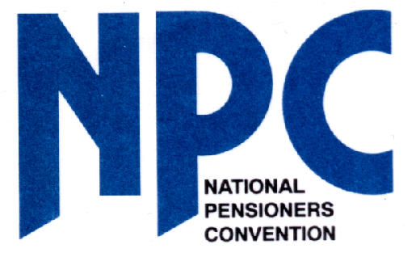

Older People and the Coalition’s Programme for Government
The new Conservative/Lib Dem Coalition has issued a Programme for Government, which includes a number of policies affecting older people. The NPC’s brief analysis of these proposals is also given in italics:
PENSIONS
- Restoration of the earnings link for the basic state pension from April 2011 with a "triple guarantee" that pensions are raised by the higher of earnings, prices or 2.5%.
If the increase next April is based on a 4% rise, the extra that pensioners will receive more than they would have got anyway under the old system will be just £1.45 a week. After 30 years of the state pension’s decline, substantially raising the state pension and then restoring the link would be a more effective way of tackling pensioner poverty.

- Establishment of an independent commission to review the long term affordability of public sector pensions, while protecting accrued rights.
Average local government, civil service and public sector pensions are less generous than are often portrayed. Further reducing these occupational pensions will inevitably strengthen the need for a better state pension.

- Phasing out the default retirement age.
Removing the default retirement age without also raising the state pension above the official poverty level will mean that many workers will not have any choice but to keep on working.

- Reviewing the date at which the state pension age starts to rise to 66, although it will not be sooner than 2016 for men and 2020 for women.
Raising the state pension age will have the greatest impact on the lowest paid and fails to take into account issues such as the rate of unemployment and availability of work, the rights of younger people to find a job, the quality of the jobs older people will be offered (and will be prepared to accept) and the loss to wider society if pensioner volunteers (currently undertaking unpaid caring and charitable work) were otherwise in paid employment.

- Ending the rules that make it compulsory to buy an annuity no later than 75.
For the relatively small number of pensioners with private personal pensions the current annuity rules are unfair and should be addressed.

- Encourage companies to offer high-quality pensions to all employees.
The current NEST scheme (National Employee Savings Trust) contains no guarantee that after making a lifetime of contributions, individuals will receive sufficient income to take them above the means-tested benefit level. On average, the NEST is likely to provide around £3000 a year in retirement.

TAXATION
- The first Budget will announce a substantial increase in the personal allowance from April 2011, with the benefits focused on those with lower and middle incomes. In time the personal tax allowance for all, including pensioners, will rise to £10,000.
The NPC is currently looking at the level of personal tax allowances, upper thresholds and transferability.

BENEFITS
- Protection of the winter fuel allowance, free TV licences for the over 75s, free bus travel and free eye sight tests and prescriptions.
It is vital that these benefits that have been secured after years of campaigning are retained and improved wherever possible. The Coalition’s programme makes no mention of the means-tested Pension Credit although we assume that this will also continue.

CARE
- Establish a commission on long-term care to report within a year.
- Extend the use of personal budgets.
- Help people to live at home for longer through home adaptations and community support programmes.
- Strengthen the role of the Care Quality Commission so that it becomes an effective quality inspectorate.
Social and long-term care in Britain has been in crisis for a number of years. Work has already been done by the previous government and others to lay out the basis for introducing a National Care Service which would provide free, non-means-tested care at the point of need. The setting up of another Commission simply delays the decision further and is unnecessary. In addition, the use of personal budgets raises serious concerns for many older people and should not become the only way to access care services. Issues of quality and standards are vital and a strong inspectorate is an essential part of that, but that will mean significantly increasing the number of inspectors. There is no offer of additional help for carers.

COUNCIL TAX
- Council will be frozen for at least one year, and consider freezing it for a further year where possible. There will also be a review of local government finance.
Council tax remains one the biggest outgoings for many pensioners and it has failed to deliver the good quality services on which they rely. The previous government also set up a review into local government finance which was never implemented. Council tax remains a regressive tax that should be replaced by national income tax and the review should consider this as a serious option for reform.

FUEL
- Post Office Card account holders will have the chance to benefit from direct debit discounts on utility bills.
- Social tariffs on energy bills should offer the best prices available.
Fuel poverty amongst pensioners was never properly addressed by the previous government, and last year over 36,000 older people died from cold related illnesses. Social tariffs will only work if there is one single industry-wide price that is the lowest available and offered to all vulnerable customers. The winter fuel payment should also be increased to £500 for every pensioner household.

POST OFFICE
- Consider the case for creating a Post Office bank.
The NPC is part of the Post Bank coalition and will be campaigning to see a People’s Bank introduced at the Post Office, as a way of tackling social exclusion and maintaining the Post Office network.

CAMPAIGNING
- Any petition that secures 100,000 signatures will be eligible for formal debate in Parliament. The petition with the most signatures will enable the public to table a bill eligible to be voted on in Parliament.
The NPC will be considering if it can launch a suitable petition and gain sufficient public support to have it debated in Parliament.

