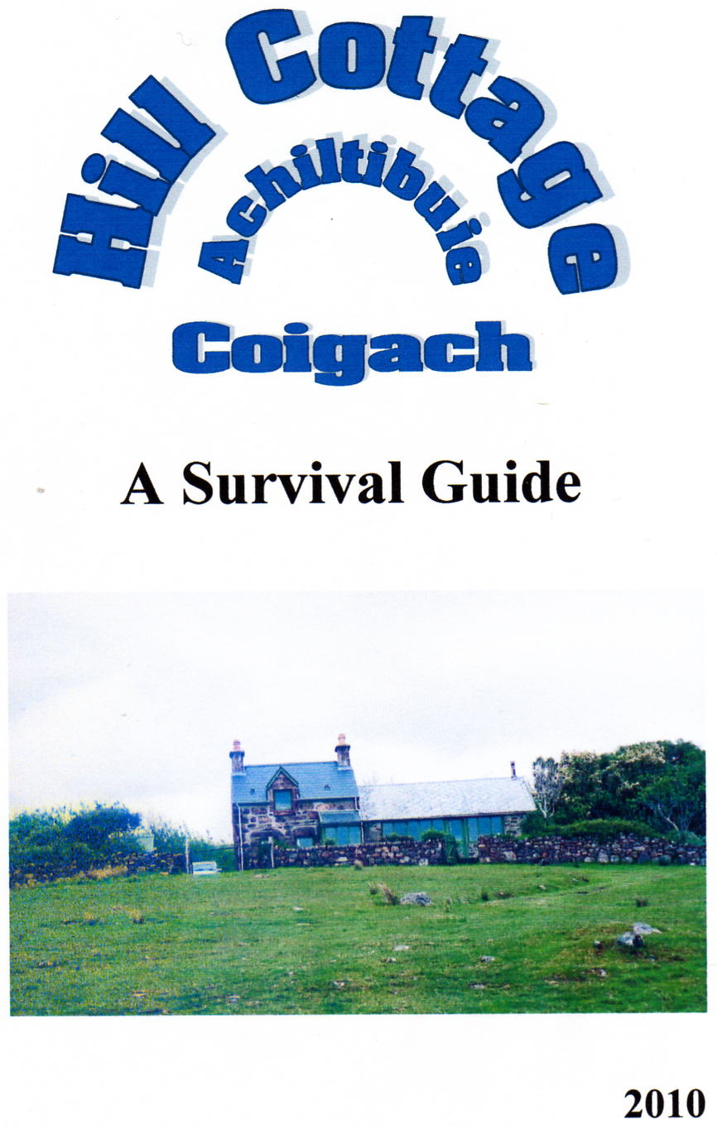
Address

Hill Cottage
121 Polglass
Achiltibuie
Ullapool
Highland
IV26 2YH

Telephone

01854 622431

Location

First house on the left beyond the school

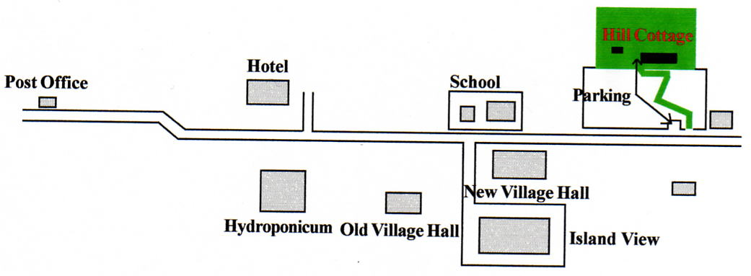

On Arrival

The road to the house is a grass track and negotiable only with a 4WD if the ground is reallywet. In dry weather, however, it is possible to drive up the hill and through the gate into the property. (See "Important" notice at the back of this guide) Electricity and Water -- see under these headings.

Gates

Please keep all gates shut. Sheep from a mile away seem to know one has been left open.

Septic Tank

Remember that it's not like home; waste matter does not automatically disappear to the sea. It lingers on for a long time approximately 50 feet from the house. In order that the organisms that break down the solids can survive, the septic tank must be kept free from such items as bleach, biological washing powder, disinfectant.

Water

The water is usually turned off at the stopcock under the sink. On a few occasions during the winter it may also be turned off at the main stopcock on the hill in front of the house (see diagram below). A key ( on the back wall of the workshop) is required to carry out this task. It's a bit fiddly because there's nearly always water in the hole and the stopcock is not exactly in the centre, but towards 10 o'clock.
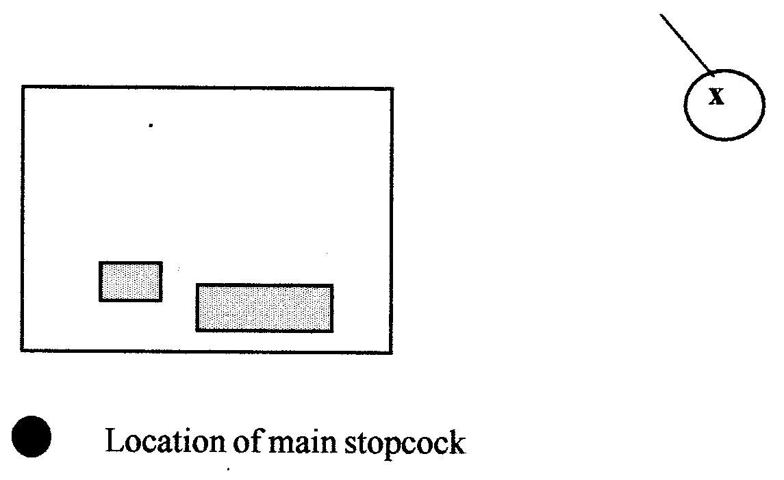

There is an outside tap at the back of the house (hose reel in workshop). It can be turned on by a wheel valve under the kitchen sink.

Sometimes, after heavy rain usually, the water will turn a peaty brown. This colouration is harmless. Ignore. Occasionally, if they've been working on the supply, the water will appear very frothy; don't worry it's just air in the system.

If the system has been drained, the taps in the kitchen area and toilet will have been left open. To prevent air-locks, keep these open when you turn on the water and only turn them off when the water is running freely.

Electricity

Turn on the electricity at the meter in the lobby. The circuit-breaker (main fuse) for the workshop is also located there. The immersion heater is in an obvious position at the bathroom door.
Power cuts are no longer a frequent occurrence, but do make sure that you know where torch and candles can be found.
In such an emergency, there is a gas double burner in the workshop for use with the small blue gas bottle (also in the workshop). Candles abound, and there is a
rechargeable torch in the lower bedroom.
Fires: there are three electric fires-- one blower, and two oil-filled radiators.
The cooker is fairly recent and appears to work quite well. The oven clock needs to be reset after the power has been switched off otherwise the oven doesn't work (instructions beside the telelphone). There's an electric toaster in the cupboard.

Beds

Please use your own bed linen.

Morsø Stove

The Morsø stove works as a very hot radiator; it is not an open fire. One firelighter, a few sticks (usually available in the workshop), and some coal and/or logs is all that is required to start the fire, though it's easier if the bottom door is kept open for a minute or two immediately after a match is applied. Fine adjustments to the burning process are made with the bottom control. When you go out, the fire will keep burning slowly if the bottom control is screwed tightly shut. The top control should always be kept open a few turns. More details about the fire can be found in the red folder in the bookcase. PLEASE DO NOT OVER-FIRE AND ON NO ACCOUNT LEAVE THE FIRE WITH THE BOTTOM DOOR OPEN FOR ANY LENGTH OF TIME.

Toilet

The electric fire in the toilet is very efficient and makes the bathroom the
warmest room in the house.

Rubbish

There is a green wheely-bin at the side of the house. On a Sunday evening or early on a Monday morning, it should be taken down to the roadside. It is collected any time from 9am onwards

Bank

The Royal Bank of Scotland Travelling Bank comes on Fridays before lunch time. It does not stop on demand; you can usually get it at the store, the post-office, or the School (about 10.00). Both stores accept credit cards.

Post

The post usually arrives about or after lunchtime. Any mail will be left in the box at the foot of the hill. Outgoing mail: 9.30am collection from Post Office.

Coal

Coal is delivered to the village every Wednesday around lunchtime. Most weeks the lorries have coal to spare, but they only deliver to the bottom of the road! A better bet, though a slightly more expensive one, is the 10KG bags of good quality coal available at Polbain or Achiltibuie Stores.

Doctor

The Ullapool doctor (612015) can be consulted in the Achiltibuie Village Hall on a Wednesday between 11.00 and 1.00. An appointment system operates. In an emergency, contact the District Nurse(s) on 622253.

Library

Wednesday in the Village Hall from 11.00 to 1.00 and from 6.00 to 8.00.

Spare Keys

These are held by Ken Lowndes (622361) and Margaret Starling (622336) both of whom can be contacted in a non-medical emergency

Leaving the House

Switch off electricty at the two consumer units in the lobby and the water at the stopcock under the sink. In the winter months(Dec. to Feb), unless someone is coming to the cottage that day or the next, it is better to drain the water, by shutting off the house stopcock and the one on the hill (see under "Water") and then opening all the taps in the kitchen area and the toilet (including the shower).

Please don't leave any perishable foodstuffs.

Fridge: leave empty with the door open
Kettle: leave empty with the top off.

Make sure that all doors are locked.

The Workshop

The workshop is a pleasant place to relax in and is usually quite warm. The electricity is switched on in the lobby (the RCD above the meter) and also at the
consumer unit in the workshop. In both cases UP is ON. The key for the workshop is with the house keys..

If there are any problems, ring us at home on 01592 741614 or ring Fraser on 01381600837.

Donald and Isobel

