Document Control Sheet
Project Title | BORDER RAILWAY TWEEDBANK DRIVE PEDESTRIAN IMPROVEMENTS
Report Title | TRAFFFIC CALMING PROPOSALS
Status | Final
Control Date | 11 MARCH 2011

Record of Issue
Issue | Status | Author | Date | Check | Date | Authorised | Date
01 | Draft | P Gilhooly | 07.03.11 | G Johnstone | 08.03.11 | G  Johnstone | 08.03.11
02 | Draft | P Gilhooly | 08.03.11 | G Johnstone | 08.03.11 | B  Young | 08.03.11

Distribution
Organisation | Contact | Electronic Copies | Hard Copies
Borders Railway Working Group | Andrew Mackie | 1 | 1

Contents
1 Background 2
1.1 Project Client 2
1.2 History of Project 2
1.3 Location of Scheme 2
2 Aims 4
3 Current Situation 5
3.1 Description of Scheme 5
4 Options 6
4.1 Suggested Options 6
5 Recommendations 7
6 Appendices 8

Background

Project Client
Transport Scotland approached Scottish Borders Council to conduct an audit of Tweedbank Drive in Galashiels and propose road safety improvements in anticipation of the Borders Rail Project.

History of Project
With the proposed re-introduction of rail services to the Scottish Borders, there have been concerns raised by the local community in Tweedbank regarding the potential impact that the terminating station in the village may have on vehicle volumes and traffic speeds on Tweedbank Drive, which is the main distributor route through the settlement.
In October 2010, an officer from Scottish Borders Council met with the chair of Tweedbank Community Council to discuss the road safety concerns raised by residents. In addition, discussions were also held with local councillor and Council Leader David Parker.
In February 2011 the same officer met with Tweedbank Community Council to discuss traffic survey data and various traffic calming options that could be available to the local community.

Location of Scheme
The settlement of Tweedbank lies to the east of Galashiels, just off the A6091 trunk route. The main vehicular distributor route through Tweedbank is Tweedbank Drive which can be accessed off the A6091, by either the Tweedbank roundabout or the Melrose roundabout. A location plan has been provided in Figure 1.1.
The intention is for the railway station to be located on the north side of Tweedbank Drive, with a final location yet to be finalised.
Figure 1.1 Location Plan of Tweedbank

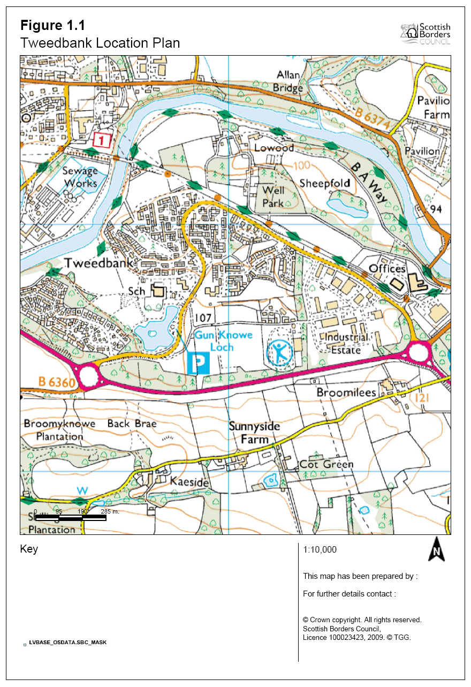

Aims
The aims of the study were to determine the:
- Existing traffic volumes and vehicular speeds;
- Existing and future pedestrian crossing points;
- Concerns of Tweedbank Community Council; and
- Potential road safety/traffic calming measures to mitigate concerns.

Current Situation

Description of Scheme
The existing traffic flows and speeds on Tweedbank Drive were assessed at three key locations where pedestrians are known to cross at present and where it is anticipated that they will cross in the future based on the railway platform being located to the north of Tweedbank Drive. The traffic survey data is provided in Appendix A
From the traffic survey data recorded in November 2010, it is apparent there are a number of vehicles driving in excess of 30mph on Tweedbank Drive, but that the average speeds at the three locations are less than 30mph.
There has been one reported injury accident in the last 5 years on Tweedbank Drive.
Although 15% of vehicles were recorded travelling at more than 32mph, which is obviously a concern, the average speeds demonstrate that the perceived speeding issue is, thankfully not as significant as originally thought.
The existing infrastructure on Tweedbank Drive including details of traffic islands, electronic signs, bus stops, etc has been provided in Appendix B. The village of Tweedbank has its school, shop, restaurant and loch on the west side of the Drive and pedestrians can cross using a series of strategically placed traffic islands as well as an underpass. In 2008 electronic signs were installed as part of the Safer Routes to School project to remind drivers to slow down, especially at the school run times.

Options

Suggested Options
A number of possible options were suggested to the Community Council. These options were as follows:
- DO NOTHING;

- BASELINE OPTION 1 - Puffin crossing to station, bus lay-bys and twin shelters on either side of the road;

- OPTION 2 - Baseline + Double yellow lines on Tweedbank Drive;

- OPTION 3a - Baseline + three sets of speed cushions set at strategically positioned locations;

- OPTION 3b - Baseline + twelve sets of speed cushions set at strategically positioned locations;

- OPTION 4 - Tweedbank Drive stopped up, bus turn round and single shelter, along with double yellow lines on Tweedbank Drive.

An option appraisal is available in Appendix C.

Recommendations
From the very positive and constructive meeting in February 2011 it was apparent that the Community Council has concerns over inappropriate speed and the likely increases in traffic once the railway opens. The Community Council were also realistic in the need to balance the potential increase in vehicles with the daily needs of the Tweedbank residents, with particular attention to be paid to the busier pedestrian area, which is near the school, shop and loch.
After much discussion of the various options the group generally agreed on Option 3a with an absolute bare minimum number of speed cushions that would be required to actively discourage drivers from using the Tweedbank roundabout to approach the new railway station, coupled with positive signing on the A6105 to direct all traffic to the Melrose roundabout for railway station access. Appendix B shows Tweedbank Drive’s existing infrastructure and locations of 3 no. sets of proposed speed cushions, proposed puffing crossing and bus stop locations.
As Tweedbank Drive is a bus route the proposed speed cushions would number 3 at each site evenly spaced across the carriageway with dimensions of 1600mm wide, 2000mm in length with a 50mm upstand/domed top.
A Puffin Crossing on Tweedbank Drive to suit rail users was agreed as being vital not only for pedestrians, but also to remind drivers of the residential environment and the need to drive with caution.
The group discounted option 5 of stopping up Tweedbank Drive between industrial estate and Craw Wood junction (buses to turn at Craw Wood Drive bellmouth/turning head) as they felt the increase in traffic would not justify such a measure.
Consideration was given to a double yellow line series on Tweedbank Drive but placed on hold until after rail construction.

Appendix A

Traffic Survey Data
Locations: Dates: 2010
Industrial Estate (east of Craw Wood) Tues 2 November to Thu 8 November
Underpass Mon 25 October to Thu 04 November
Weavers Linn Thu 4 November to Tue 9 November

24/7 results
Location | Average Daily Vehicle Count | Average Speed (mph) | 85%ile Speed (mph)
Industrial Estate | 1765 | 26 | 32
Underpass | 2584 | 27 | 32
Weavers Linn | 3509 | 26 | 30

Results between 06:30 and 18:30
Location | Average Daily Vehicle Count | Average Speed (mph) | 85%ile Speed (mph)
Industrial Estate | 1799* | 26 | 32
Underpass | 2006 | 27 | 32
Weavers Linn | 2819 | 26 | 29

* Data only available over fewer days.

Appendix B

Tweedbank Drive: Existing infrastructure with Option 3a

Appendix C

Option Appraisal

