-
St. John’s CE Primary School – Relationship and Sex Education
Pray, Play and Prosper with God at our side
Encourage one another and build each other up.
1 Thessalonians 5:11



Date of Policy: September 2025
Date the Policy was approved by Governors: September 2025
Date for next review: September 2026

Definition of RSE:
RSE is learning accurate and age-appropriate skills, attitudes and knowledge about the body, reproduction, sex and sexual health. RSE also gives children and young people essential skills for building positive, enjoyable, respectful and non-exploitative relationships and staying safe both on and offline. Some aspects are taught in science, and others are taught as part of Personal, Social, Health and Economic Education (PSHE).

Aims and Outcomes of RSE in the curriculum:
The overall aim of RSE is to foster a positive notion of lifelong learning about physical, moral and emotional development, including how to look after physical and mental health. It aims to support the development of self-respect and empathy for others and promotes the development of skills and understanding necessary to manage conflict peacefully and learn how to recognise and avoid exploitation and abuse.

RSE provides opportunities for pupils to:
- better understand the nature of human relationships
- learn about relationships, the importance of communication and assertiveness skills including the importance of values such as respect (for self and others), equality, responsibility, care and compassion
- reflect upon the importance of stable and loving relationships for family life, including the bringing up of children, this also includes marriage and civil partnerships
- consider and understand the changes that occur to their bodies, minds and emotions as a consequence of growth from childhood to adulthood
- reflect upon how to make good, informed and safe choices concerning relationships and healthy lifestyles.

Morals, Values, Equalities and Safeguarding
The RSE programme at St John’s demonstrates and promotes the following:
- Learn the value of respect, care and love
- Valuing family life within stable, loving and committed relationships
- Acceptance of same sex unions as also offering stable, loving and committed relationships to nurture children
- Respect for self and others
- Respect for rights and responsibilities within relationships
- Appreciate that different, successful family structures exist
- Understanding diversity regarding religion, gender, culture and sexual orientation
- Importance of striving to reduce intolerance and discrimination based on sexual orientation, disability, ethnicity, religion and gender.
- Acceptance of difference and diversity
- Promote gender equality and equality in relationships
- Challenge gender stereotypes and inequality
- Develop spiritual, moral, social and cultural awareness in line with the 2010 Equality Act and the schools’ safeguarding and child protection protocols.

Content of the RSE Curriculum
St. John’s has adopted the Twinkl scheme of work for RSE and PSHE
Appendices to this policy provide further information about the learning outcomes and vocabulary for each year group.

How Relationships and Sex Education is organised in the curriculum.
RSE is delivered in conjunction with PSHE. The following units of work are specifically linked to RSE
- Be Yourself
- Safety First
- VIPs
- It’s My Body
- Digital Wellbeing
- Growing Up

- RSE is normally delivered by class teachers in mixed gender groups other than when it is deemed more appropriate for topics to be covered in single sex groups.
- Ground Rules are used in all PSHE and RSE lessons (ie be respectful, listen to others)
- Pupils are able to ask anonymous questions by writing a note for the class worry box.
- Resources used are flexible in order to meet the needs of the pupils and curriculum. A selection of these can be viewed during the parent session.
- Correct medical vocabulary will be used throughout the RSE and PSHE curriculum
- RSE is delivered through a varied range of activities, which promote dialogue and understanding. These include: Circle time, active teaching and learning, role play/scenarios, card sorting and discussions.
- External agencies can be invited to support the delivery of RSE. These include: the school nurse and the police.
- External agencies and visitors are familiar with and understand the school’s RSE policy and safeguarding policy and work within these documents
- All input to RSE lessons is part of a planned programme and negotiated and agreed with staff in advance
- All visitors are supervised/supported by a member of staff at all times
- The input of visitors is monitored and evaluated by staff. This evaluation informs future planning.

Parental involvement
St. John’s is committed to working with parents and believes that it is important to have the support of parents and the wider community for the RSE curriculum. Parents are provided with the opportunity to find out about and discuss the school’s programme through the Parent Forum, parents’ evening, in policy development and the school website.

Parental rights to withdraw their children
The Children and Social Work Act 2017 states that pupils receiving a primary education must be taught Relationships Education and Health Education. This is a statutory requirement from September 2020.

Relationship and Sex Education at St. John’s will be taught to fulfil the requirements of the Science Curriculum and will focus on:
- Physical, social and emotional changes which take place during puberty
- menstruation
- names and functions of sexual organs

Parents have the right to withdraw their children from all, or part of the Sex Education curriculum, except for those parts included within the National Curriculum for Science, which are statutory. (Please see Appendix 3)

The schools’ approach to RSE, including the parental right to withdraw their child, are communicated to parents.

Parents are also informed that the RSE curriculum is an essential vehicle in supporting a school’s statutory duty to:
- safeguard and promote the welfare of their children,
- advance the 2010 Equality Act,
- encourage the spiritual, moral, social and cultural development of pupils, foster British values,
- prepare children and young people for the challenges, opportunities and responsibilities of adult life, along with the coverage of the National Curriculum for Science.

Those parents/carers wishing to exercise the right to withdraw their child from Sex Education are invited in to see the teacher and/or RSE Co-ordinator who will explore any concerns and discuss any impact that withdrawal may have on the child. Once a child has been withdrawn they cannot take part in the RSE programme until the request for withdrawal has been removed. It is then the responsibility of the parents/carers to deliver the content of the RSE to their child as they see fit. Information and support materials are available for parents/carers to use and are offered by the staff. Pupils who are withdrawn from RSE continue with individual learning tasks for other curriculum areas, which are carried out in another classroom or the library.

If a conversation arises about sexual health issues in a non-RSE lesson with pupils present who have been withdrawn from RSE lessons, the teacher must stop the conversation and ask that the issues be discussed at an appropriate time. The teacher must, as soon as possible, find an appropriate time to continue the conversation with pupils when the withdrawn child is not present.

How the school responds to specific issues related to Relationships and Sex Education
Answering Difficult Questions
Staff are aware that views around RSE related issues are varied. However, while personal views are respected, all RSE issues are taught without bias. Topics are presented using a variety of views and beliefs so that pupils are able to form their own, informed opinions but also respect others who may have a different opinion. Both formal and informal RSE arising from pupils’ questions are answered according to the age and maturity of the pupil(s) concerned and the limits of the year group topics. The school believes that individual teachers must use their skill and discretion in this area and refer to the Designated Safeguarding Lead if they are concerned or believe any pupil to be at risk.

Ground Rules
RSE is taught in a safe, non-judgmental environment where adults and children are confident that they will be respected. Specific ground rules will be established at the beginning of the RSE work, in addition to those already used in the classroom.

Inclusion.
The RSE policy reflects and is line with the school’s Equal Opportunities Policy and the school ensures that the RSE teaching programme is an inclusive one and is appropriate and relevant to all pupils, including those with SEN and disabilities. Teachers ensure that the content, approach and use of inclusive language reflect the diversity of the school community, and help all pupils feel valued and included, regardless of their gender, ability, disability, experiences and family background. RSE strives to meet the needs of all pupils regardless of their developing sexuality and deals honestly and sensitively with sexual orientation, answers appropriate questions and offer support. Homophobic and transphobic references and homophobic and transphobic actions and bullying are not tolerated at St. John’s and are challenged and dealt with as part of our commitment to promoting inclusion, gender equality and preventing bullying.

Confidentiality and Child Protection Issues
As a general rule a child’s confidentiality is maintained by the teacher or member of staff concerned. RSE discussions may prompt a pupil to disclose related incidents; for example, FGM, Forced marriage, child exploitation or abuse. If the member of staff believes that the child is at risk or in danger or has concerns about any information disclosed, she/he talks to the named Designated Safeguarding Lead/Deputy Designated Safeguarding Lead who takes action as laid down in the Child Protection Policy. All staff are familiar with the policy and know the identity of the members of staff with responsibility for Child Protection issues.
The child concerned will be informed that confidentiality is being breached and reasons why. The child will be supported by staff throughout the process.

How the Relationships and Sex Education Programme is Monitored, Evaluated and Assessed
We ensure that all pupils have equal access to the RSE programme through a thorough process of monitoring, evaluation and assessment, which takes into consideration pupils’ needs, maturity, age, ability and personal circumstances.

Class teachers assess pupils’ understanding and progress through formative and summative processes. These may include pre- and post-topic mind maps, drawings, task outcomes, questioning and observation. At the end of the year each, staff review the RSE programme they have implemented and pass on any comments to the RSE leader as part of her monitoring cycle. A random selection of pupils are interviewed and all parents are invited to provide written feedback on the provision of RSE. The RSE policy is reviewed on an annual basis taking into account the feedback from teaching staff, pupils and parents. Governors consider evaluations and recommendations before amending the policy. Governors remain ultimately responsible for the policy.

Professional Development for Staff
Staff are kept informed of developments in key aspects of RSE, including links with safeguarding, inclusion, equality, child protection and antibullying, through regular training provided at staff meetings and INSET days.

Links to other policies and advice
- This RSE Policy is supported by, but not limited to:
- PSHE Policy Behaviour Policy
- Health and Safety Policy
- Safeguarding/Child Protection Policy
- School Visits
- Confidentiality Policy
- Equality Policy
- Anti-bullying Policy
- Relationship and Sex Education Guidance – DfE

Appendix 1
Science National Curriculum

Year 1
- identify, name, draw and label the basic parts of the human body and say which part of the body is associated with each sense

Year 2
- notice that animals, including humans, have offspring which grow into adults

Year 5
- describe the changes as humans develop to old age. (Pupils could work scientifically by researching the gestation periods of other animals and comparing them with humans; by finding out and recording the length and mass of a baby as it grows.)

Appendix 2
Content of RSE Curriculum

Health and Wellbeing

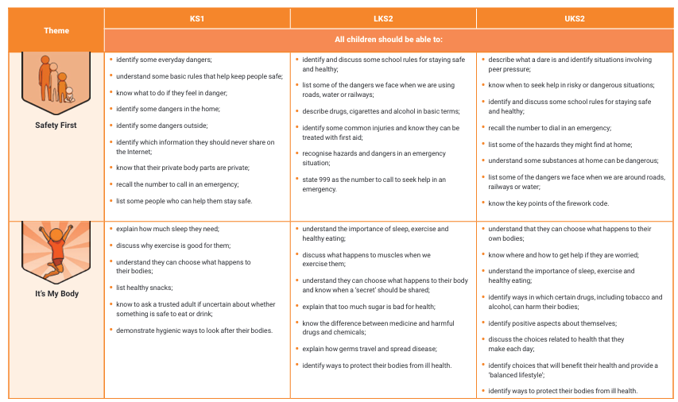

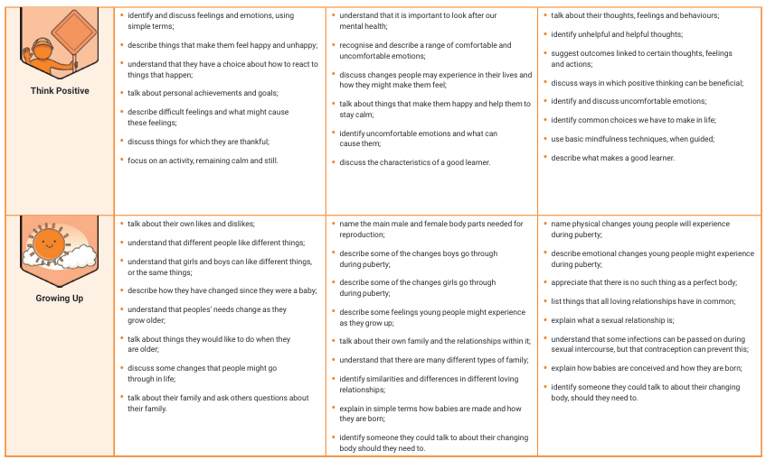

Relationships

