Design & Technology Product Design - 3D Design

- Undertake a ‘Product Disassembly’ of a product of your choice.
- Use ‘ACCESS FM’ to fully explore the product and remember that this is to be based on exploration and investigation (facts). Include pictures of the product at each stage of disassembly.
- Through research attempt to identify specific manufacturing methods and materials used in every aspect of the product.
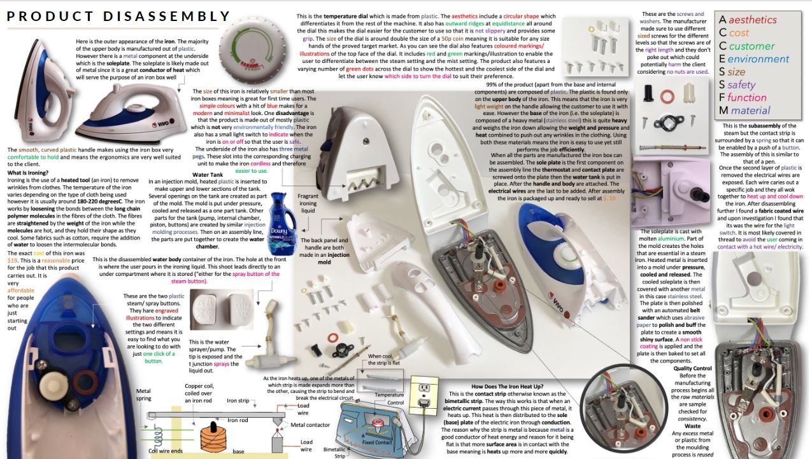
- Produce 1 A3 Powerpoint slide to evidence your disassembly, using the examples below as a guide to the quality of work anticipated.
