
A Level Politics Bridging Work 2026

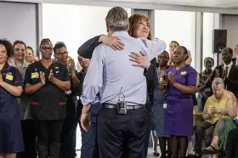



You are required to complete ALL of the activities in this transition pack for submission in the first week of the new academic year. The A Level in Politics is a fun, embracing yet challenging qualification. It will develop your thinking skills and vastly expand your knowledge of politics both in the UK and in the wider world. There will be ten taught hours per fortnight. It is then expected that students do approximately seven hours per week of independent study at home and during their study periods in weeks A and B.
People, Politics and Participation

Politics in the UK
This is a detailed assignment that you have been given. Do not rush it. We advise that you complete different parts of the transition pack at different points in the Summer holiday, rather than leaving it all until the final week of your break. You should expect to spend longer on these tasks than any homework you have completed before. A Level Politics may be a significant step up from the work you have completed previously in Year 11.
Task 1 – People in Politics

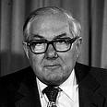
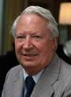
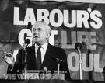

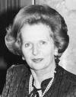
Look at the below photographs of British politicians. You must identify who they are, which party they belonged to and whether or not they were Prime Minister (PM) or Leader of Her Majesty’s Opposition (HMO). Get your family involved in this task – your parents will remember many of these faces, and some of them might be better suited even to your grandparents!

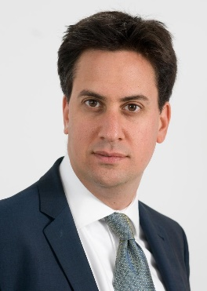
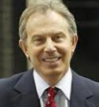
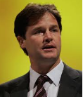
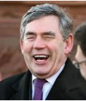
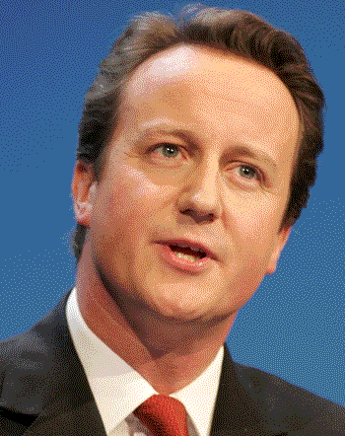


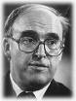
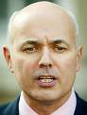

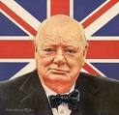


Task 2 – News and Elections
Politics is a subject which cannot be unplugged from news and current affairs. TwitterX is seen by some to be the future of Politics – it is used by journalists, politicians and politicos alike to share news and information as well as discuss political issues. I would advise that you create yourselves Twitter accounts as soon as possible and follow the below users for Political information and news:
@Britainelects (for news and updates on all things electoral in the UK)
@BBCNews / @SkyNews (or any other news station of your choice – or even more than one!)

Podcasts – The Rest is Politics
Rock n Roll Politics

Your next task is to keep an eye on Political X Twitter accounts (as well as wider sources – the news and politics podcast shows on TV, newspapers and others) over the summer holidays and make a note of any particularly interesting news that is relevant to Politics in the UK. You may even find some stories which are interesting internationally, particularly if you choose to follow some controversial commentators on X Twitter !!
Task 3 Title : The UK today
Design a short Powerpoint or an A4 Word document
1 In four points summarise the key problems facing the UK’s schools today
2 Why is the Metropolitan Police force in special measures ?
3 What three reforms do you think would improve the environment in the UK today ?

If you have any further questions while you are enjoying your Summer holiday, my email address can be seen below J
Mrs Sharpe
Head of Politics Room G4A
JULY 2026.
csp@herschel.slough.sch.uk

