Bridging Work - Summer 2026:

MATHS

Exam Board: Edexcel Specification: 9MA0

The following questions will help prepare you for Maths in Year 12. They are all topics that you have studied at GCSE and will come across again next academic year.

Please bring your solutions to your first Maths lesson in Year 12.

Your solutions should be clearly and logically communicated making correct use of mathematical symbols and notation.

Good mathematics is not about ‘answers’ it is about well-crafted solutions that show a logical chain of reasoning from the information given in the question through to the final answer.

Once you complete these, it would be helpful to find similar questions to practice.

You will need to get this calculator. The school will order some of these in September for you to purchase. Beware buying your own as there are counterfeit versions being sold that do not work.
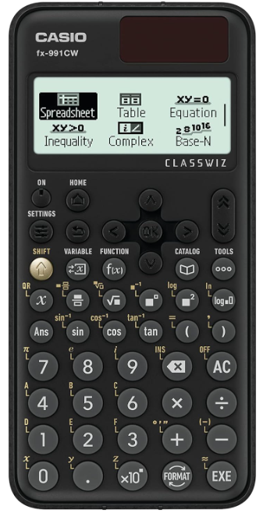

Topic 1: Algebra and Functions
- Evaluate ${\left(\frac{8}{27}\right)}^{\frac{2}{3}}$

2) Rationalise $\frac{\sqrt{12}}{\sqrt{156}}$

- $\frac{1+ \sqrt{2}}{{(3-\sqrt{2})}^{2}}$ can be written in the form $a+b\sqrt{2}$. Find the value of $a$and $b$

3) The function f is defined as $f\left(x\right)= \frac{1}{2}x+4$

- Work out f(6)

- Solve for x when f(x) =19

- Find f⁻¹(x)

4) Simplify fully $\frac{3-4x-4x^{2}}{2x^{2}-7x+3}$

Topic 2: Quadratic Functions

- Complete the square for the expression x² + 6x + 1

- Solve for x using the quadratic formula x² + 6x + 6=0

Topic 3: Equations and Inequalities

- Find the set of values of x for which 12 – 3x < 27

- Find the set of values of x for which x - 1 > 1- x and 15 - 3x > 5 +2x

- Find the set of values for which x² + 2x – 8 ≥ 0

Topic 4: Sketching Curves

- Sketch the curve with the equation y =(x - 2)(x + 3)
  - You should not attempt to plot the graph – this shows no understanding.
  - You should draw a neat sketch showing:
    - The general shape of the curve.
    - The coordinates of the intercepts with the x and y axes.
    - The coordinates of any turning points on the graph.

Topic 5: Coordinate Geometry

- A line is parallel to the line y= ½ x -5 and goes through the point (4,-4). Write down the equation of the line.

- Work out the gradient of the line 4x + 2y – 9 = 0

- Work out the equation of the coordinate bisector of the points (3 , 6) and (7 , 8).

Topic 6: Sequences and Series
- The $n$th term of a sequence is given by $U_{n}=\frac{n^{2}}{(n+1)}$ work out the first three terms

- Find the value for $n$ for which $U_{n}$ = $5n-2$ and $U_{n}=153$

Topic 7: Trigonometry
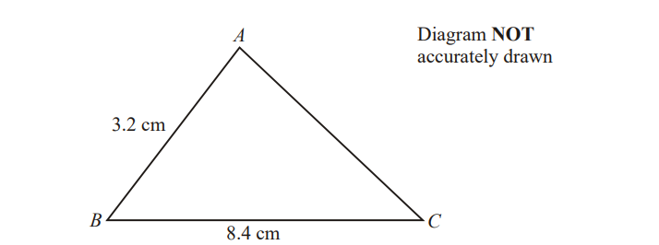

AB = 3.2 cm BC = 8.4 cm
The area of Triangle ABC is 10cm²
Calculate the perimeter of triangle ABC, giving your answer correct to 3 significant figure

If you have any queries, please contact:

Mrs S Ruddy, Head of Maths
sru@hershel.slough.sch.uk

