Bridging Work - Summer 2026:
MEDIA STUDIES

Exam Board: OCR Specification: H409

- Long Form Television Drama (LFTVD)

Pick an LFTVD of your choosing and consider the social, cultural and political implications that are
i) represented in the narrative
ii) developed from the show
iii) intertextualised in other forms of media

You will be presenting your findings to the class, the first lesson back in September. You may use a PPT for support, however there should be no more than a few sentences on a slide – reading from a slide does not count as presenting. You can embed clips to aid your analysis.

- Newspapers

Look at the following sources and answer the extended question. You should type approximately half-three quarters of a page (300-400words).
Have it printed and ready to submit first lesson back in September.
Source A and Source B cover the same news event from two different newspapers, one tabloid and the broadsheet.
Explore how the sources present viewpoints of the main story.
In your answer you must:
• explain how newspapers, through representation, construct viewpoints and ideologies
• analyse the representations in the sources
• make judgements and reach conclusions about how far the sources viewpoints.

If you have any queries, please contact:

Mrs J Jandu, Head of Media Studies
jja@herschel.slough.sch.uk

Source A – The SUN
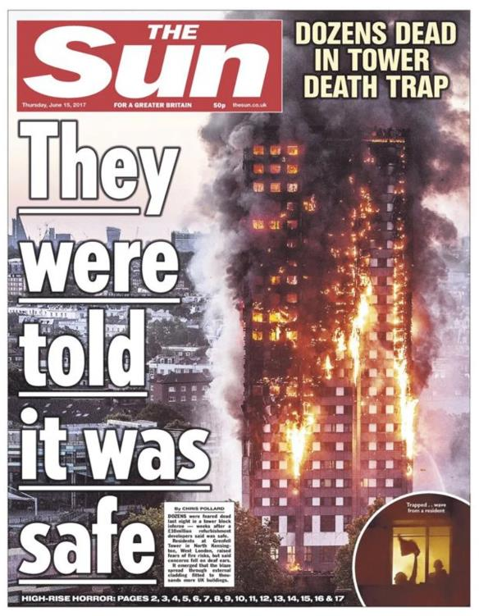
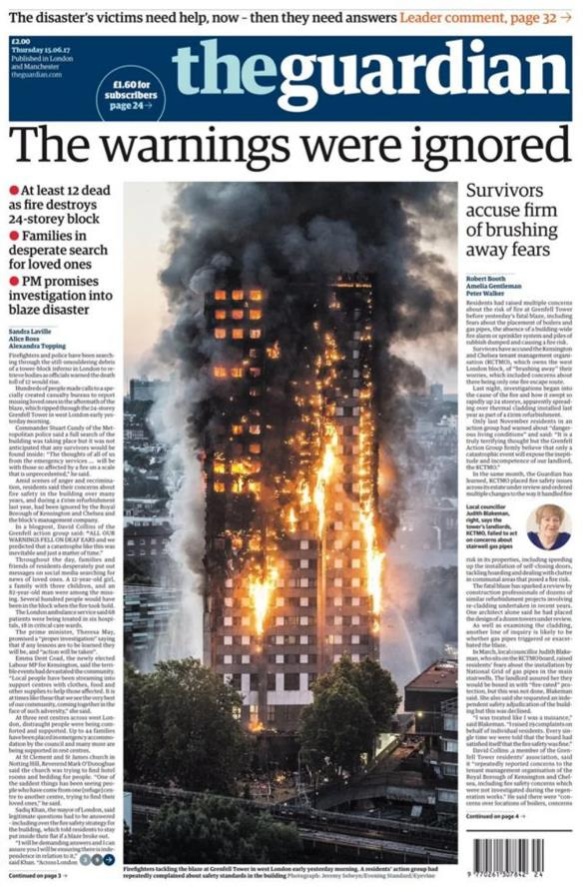
Source B – The GUARDIAN

