
Eco- Schools Newsletter (October 2023)

We are delighted to announce that we have been awarded a Green Flag with distinction from the work carried out by The Eco-Committee over the years particularly last year!
The Eco-Schools Green Flag is an international accreditation that recognises efforts to raise environmental awareness amongst young people, whilst taking action to make their school more sustainable.
We have been committed in finding strategies to lower our carbon footprint with the aim to reach net zero by 2030.
By March we had saved 403 Kg of CO₂ with 4 campaigns: House clean up and recycling, Switch off Fortnight, Preloved Christmas jumper fair and Veggie Challenge.
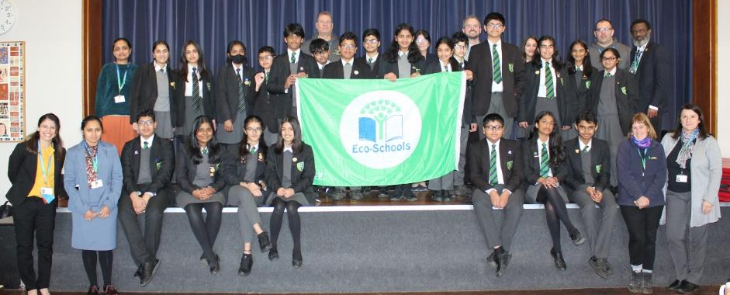In addition we have run other campaigns, improved school grounds and changed our electricity and gas provider, all reducing our carbon further:
- Aloe Vera’s in forms – introduced last September, and looked after by form over the last academic year. By this September, many have grown 3 or 4 extra baby plants
- Great Big school clean- Members of the Eco-Committee and duty staff collected and recycled 11 out of our target of 50 large bin bags worth of litter and raised £20 for WWF which is committed to safeguarding the natural world, tackle climate change and enabling people to use only their fair share of natural resources. 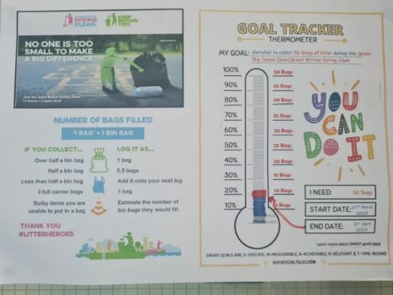
- Food garden by window sill- Most forms have successfully germinated and grown tomato plants ( using 1 single tomato), as well as courgette, pepper, cucumber, aubergine and melon plants by window sill in upcycled pots (milk cartoons, plastic trays). We had successful crops from tomatoes, courgettes and aubergines.
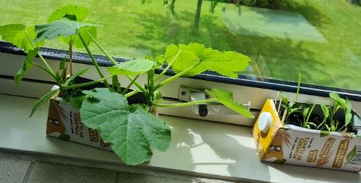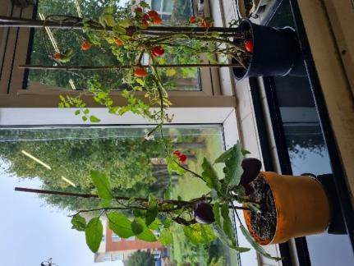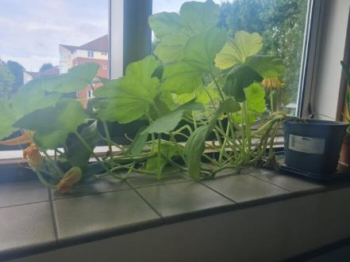
- Green wall- Outdoor green wall set up outside the 6form block.
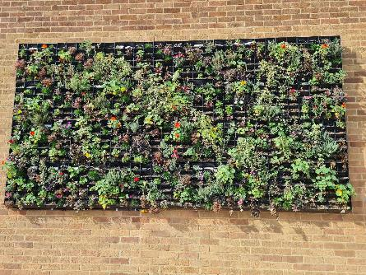
- More outdoor table tennis- 2 extra tables added by the astroturf.
- 100% renewable Energy - Electricity supplier 100% carbon neutral.
- Green gas - Gas supplier partly Biogas (carbon neutral), which means we reduced our use of natural gas significantly.
- TVLP Make a change event & Willow Sculpture workshop – after attending both TVLP events students got enthused about increasing Biodiversity further, by planning to grow an edible and sensory garden. With the help of the previous TVLP coordinator Clare Mathusan, we have been generously donated a pre-loved Compost Bin from Ms Jane Atherton, and £110 worth of items from Ms Laura Miller from Eton College, such as worms for our compost bin, a water butt, raspberry, strawberry, passionfruit and blueberry plants pear and apple trees, potatoes for winter cropping, fertilizer and a collection of seeds for students to grow next year by the window sill. Thank you so much for our generous sponsors! More details here: https://tvlp.org.uk/newsletters . Over the Summer we have also built a raised bed out of pallets for our first outdoor project! 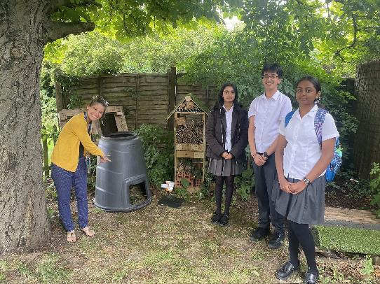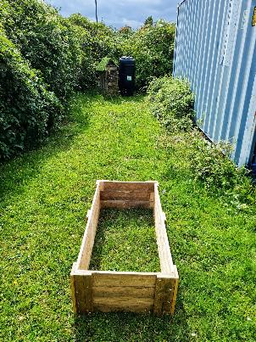

- Upcycled milk bottle Doves- made by year 7’s in activitivies week with the help of Mrs Smith, are definitely brightening up the fence by the field! 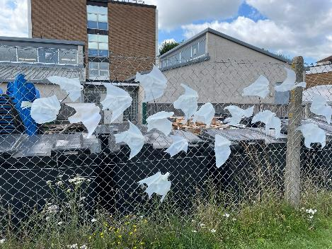
What next?
1.In November we will be launching the #Cut Your Carbon challenge. Pupils and their families will be encouraged to take 9 actions to reduce their carbon footprint using this visual checklist! We will also encourage all to download the Giki Zero app ( https://zero.giki.earth/ ) which helps you track and compare carbon savings and make more informed choices.
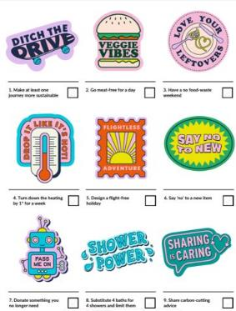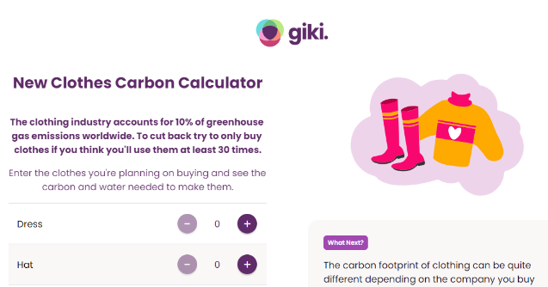
2.Competition – Best sensory garden design- Pupils will be given the template of the space available and criteria. The best designs will be used to finally construct our sensory garden. This aligns with the mental health week in October.
3. Pre-loved Christmas Jumpers- We are accepting and encouraging donations of any Christmas jumpers (laundered please) so these can be used in our Eco Christmas fair, as well as the reuse of jumpers during Christmas jumper day, as part of “Say No to new” #cut your carbon.

We hope you can join us in our commitment and care for the environment!
Best green wishes,
The Eco-Committee
Please Follow us on X: @HGS_EcoHerschel (https://twitter.com/HGS_EcoHerschel )

