Bridging Work - Summer 2026:

PHYSICS

The aim of this Bridging work is to ensure you have the knowledge and understanding required to start the A-Level in Physics. Physics requires a lot of Mathematics, which is why you can expect this to be present in this pack.
You must complete this pack before your first Physics Lesson, during which you will be checking your work for its correctness.

Course overview (Exam board OCR A)
You should:
- Make a hard copy of this pack.
- Complete the questions on the sheets. Should you need more space, you can add more sheets.
- Bring it with you, completed, to your first Physics lesson in September.

Best of luck for the course. We look forward to seeing you in September!

Table of Contents
Concepts 3
SI units 3
TASK 1 3
Prefixes 3
TASK 2 4
Vectors and Scalars 4
TASK 3 5
Rearranging formulae 6
TASK 4 6
Important Command words 7
TASK 5 7
Physics 8
Waves 8
Mechanics 10
Density 11
Electricity 12
Heat 13
Electromagnetism 14
Atomic Structure 15
Summer reading list……………………………………………………………………………………………………………………..16

Concepts

SI units
In science, the metric system is used for measurements. This enables easy conversion: no constants (other than whole powers of 10) are needed to convert between different units. For instance, to convert between inch and feet, we use the number 12 (12 inch to a foot). But to convert from feet to yard, it’s 3 (3 feet to a yard).
There are many different units of measurements for different quantities: the second (for time), the kilogram (for mass), the metre per second (for speed), the newton (for weight), etc. All of these can be reduced to 7 SI base units.

TASK 1
Complete the following table. Ensure you are clearly writing whether a letter is capitalised or not, and whether they are superscript (like powers), subscripted, or not.

Quantity | Abbreviation | Unit | Abbreviation
time | t | second | s
length |  |  | m
 |  | kilogram
temperature | θ |  | °C
absolute  temperature | T
 |  | ampere
force
work
energy
 |  |  | W
 |  | Ohm
 |  |  | Hz

Prefixes
To avoid writing too large numbers – or too large powers of ten – a set of prefixes exist. They signify a power of ten, and it is important you write clearly whether they are a capital or a lowercase letter. For example, M stands for mega, 10⁶. But m is milli, 10⁻³. Remember: mega or larger is capitalised. Everything smaller (kilo and lower) is lowercase.

TASK 2
Complete the following table. Ensure you are clearly writing whether a letter is capitalised or not, and whether they are superscript, subscripted, or not.

Prefix | Name | Power of ten
E
 |  | +6
K
 | peta
G
 |  | -1
Da
 | milli
 |  | +12
 | nano
F
 | micro
 |  | +2
 |  | -12
C

Vectors and Scalars
A vector is an object which has magnitude (size) and direction. Conversely, a scalar is an object which only has magnitude, no direction. Energy, mass and time are scalars. Force, weight and displacement are vectors.
As a general rule of thumb: if the magnitude of the sum of two objects is not equal to the sum of the magnitudes of the two objects, they are vectors. For example, if I walk three metres in a straight line, then make a right angle, and walk another 4 metres in a straight line, I will have walked 7 metres (3+4=7). However, the distance to my original point is only 5 metres (as I turned during the walking). The quantity which has magnitude of 5 metres is called displacement, and it is a vector.
In A-Level Physics, we will only consider vectors in two dimensions (x and y). To add vectors together, you separately add their x and y components together.

TASK 3
Use the diagram to add these vectors together:
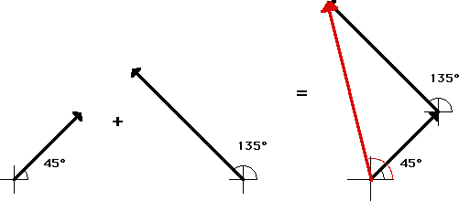

(The first vector is 3.0 m/s; the second vector is 5.0 m/s)
Show your working out here:
Answer:

Rearranging formulae
You need to be able to use any formula which is given to you – you get the majority of the formulae on the 5 page long formula sheet on every test. “use” in this context includes rearranging.

TASK 4
Complete the next table, to make the asked quantity the subject:

Formula | Subject | New formula
𝑽 = 𝑰𝑹 | 𝑅
𝒗^{𝟐} = 𝒖^{𝟐} + 𝟐𝒂𝒔 | 𝒖
𝒗 = 𝒇𝝀 | 𝒇
𝑽 = 𝑰𝑹 and 𝑷 = 𝑰𝑽 | 𝑷 in terms of 𝑰 and 𝑹
𝚫𝑬 = 𝒎𝒄𝚫𝜽 | 𝒄

Important Command words

TASK 5
Questions in the Physics exam are asked using very specific command words. You are required to understand these words very clearly. Below are a selection of the command words – link them with their correct meaning.

Command word |  | Meaning
Calculate |  | Give reasons to a statement, which follow logic.
State |  | Draw approximately. Whilst it should be a “best guess” drawing, you should normally not worry about being accurate.
Explain |  | Repeated measurements give answers close to each other.
Sketch |  | Present key points about different or opposing ideas, including their strengths or weaknesses.
Precision |  | Express in clear terms. No explanation is required.
Precise |  | To work out something. It is necessary to show how you obtain the answer, as well as use  correct rounding rules.
Accurate |  | The exam board gets it wrong – they really mean resolution. The lowest non-zero measurement one can make with a specific piece of equipment.
Discuss |  | Provide an answer from a number of alternatives.
Identify |  | Close to the true value. Whilst it is impossible to be certain of this, how close the points are to a line of best fit gives a good measurement of this.

Physics

Waves
On the wave, label:
- Wavelength
- Amplitude
- Trough
- Peak
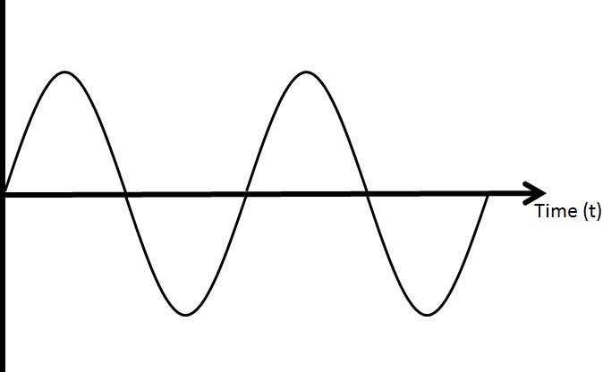

Write a short definition for:
Frequency: ........................................................................................................................................
...........................................................................................................................................................
Time period: .......................................................................................................................................
...........................................................................................................................................................
Amplitude: ........................................................................................................................................
...........................................................................................................................................................
Wavelength: ......................................................................................................................................
...........................................................................................................................................................

The diagram below shows a light ray entering a glass block. Complete the diagram, by drawing:
- the refracted ray
- the emerging ray
- label the angle of incidence
- label the angle of refraction
- draw the two normal lines.

Glass block
Air
Light ray

Mechanics
Write down the principle of moments:
............................................................................................................................................................
............................................................................................................................................................
............................................................................................................................................................
Write down the law of Conservation of Momentum:
............................................................................................................................................................
............................................................................................................................................................
............................................................................................................................................................
Write down the law of Conservation of Energy:
............................................................................................................................................................
............................................................................................................................................................
............................................................................................................................................................

Density
Challenge question: The weight of a stone is 3.139 N in air. When suspended in water, it only weighs 2.845 N. What is:
  - the mass of the stone?
  - the volume of the stone?
  - The density of the stone?
You may assume that water has a density of 1 g cm⁻³, and the Earth’s gravitational field strength is
9.81 N kg⁻¹.
............................................................................................................................................................
............................................................................................................................................................
............................................................................................................................................................
............................................................................................................................................................
............................................................................................................................................................
............................................................................................................................................................
............................................................................................................................................................
............................................................................................................................................................
............................................................................................................................................................
............................................................................................................................................................

Electricity
Calculate the current through, and the potential difference across every component in this circuit:

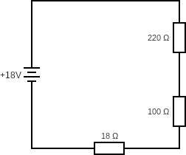

............................................................................................................................................................
............................................................................................................................................................
............................................................................................................................................................
............................................................................................................................................................
............................................................................................................................................................
............................................................................................................................................................
............................................................................................................................................................
............................................................................................................................................................
............................................................................................................................................................
............................................................................................................................................................
............................................................................................................................................................
............................................................................................................................................................
............................................................................................................................................................
............................................................................................................................................................
............................................................................................................................................................
............................................................................................................................................................
............................................................................................................................................................
............................................................................................................................................................

Heat
A block of 2.1 kg water ice at -5.0°C is heated up until it reaches 200°C. How much energy is needed?

Latent heat of fusion | 333 kJ/kg
Latent heat of vaporisation | 2256 kJ/kg
Specific heat capacity of solid water | 2108 J/kg °C
Specific heat capacity of liquid water | 4186 J/kg °C
Specific heat capacity of gaseous water | 1850 J/kg °C

............................................................................................................................................................
............................................................................................................................................................
............................................................................................................................................................
............................................................................................................................................................
............................................................................................................................................................
............................................................................................................................................................
............................................................................................................................................................
............................................................................................................................................................
............................................................................................................................................................
............................................................................................................................................................
............................................................................................................................................................
............................................................................................................................................................
............................................................................................................................................................
............................................................................................................................................................
............................................................................................................................................................
............................................................................................................................................................
............................................................................................................................................................
............................................................................................................................................................

Electromagnetism

Explain how “Fleming’s Left Hand Rule” is used in electromagnetism. You may use a diagram.

............................................................................................................................................................
............................................................................................................................................................
............................................................................................................................................................
............................................................................................................................................................
............................................................................................................................................................
............................................................................................................................................................
............................................................................................................................................................
............................................................................................................................................................
............................................................................................................................................................
............................................................................................................................................................
............................................................................................................................................................
............................................................................................................................................................
............................................................................................................................................................
............................................................................................................................................................
............................................................................................................................................................
............................................................................................................................................................
............................................................................................................................................................
............................................................................................................................................................

Atomic Structure

Neptunium -237 is radioactive. It will decay to a new nucleus, which is still radioactive. This process continues, until Thallium-205 is reached – a stable nucleus.
Assuming only α- and β-decay occur, calculate how many α- and how many β-particles are emitted, when one ²³⁷Np nuclide decays to form one ²⁰⁵Tl nucleus.
Extra information: the correct notations for the particles involved are:
²³⁷𝑁𝑝, ²⁰⁵𝑇𝑙, ⁴𝛼, ⁰𝛽
93 81 2 −1

............................................................................................................................................................
............................................................................................................................................................
............................................................................................................................................................
............................................................................................................................................................
............................................................................................................................................................
............................................................................................................................................................
............................................................................................................................................................
............................................................................................................................................................
............................................................................................................................................................
............................................................................................................................................................
............................................................................................................................................................
............................................................................................................................................................
............................................................................................................................................................
............................................................................................................................................................
............................................................................................................................................................
............................................................................................................................................................
............................................................................................................................................................
............................................................................................................................................................

Summer Reading List:
A level lessons will also involve a lot more discussion than at GCSE. To get the most out of your studies, you should take an active interest in the subject. This would require you to use additional resources, both print and online to read around the subject and familiarise yourself with the most recent developments in the field.
Your summer reading list could include other physics books on more contemporary science, such as:
- A short History of Nearly Everything by Bill Bryson
- Surely You’re Joking, Mr Feynman by Richard Feynman
- Big Bang: The Most Important Scientific Discovery of All Time and Why You Need to Know About It by Simon Singh
- A Brief History of Time by Stephen Hawking
- 13 Things That Don’t Make Sense: The Most Intriguing Scientific Mysteries of Our Time by Michael Brooks
- Quantum: Einstein, Bohr and the Great Debate About the Nature of Reality by Man

You should join the Institute of Physics (www.iop.org) as a student member. This is free and gives you access to the digital version of their magazine, Physics World.

Herschel students can use their Kerboodle accounts to access the textbook we use when delivering the course. When you log in you will see tiles for different courses available on Kerboodle. From here select ‘A Level Science for OCR’. Once you have done this you can select the digital textbook tab and select OCR Physics A textbook, there is an option of ‘Year 1’, ‘Year 2’, and the final option for Physics A is a bigger book with both years. It may be worth your while logging in and having a look at the textbook to get an overview (in more detail) what you will be studying.
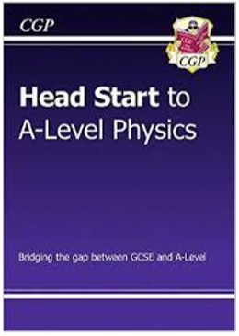
Books
This useful Head Start book from CGP is the ideal way to bridge the gap between GCSE and A-Level Physics. It recaps all the crucial topics you’ll need to remember from GCSE, with crystal-clear study notes and examples, plus practice questions to test your understanding. It also includes introductions to some of the key topics you’ll meet at A-Level!

Helpful Websites:
https://www.ocr.org.uk/qualifications/as-and-a-level/physics-a-h156-h556-from-2015/
https://www.physicsandmathstutor.com/
http://www.physbot.co.uk/
https://www.thestudentroom.co.uk/a-level/subjects/physics/

Plenty of video help from Youtube channels such as Khan academy or DrPhysicsA and many more

