Bridging Work - Summer 2026:

PSYCHOLOGY

Exam Board: AQA

Below are some guidance material and tasks that you may wish to undertake in preparation for your study of Psychology at A-Level. This will give you an insight into the course by reading up on some of the topics that will be covered over the two years.

AQA Specification - it is beneficial for you to read through the specification to gain an idea of what you will study and how you will be assessed. You will have 3 exams at the end of Year 13 that will assess you on the content from Year 12 and Year 13.

Each exam is broken down as follows:

Exam Paper (2 hours each) | Topics Assessed
Paper 1: Introductory Topics in Psychology | Social Influence, Memory, Attachment & Clinical Psychology
Paper 2: Psychology in Context | Approaches in Psychology, Biopsychology & Research Methods
Paper 3: Issues and Options in Psychology | Issues and Debates, Schizophrenia, Relationships & Aggression

Suggested Tasks:
- Read through the A-Level specification and the topics you will be studying. (see link above)

- Read some of the latest psychology articles and reports on a variety of topics at: www.psychologytoday.com

- Read and understand the way you will be assessed by identifying the main assessment objectives (AO):
- AO1, AO2 & AO3

Task1 :

- Introduction to the key approaches from Psychology.
1. The Cognitive Approach 2. The Biological Approach
3. The Humanistic Approach 4. The Psychodynamic Approach
5. The Behaviourist Approach 6. Social Learning Theory

Produce a paragraph to summarise the key concepts of each approach, this should include a definition and a brief outline of what the approach is about i.e. how they explain human behaviour.

Task 2: Eyewitness Testimony

Research real-life cases of where someone has been wrongly convicted due to incorrect EWT

Task 3: Can having a mental illness means you can plead not guilty to criminal acts?

Research real-life cases of where perpetrators have been found not guilty on the basis of diminished responsibility.

You will be given the log in code to the A’ level text book that we use. However you are more than welcome to use any other text book as long as it is for AQA.

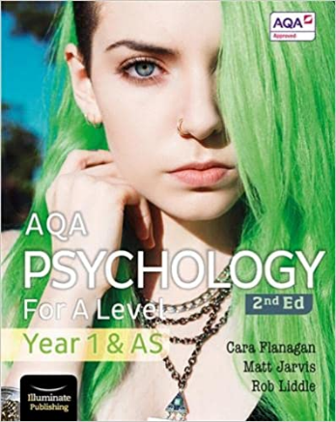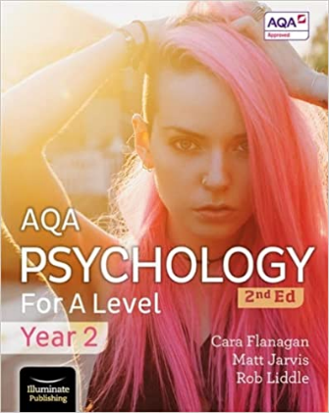 These are the books we use.

- Useful websites: www.simplypsychology.org , www.psychlotron.org.uk,
- Possible career paths www.bps.org.uk/become-psychologist/additional-careers-resources

If you have any queries, please contact:

Mrs Chall, Head of Psychology
bch@herschel.slough.sch.uk

