Florence Nightingale

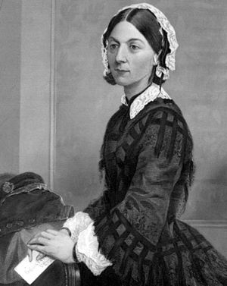

Fact file by Sophie McIntosh

Florence Nightingale was born 12th May 1820 in Florence, Italy and her family moved back to England when she was a young girl. In 1845 she decided to become a nurse and while training she campaigned for better conditions for poor people in Britain. In 1853 The Crimean war began and a year later Florence went, as a leader of a team of nurses, to a place called Scutari, in Turkey, to help treat the wounded soldiers in the war.

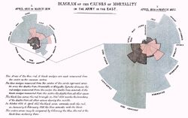
Florence was an early user of graphs and diagrams to help display information found in maths and statistics. Florence noticed that many of the wounded soldiers were dying due to disease while in the army hospitals rather than from the injuries they had received. As a result, she cleaned the hospitals and the number of deaths fell drastically.
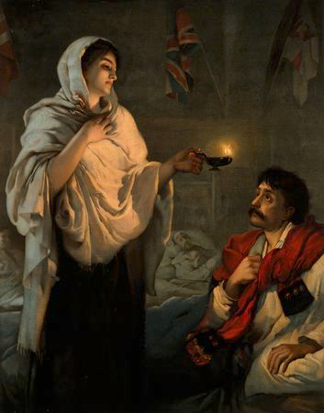

Florence became known as the Lady of the Lamp because as she cared for the wounded soldiers during the night and she walked the wards with a lamp in her hand. When the war ended in 1857, Florence returned as a heroine and in 1859 a training school for nurses was built and named after her. Florence wrote many books on nursing and medicine while at the school and introduced most conditions normally found in modern hospitals now.

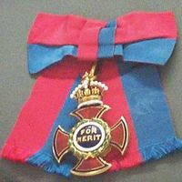
In 1883 Florence was awarded the Royal Red Cross by Queen Victoria and became the first woman to be awarded the Order of Merit medal by King Edward VII in 1907 for her services to medicine. On 13th August 1910 Florence sadly died in London aged 90.

