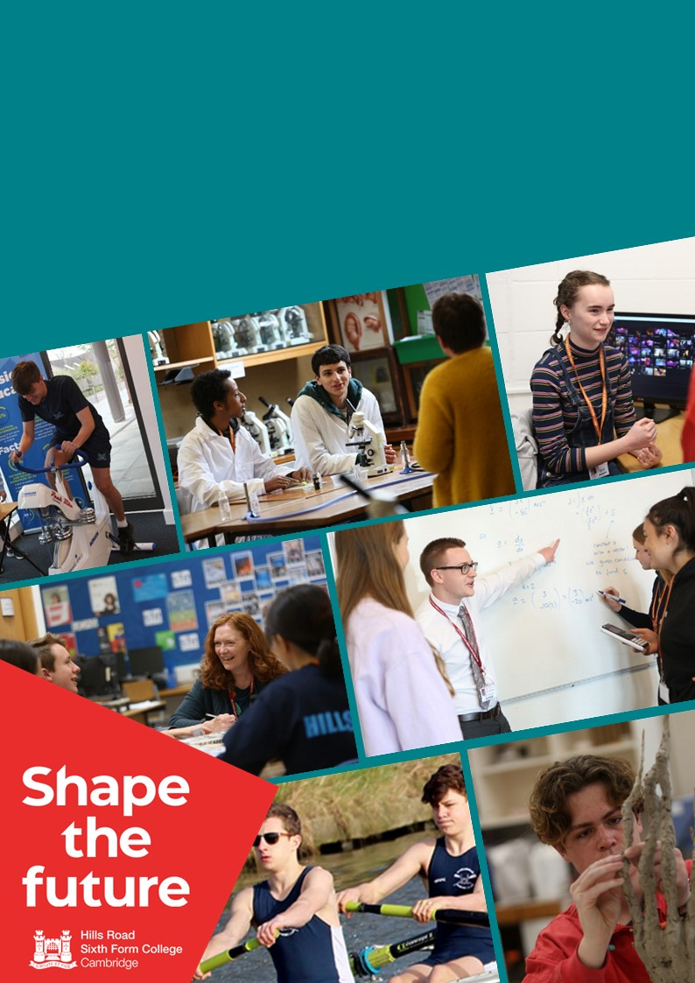
Hills Road Sixth Form College
Appointment of: Biology Technician
Location: Cambridge

Welcome from the Principal and CEO Designate

Thank you for your interest in Hills Road Sixth Form College and in this post. I hope that the information in this booklet will help you to decide whether this role and our college might be the right next step for you. I sincerely hope it is!
As I prepare to take up the role of Principal in September, this marks an important moment in the College’s continuing journey. Hills Road enjoys a strong national reputation and has led Sixth Form College performance tables for many years. But we are not complacent. In an ever-changing world, excellence is a moving target and we are ambitious - for our students, for our staff and for the future of post-16 education. We respond thoughtfully, continually reflecting and evolving to ensure that what we offer remains exceptional.
Working in a Sixth Form College brings distinctive rewards, not least the privilege of engaging with bright young minds who challenge, question and inspire. It is an intellectually rigorous environment grounded in collaboration and shared purpose. Everyone here has a role to play in helping every young person who comes through our doors to realise their potential – sometimes in ways they may never previously have been able to imagine.
I am fortunate enough to know first-hand the transformative impact that Hills Road has on our students and, as a former student, I am deeply committed to ensuring that it continues to flourish as a centre of academic excellence where kindness and integrity remain at the heart of everything we do.
We recognise that staff wellbeing is fundamental to student success and we pride ourselves on being consultative. In response to colleague feedback, we have introduced a two-week October half term and redesigned professional development. Staff consistently speak of the strength of our community. Our core values – Diversity, Kindness, Integrity, Respect, Community and Excellence – are not slogans, but lived commitments that shape how we work, how we lead and how we support one another. Hills Road is ambitious, yet humane; high-performing, yet deeply caring.
I hope I have been able to give you a flavour of Hills Road. If you would welcome an informal conversation about the role or about the College more broadly, we would be delighted to hear from you.
Finally, thank you for considering our college and for the commitment that an application entails. Whatever the outcome, I wish you every success in your future career.
With very best wishes,
Ali Kirkman
(Principal Designate)

Biology Technician
Permanent, Part-time (32 hours per week), Term time
Point 8 of the Support Staff Pay Spine: £26,343 per annum FTE (£19,427 per annum pro rata)
Hills Road Sixth Form College is looking for an efficient and highly organised Biology Technician to assist in the servicing of the laboratories, maintenance of equipment and delivery of practical work. As a Biology Technician, you will play a crucial role in supporting the teaching and learning of Biology at A level. If you enjoy working in a collaborative environment and possess excellent organisational and communication skills, we encourage you to apply. Come and help us shape the future!
Recently rated ‘outstanding’ again, Hills Road Sixth Form College continues to enjoy a strong national reputation for excellence in education. In part, this is because we continually review and refine our practice to enhance the experiences of our students and staff. We also appreciate that academic success requires a happy, healthy and caring community, so our coaching culture ensures that the wellbeing of our students and staff is at the heart of all we do.

We offer a wide range of competitive benefits including a generous pension scheme, free use of the college gym, tennis courts and sporting facilities, free on-site parking, cycle to work scheme, as well as discounts on all our Adult Education courses.
Closing date: Friday 8th May at 9.00am
Interviews: Monday 18th May
Details and an application form for the above post may be obtained from our website www.hillsroad.ac.uk
The college is committed to safeguarding and promoting the welfare of its students and staff and expects all members of the college community, volunteers and visitors to share this commitment. The college actively promotes equality and diversity and welcomes applications from all sections of the community.

Information for applicants

The Post
The College seeks to appoint a Biology Technician to assist in the servicing of the laboratories, maintenance of equipment and delivery of practical work. Although experience in a prep room environment is not necessary as training will be given, it is expected that the post-holder will have completed an A level in a science subject, has practical common sense, can work quickly and efficiently under time pressure, and has the ability to work both alone and with others. An awareness of health and safety issues is also essential, although it is not necessary beyond that encountered at A level.
The post will be for 32 hours per week, spread across the 5 weekdays, and will be term time. We are looking to appoint with a start date of 20th August 2026. The starting and finishing times will be agreed with the successful candidate, but there would be a preference for the working hours to be between 10.30am – 5.00pm.

The job description and the person specification relevant to the post are enclosed.

The Department
The Biology Department at Hills Road is highly successful and characterised by its supportive environment that values academic excellence. The current team comprises eleven members of staff (5 x full-time and 6 x part-time) delivering the A level. There are 2 full-time technicians to assist with setting up practical experiments. The department operates as a team, sharing resources and working closely together in planning, delivery and monitoring of the curriculum. There are regular departmental meetings, but much is achieved through day-to-day informal interactions.

In addition to six large, fully equipped laboratories, the accommodation for Biology includes a spacious and well-appointed preparation room and a staff base room. Every lab and teaching space has a digital screen. The department is well equipped for practical work and students have access to a wide range of textbooks, SharePoint resources and worksheets/handouts.

Students
There are approximately 800 A level Biology students in the department, with 19 sets of Year 12 and 19 sets of Year 13. The teaching is rewarded by the rapid development and achievements of our students, who readily acknowledge the high level of support they receive from their teachers. Our students are well-motivated and able, with the vast majority progressing to higher education courses. Last year, 60% of our students went on to study a Biology-related degree.

Job Description

Technician at Hills Road Sixth Form College
Purpose: To enable practical work to be carried out safely and effectively.
Reports to: Senior Biology Technician

Main Accountabilities:

Preparation of practical lesson materials, apparatus and reagents under supervision of other staff.

Clearing away equipment and materials and tidying teaching rooms and laboratories after practical work, and restocking as appropriate.

Cleaning and maintenance of glassware and other apparatus.

Administration duties and general activities within the department under supervision of other staff.

Participate in maintaining satisfactory safety standards and records.

Accountabilities that relate to all staff at the college
- demonstrate behaviour and values consistent with the person specification for this role
- promote equality of opportunity in accordance with the college’s Equality and Diversity Statement
- To comply with all college policies and procedures. This includes those where each member of staff has an individual duty to act and for which the college can be held vicariously responsible for the actions of its employees:
  - equality and diversity
  - safeguarding the welfare of young people
  - health and safety

Person Specification for Biology Technician
 | Essential | Desirable
Qualifications and training | - Good general education, including maths, English and science subjects at GCSE  - Studied a science to A level | - A-Level Biology  - Competency in excel
Experience | - An awareness of Health and safety issues | - Experience of a technician's role in an education setting
In addition, the successful candidate will demonstrate, or have potential to develop, strengths in the following areas.
Skills and Ability | - Confident user of IT, including Microsoft Office applications, Outlook and the internet  - Use of basic laboratory equipment  - Ability to work independently, manage own workload, prioritise and use initiative  - Ability to work effectively under pressure  - Ability to respond flexibly and positively to changing contexts  - Ability to exercise patience, tolerance and sensitivity  - Ability to use tact and diplomacy in all communications and to deal with confidential matters with utmost discretion
Knowledge | - A basic working knowledge of commonly encountered chemicals and their hazards  - A good knowledge of the A-level Biology syllabus
Organisation | - Well organised, able to manage own time effectively in order to meet deadlines and to develop contingencies to cope with the unforeseen  - Commitment to collaborative teamwork Commitment to safeguarding the welfare of young people
Disposition and Approach | - Excellent inter-personal skills demonstrating a professional and assured disposition and with the ability to establish a good working rapport with students and colleagues  - A mature and non-judgemental outlook  - Enthusiasm  - High degree of personal responsibility
Focus on Quality | - Commitment to high standards of work and accuracy, with strong attention to detail  - Commitment to the aim of the College to achieve Quality and Value for Money in all aspects of its work  - Commitment to continuous improvement and willingness to attend appropriate training and development events

How to Apply

Applicants are asked to do the following:
- complete the online Hills Road Sixth Form College application form (Part 1)
- complete the online equality and diversity monitoring form (Part 2)
- write a supporting statement of application (no more than 1,000 words)
- supply a brief CV

The online application forms (Parts 1 and 2) are available on the College’s webpage for this vacancy. When completing Part 1, you will have the opportunity to upload your CV and provide a Supporting Statement of Application. Once you have submitted Part 1, you should then proceed to Part 2 (Equality and Diversity Monitoring form). All documents should be submitted by 9am on Friday, 8th May 2026.
Please note that applications received after the closing date may not be eligible for consideration. If Human Resources have not contacted you by Tuesday 12th May, then unfortunately your application has not been successful.

Interviews will be held on Monday 18th May 2026
Hills Road Sixth Form College will base its decision as to whether to invite you for interview solely on the details provided on your application and how well they match the criteria for this post.
In accordance with Home Office guidance, successful candidates will be required to evidence their right to work in the UK before commencement of employment. The successful candidate therefore must be able to demonstrate their right to work during the recruitment process.
Hills Road Sixth Form College is committed to ensuring equal opportunities in all aspects of employment and selects staff on merit, irrespective of race, religion, sex, disability or age. You are not obliged to complete the equal opportunities monitoring form, but any information given will help us to monitor the effectiveness of our equality and diversity policy.
If you have a disability, you are invited to request any special arrangements you may require for interview, or any adjustments you may anticipate would be needed in your working arrangements, by contacting the Human Resources Team on 01223 278063 (direct line). Further information about accessibility to the site can be found on our website under ‘Equality and Diversity/Site Plan’ and also from ‘AccessAble:
www.accessable.co.uk.
Thank you for your interest in this post and in the college. We do hope that you will decide to apply, and we should like to thank you in advance for taking the time and trouble to do so. For more information about working life at the college, please go to our website http://www.hillsroad.ac.uk


