Budget 2020 (11 March) At-a-Glance

State of the economy
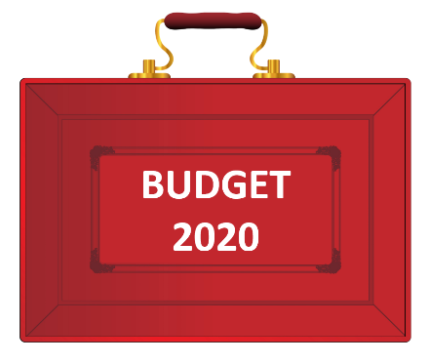
- Economy predicted to grow by 1.1% this year, not taking into account the impact of coronavirus
- Economic growth forecast to be 1.8% in 2021-22, 1.5% in 2022-23 and 1.3% in 2023-24
- Inflation forecast of 1.4% this year, increasing to 1.8% in 2021-2022
- Public sector net borrowing set to rise this year to 2.1% of GDP, rising to 2.4% and 2.8% in subsequent years
- Debt as a percentage of GDP forecast to be lower at end of current Parliament than now

Combatting Coronavirus
- A £30bn package to help the economy get through the coronavirus outbreak.
- Statutory sick pay for "all those who are advised to self-isolate" even if they have not displayed symptoms
- Business rates for shops, cinemas, restaurants and music venues in England with a rateable value below £51,000 suspended for a year
- A £500m "hardship fund" to be given to local authorities to help vulnerable people in their areas
- "Fiscal loosening" of £18bn to support the economy this year, taking the total fiscal stimulus to £30bn
- A "temporary coronavirus business interruption loan scheme" for banks to offer loans of up to £1.2m to support small and medium-sized businesses
- The government will meet costs for businesses with fewer than 250 employees of providing statutory sick pay to those off work "due to coronavirus"
- Those on in-work benefits who get ill will be able to "claim from day one instead of day eight".

Personal taxation, wages and pensions
- National Insurance Contributions tax threshold to rise from £8,632 to £9,500 - saving employees just over £100 a year
- 5% VAT on women's sanitary products, known as the tampon tax, to be scrapped

Alcohol, tobacco and fuel
- Fuel duty to be frozen for the 10th consecutive year
- Duties on spirits, beer, cider and wine to be frozen
- Business rate discounts for pubs to rise from £1,000 to £5,000 this year

Business, digital and science
- Entrepreneurs' Relief will be retained, but lifetime allowance will be reduced from £10m to £1m
- £5bn to be spent on getting gigabit-capable broadband into the hardest-to-reach places
- Science Institute in Weybridge, Surrey to get a £1.4bn funding boost
- An extra £900m for research into nuclear fusion, space and electric vehicles.
- VAT on digital publications, including newspapers, books and academic journals to be scrapped from December

Environment and energy
- Plastic packaging tax to come into force from April 2022
- Manufacturers and importers whose products have less than 30% recyclable material will be charged £200 per tonne
- Subsidies for fuel used in off-road vehicles - known as red diesel - will be scrapped "for most sectors" in two years' time
- Red diesel subsidies will remain for farmers and rail operators
- £120m in emergency relief for communities affected by this winter's flooding and £200m for flood resilience
- Total investment in flood defences to be doubled to £5.2bn over next five years
- £640m "nature for climate fund" to protect natural habitats, including 30,000 hectares of new trees

Transport, infrastructure and housing
- More than £600bn is set to be spent on roads, rail, broadband and housing by the middle of 2025
- £2.5bn will be made available to fix potholes and resurface roads over five years
- £1.5bn in capital spending on further education colleges
- £650m package to tackle homelessness, providing an extra 6,000 places for rough sleepers
- Stamp duty surcharge for foreign buyers of UK properties to be levied at 2% from April 2021
- £1bn fund to remove all unsafe combustible cladding from all public and private housing higher than 18 metres

Nations and Regions
- An extra £640m for Scotland, £360m for Wales, and £210m for Northern Ireland.
- Treasury's Green Book rules to be reviewed to put regional prosperity at heart of spending decisions
- Treasury to open new offices in Wales and Scotland
- New civil service hub in the North of England, employing 750 staff
Public Sector spending 2020-21
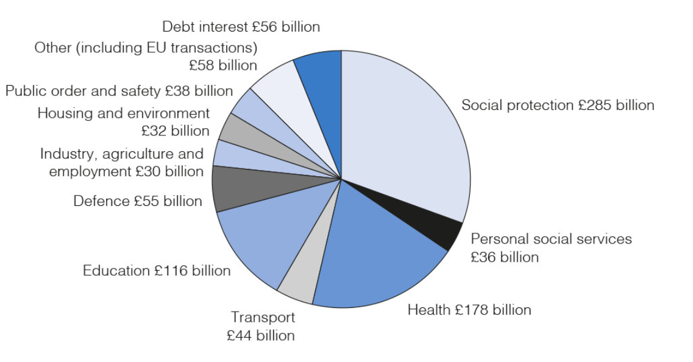
Source: OBR and HM Treasury

Public Sector Current Receipts (2020-2021)
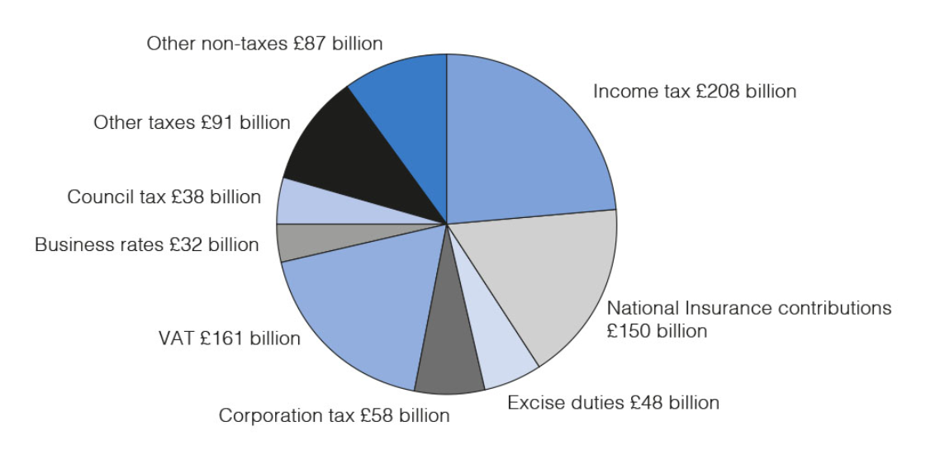
Source: OBR and HM Treasury

Public sector net debt from 2000-01 to 2024-25
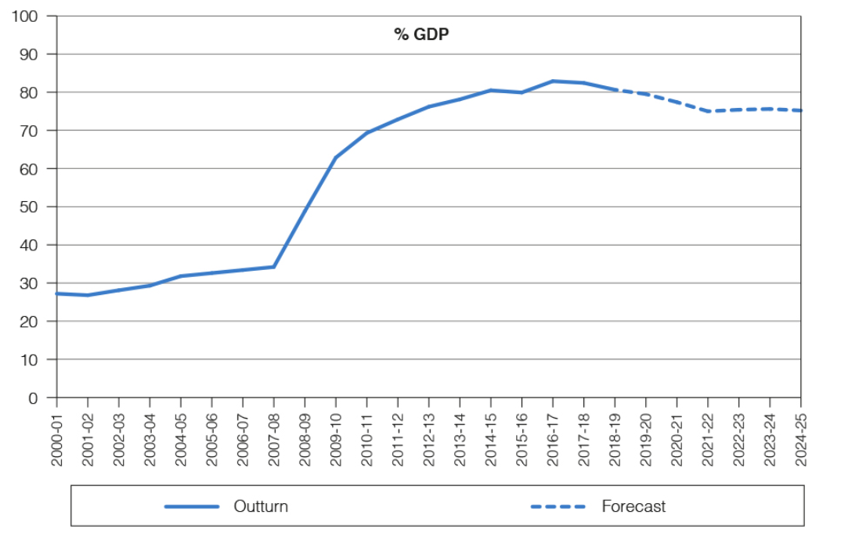
Source: ONS and OBR

