

Wedding packages 2019

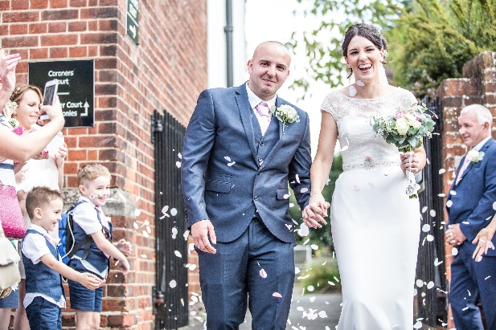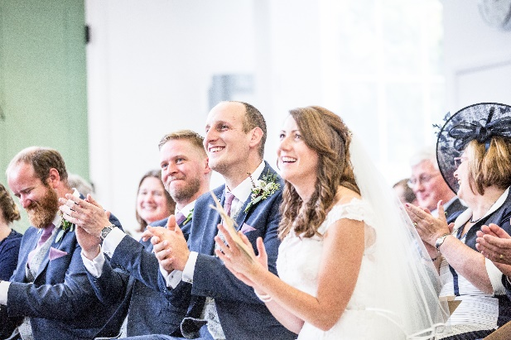

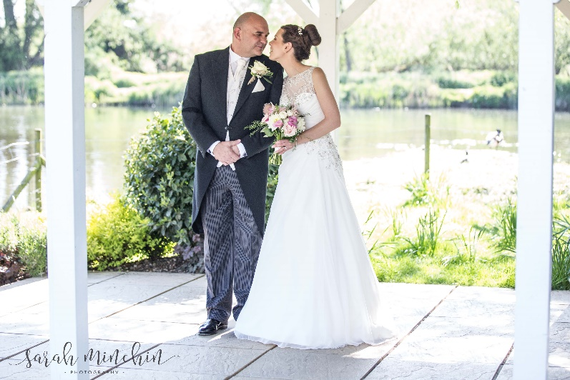

Silver package

1 hour engagement / pre-wedding session before the wedding day

Up to 3 hours photography (e.g. preparations at Church, ceremony, group photos)

**£600**

Gold package

1 hour engagement / pre-wedding session before the wedding day

Up to 6 hours of photography (e.g. as above plus reception up to cake cutting)

**£850**

Platinum package

1 hour engagement / pre-wedding session before the wedding day

Up to 8 hours of photography (e.g. getting ready shots through to first dance)

**£1100**